**SQL (structured query language)**

* Query data
* Standardize language, supported by all of the major commercial databases
* Interactive use via graphical user interface or embedded in programs
* Declarative, based on relational algebra

MySQL: an open-source relational database management system

(Oracle, SQL server from Microsoft are alternatives)

MySQL Workbench: an open source visual database design tool that integrates SQL development, administration, database design, creation and maintenance into a single integrated development environment for MySQL

(PhpMyAdmin is an alternative)

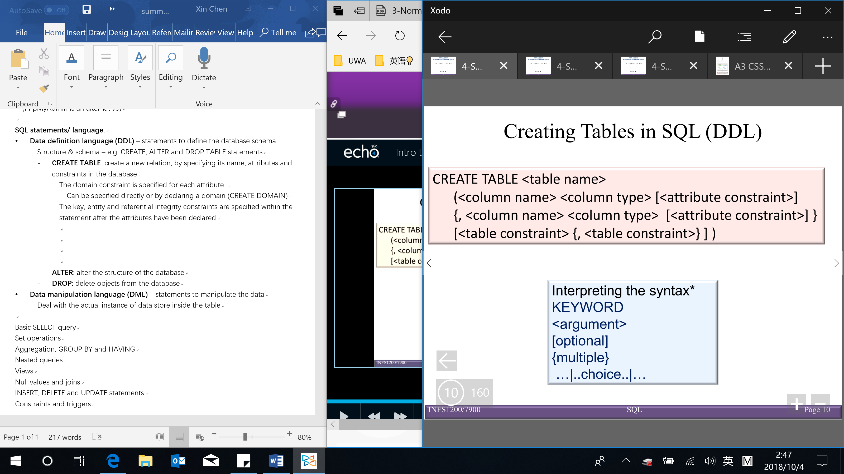

**SQL statements/ language**:

【The result of a SQL query is a table/relation】

* **Data definition language (DDL)** – statements to define the database schema

Structure & schema – e.g. CREATE, ALTER and DROP TABLE statements

* **CREATE TABLE**: create a new relation, by specifying its name, attributes and constraints in the database

The domain constraint is specified for each attribute

Can be specified directly or by declaring a domain (CREATE DOMAIN)

e.g. integer, character, varchar, date

Varchar (variable character) V.S. character (fixed length character)

The key, entity and referential integrity constraints are specified within the statement after the attributes have been declared

Enforcing referential integrity

A referential triggered action clause can be attached to a foreign key constraint, that specifies the action to take if a referenced tuple is deleted, or a referenced primary key value is modified

Possible actions (4):

* NO ACTION (default): the delete/update is rejected
* SET NULL
* SET DEFAULT
* CASCADE: delete/update all roles that refer to

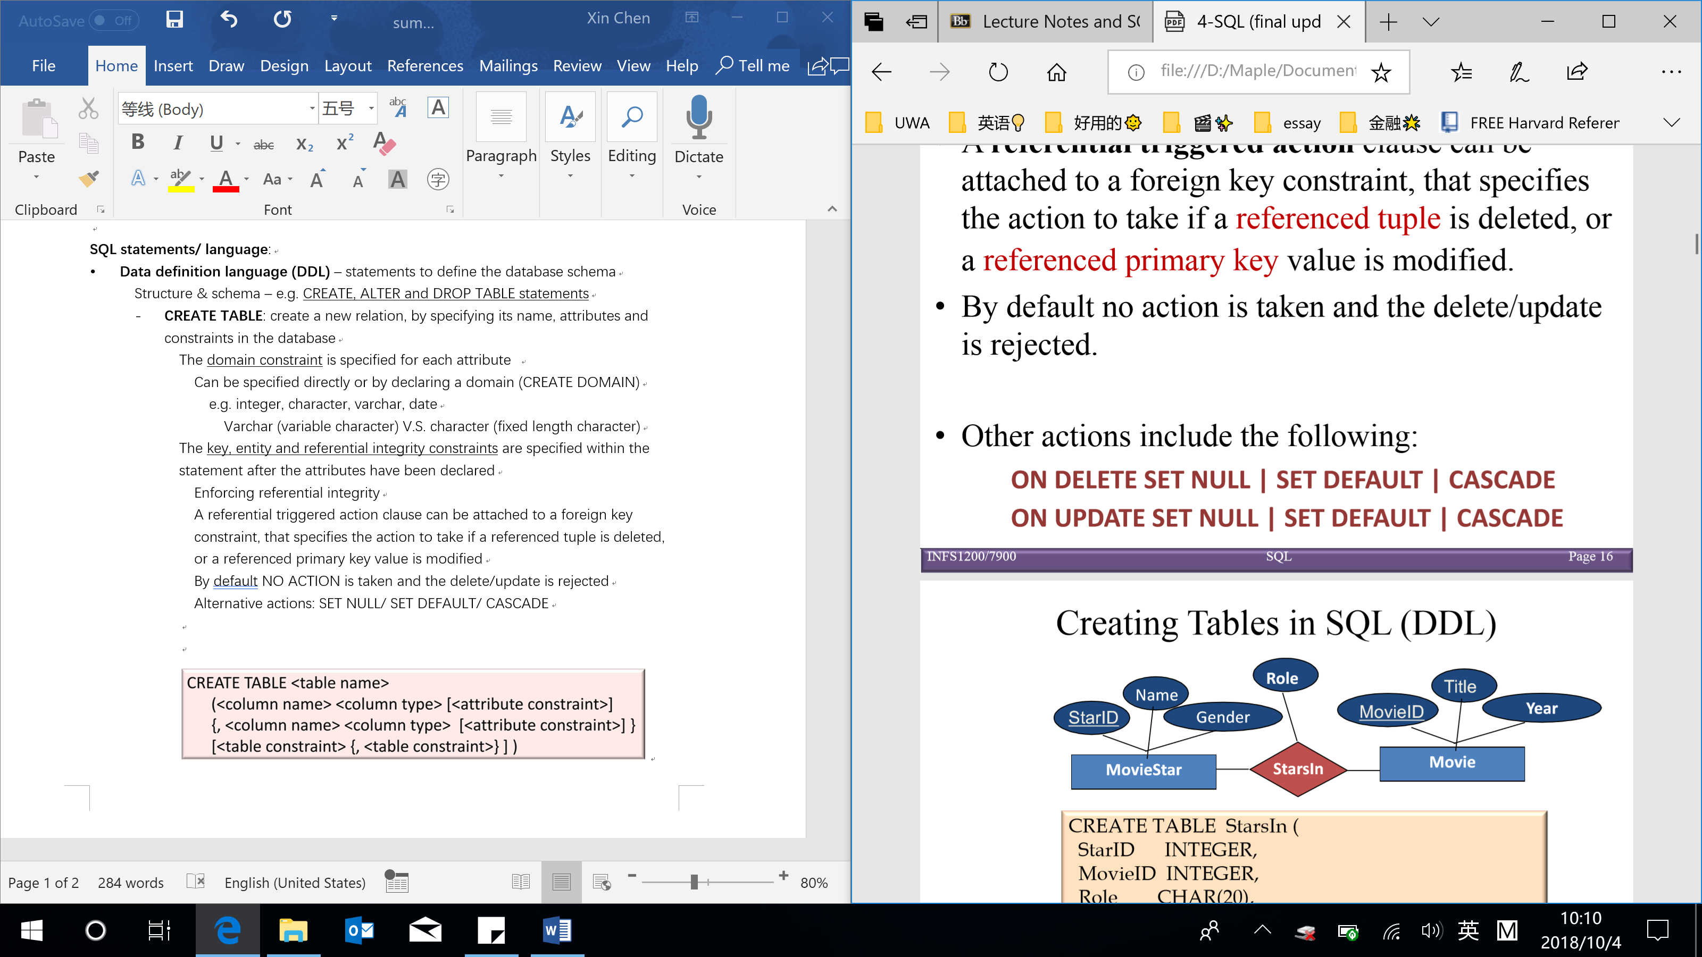



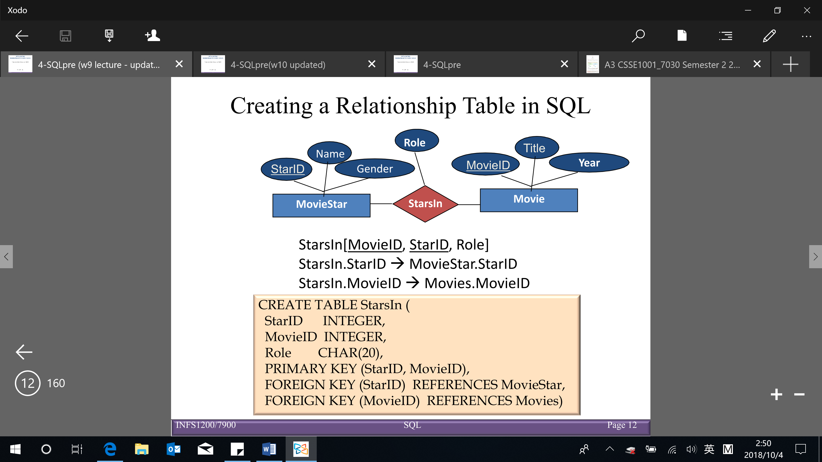

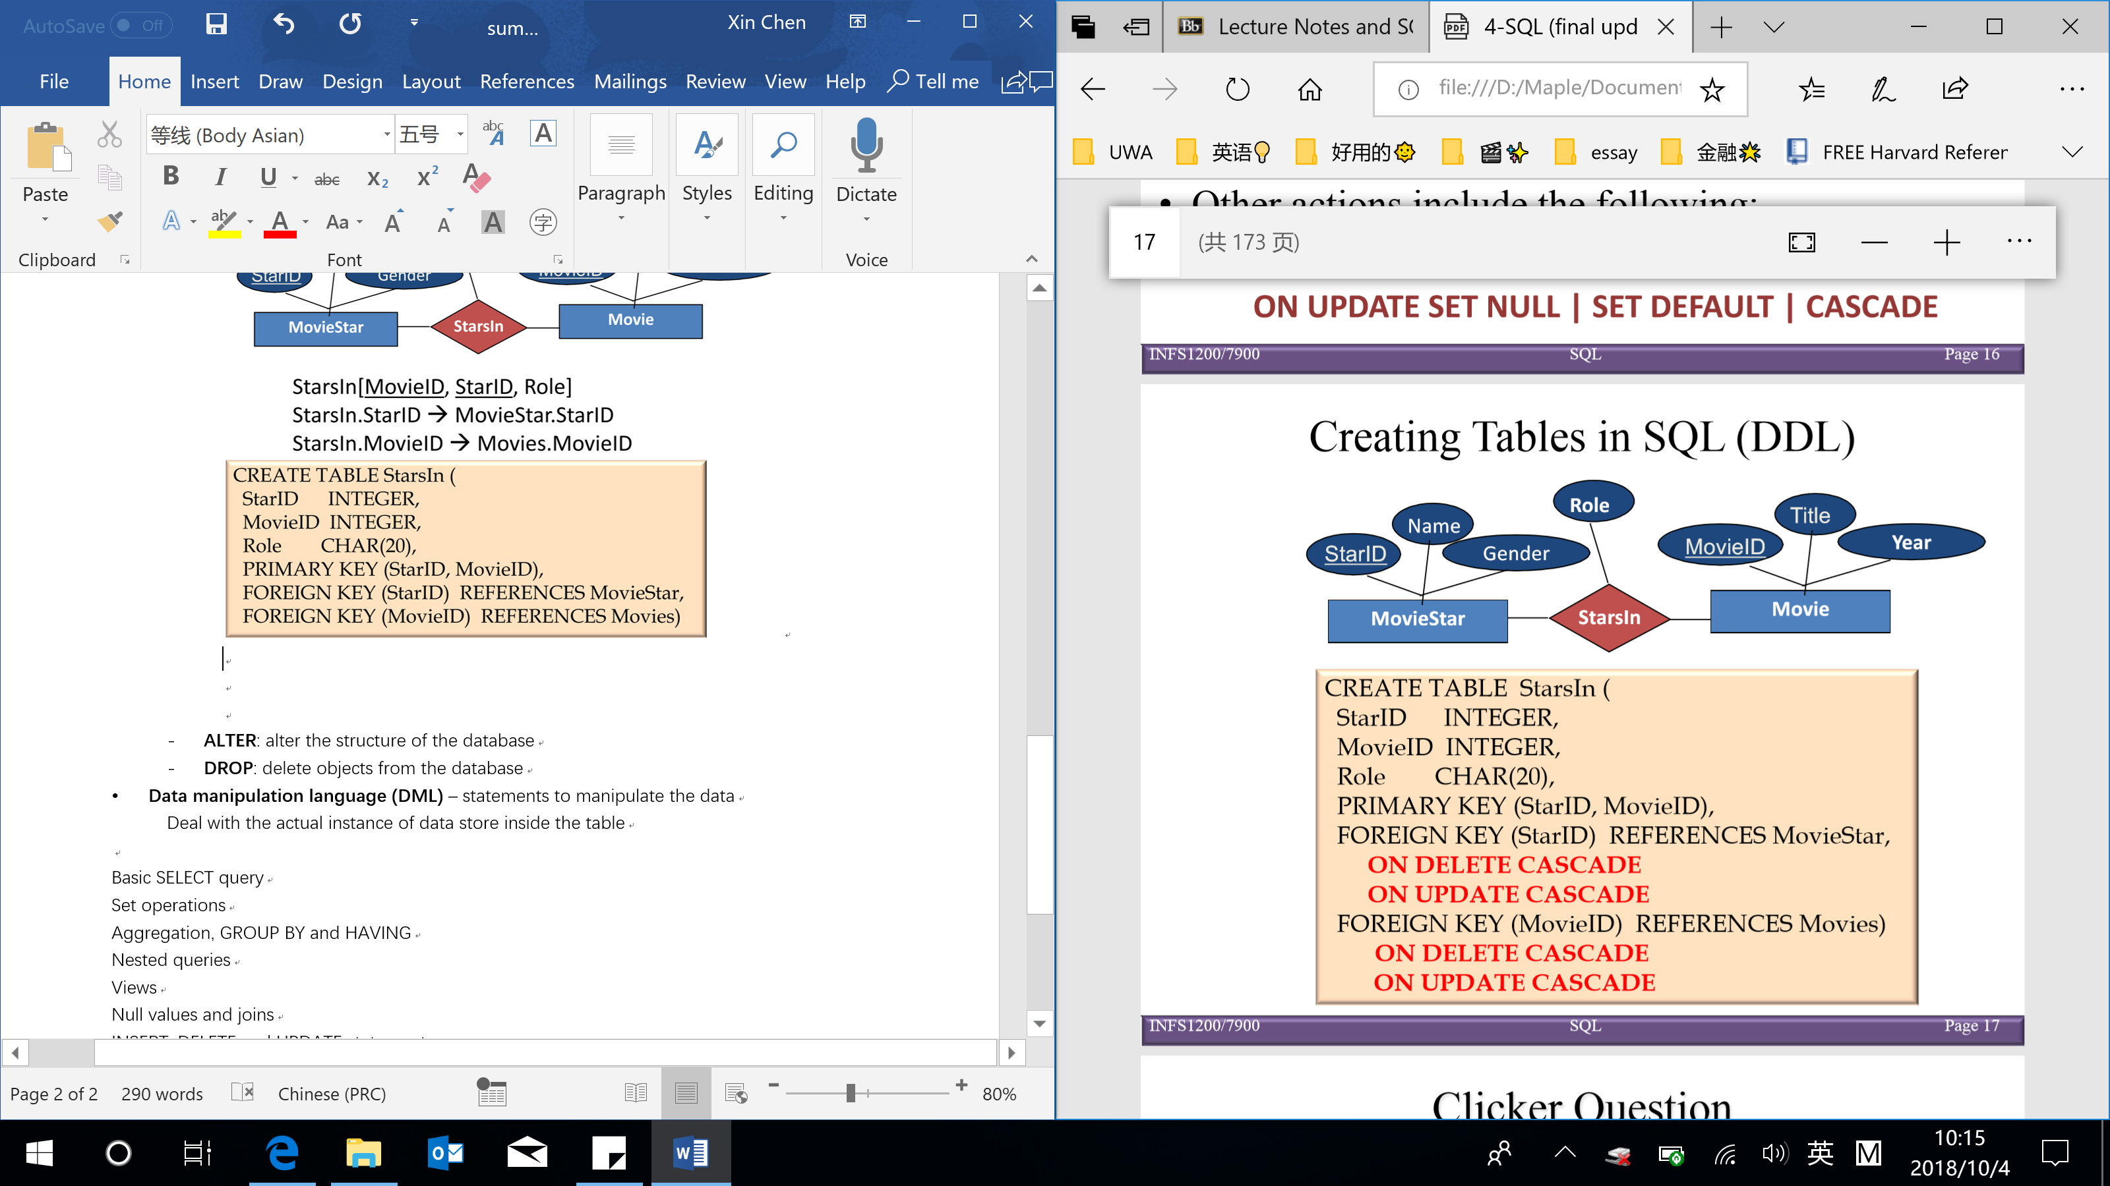

* **ALTER TABLE**: command used for schema evolution, that is the definition of a table created using the CREATE TABLE command, can be changed using the ALTER TABLE command (alter the structure of tables)

Possible actions:

Adding/ dropping a column

Changing a column definition/domain

Adding/ dropping constraints

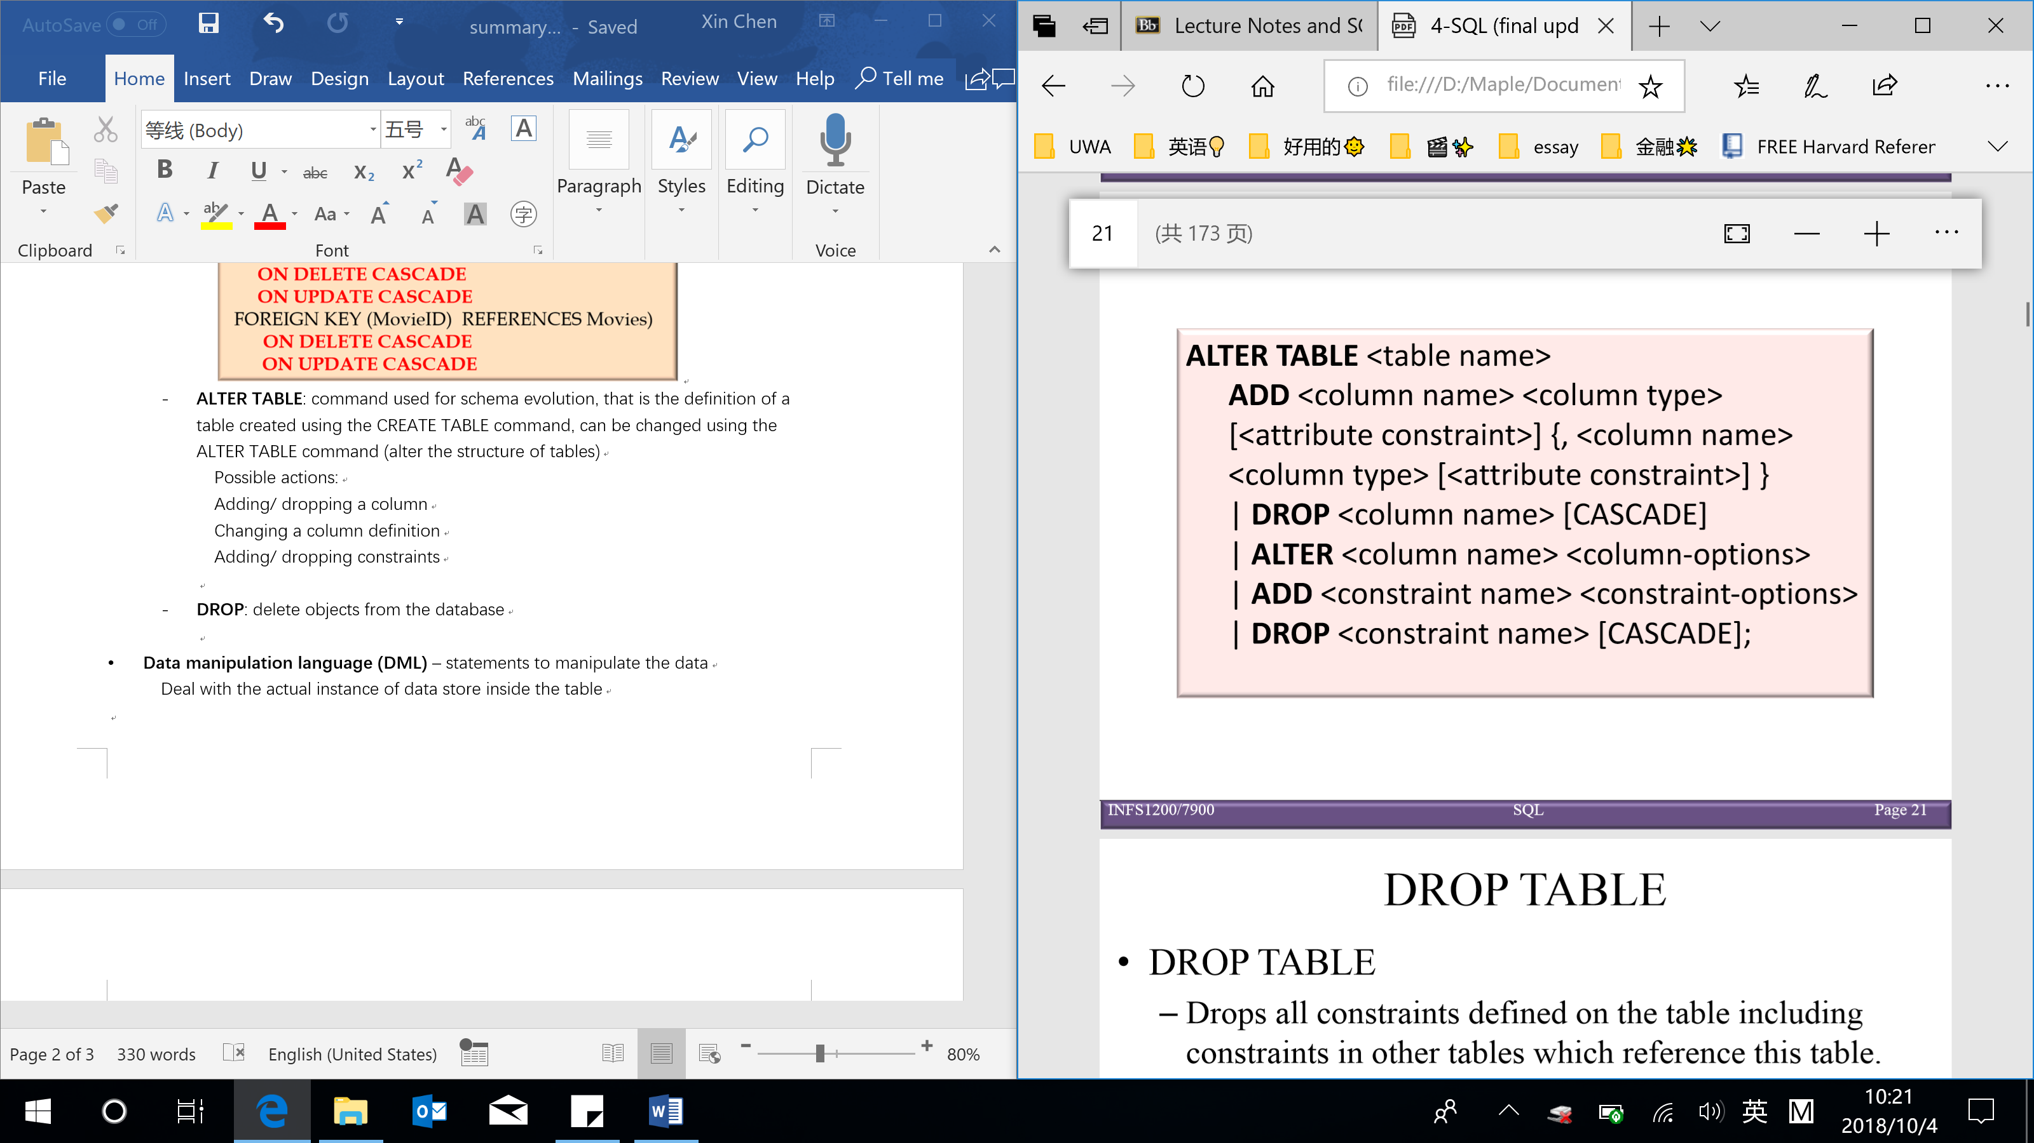

* **DROP TABLE**: delete/remove/drop tables/objects from the database, including:
* Drops all constraints defined on the table including constraints in other tables which reference this table
* Deletes all tuples within the table
* Removes the table definition from the system catalog

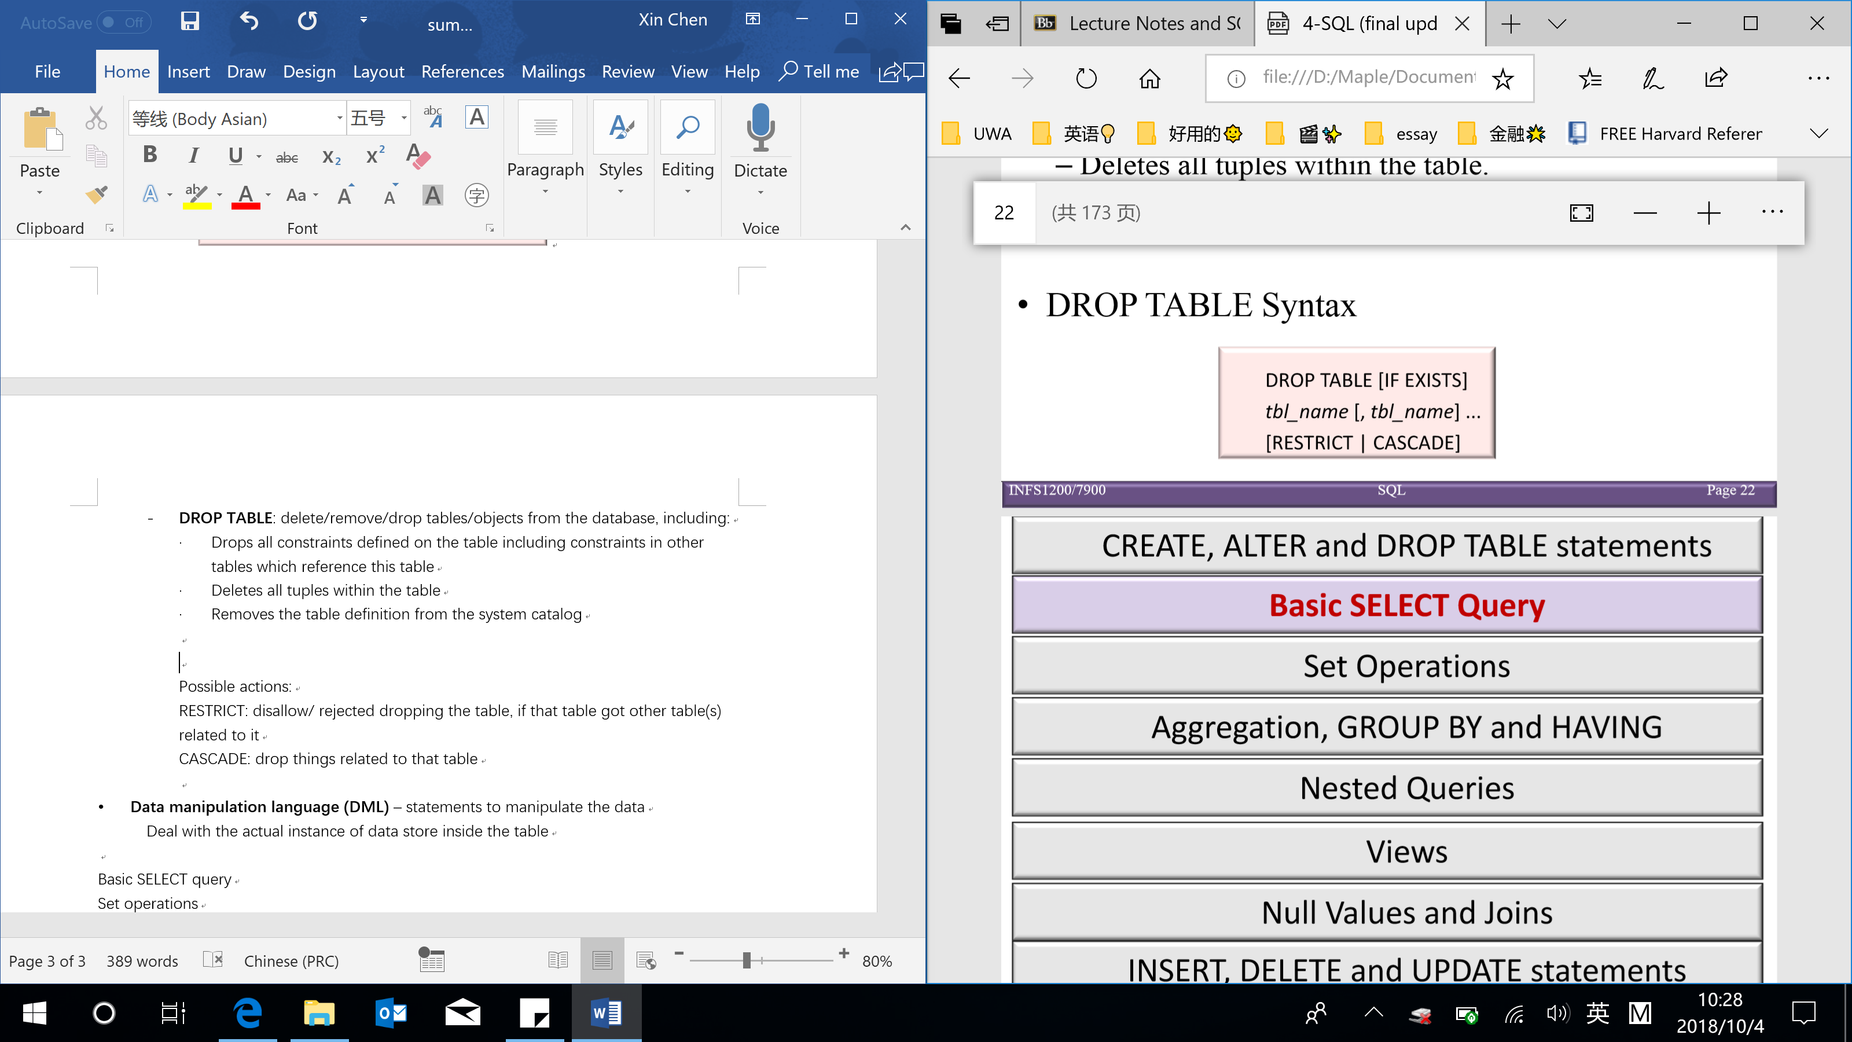

RESTRICT: disallow/ rejected dropping the table, if that table got somethings related to it

CASCADE: drop things related to that table

* **Data manipulation language (DML)** – statements to manipulate the data/ managing data within schema objects (deal with the actual instance of data)
* **SELECT**: retrieve data from a database

Basic SELECT query:

In the SELECT statement, users specify what the result of the query should be, and the DBMS decides the operation and order of execution (in the optimization) to return the result → SQL queries are ‘declarative’ (specify what you want not how you want)

[NOTE: the SQL SELECT statement has NO relationship to the SELECT operation of relational algebra]

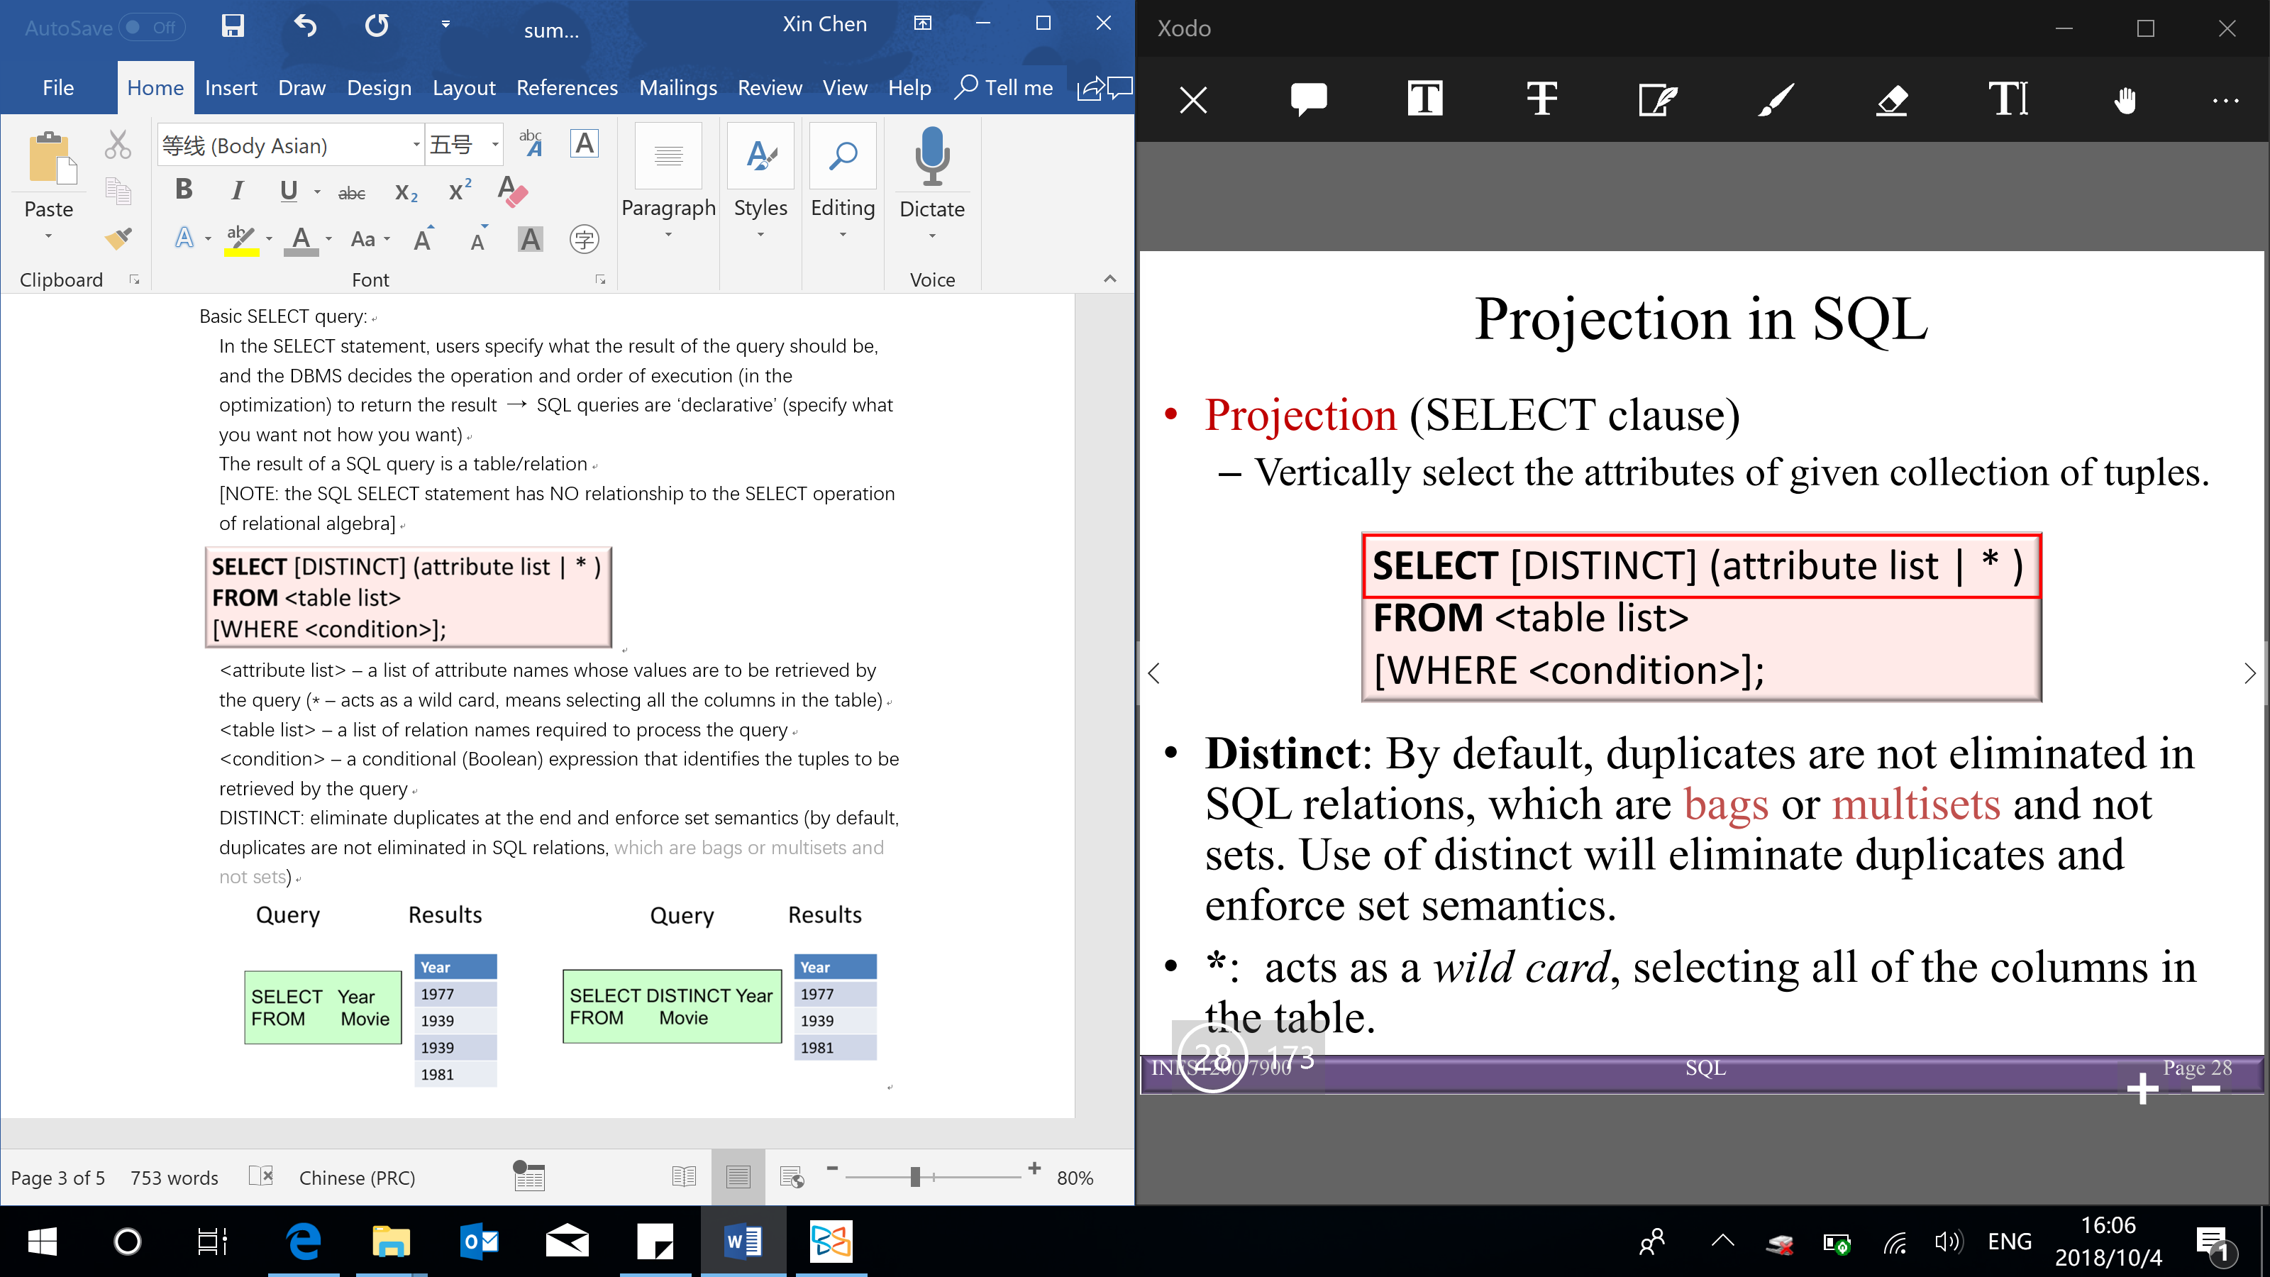

<attribute list> – a list of attribute names whose values are to be retrieved by the query (* – acts as a wild card, means selecting all the columns in the table)

<table list> – a list of relation names required to process the query

<condition> – a conditional (Boolean) expression that identifies the tuples to be retrieved by the query

Relational algebra:

* **Projection (SELECT clause)**: vertically select the attributes of given collection of tuples (the column/attributes wanted to return)

SQL queries can evaluate expressions and return the value of these expressions together with the projected attributes

Expressions use standard arithmetic operators (+, -, *, /) on numeric values or attributes with numeric domains

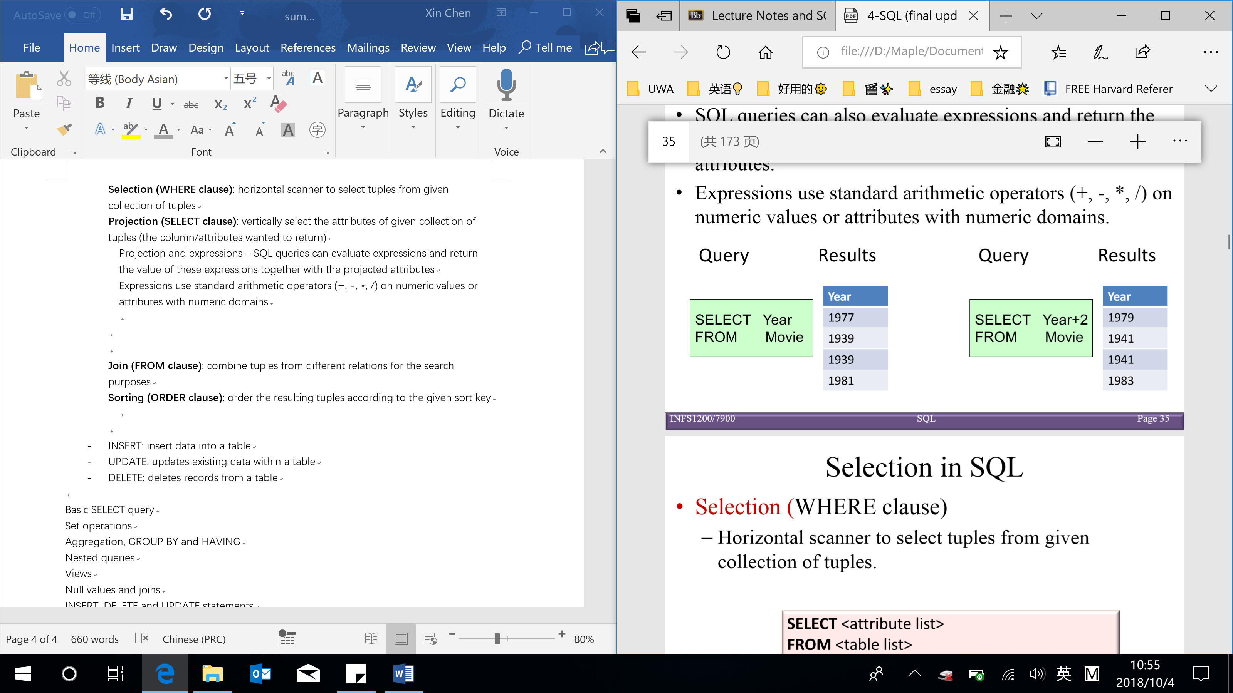

DISTINCT: eliminate duplicates at the end and enforce set semantics (by default, duplicates are not eliminated in SQL relations, which are bags or multisets and not sets)

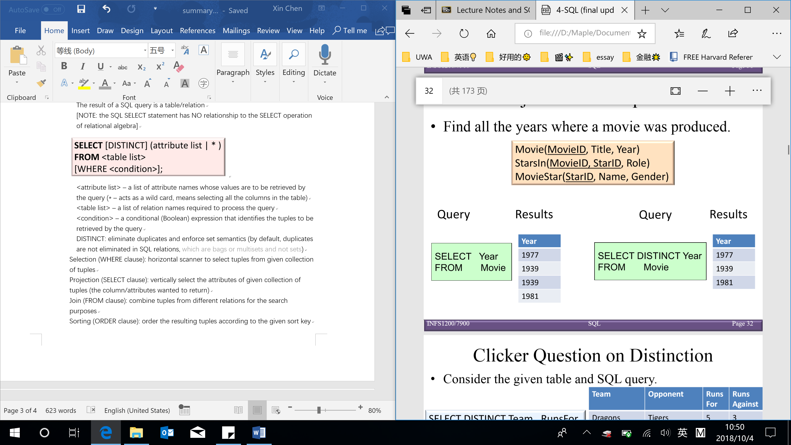

Renaming attributes using AS clause:

*Old-name* AS *new-name*

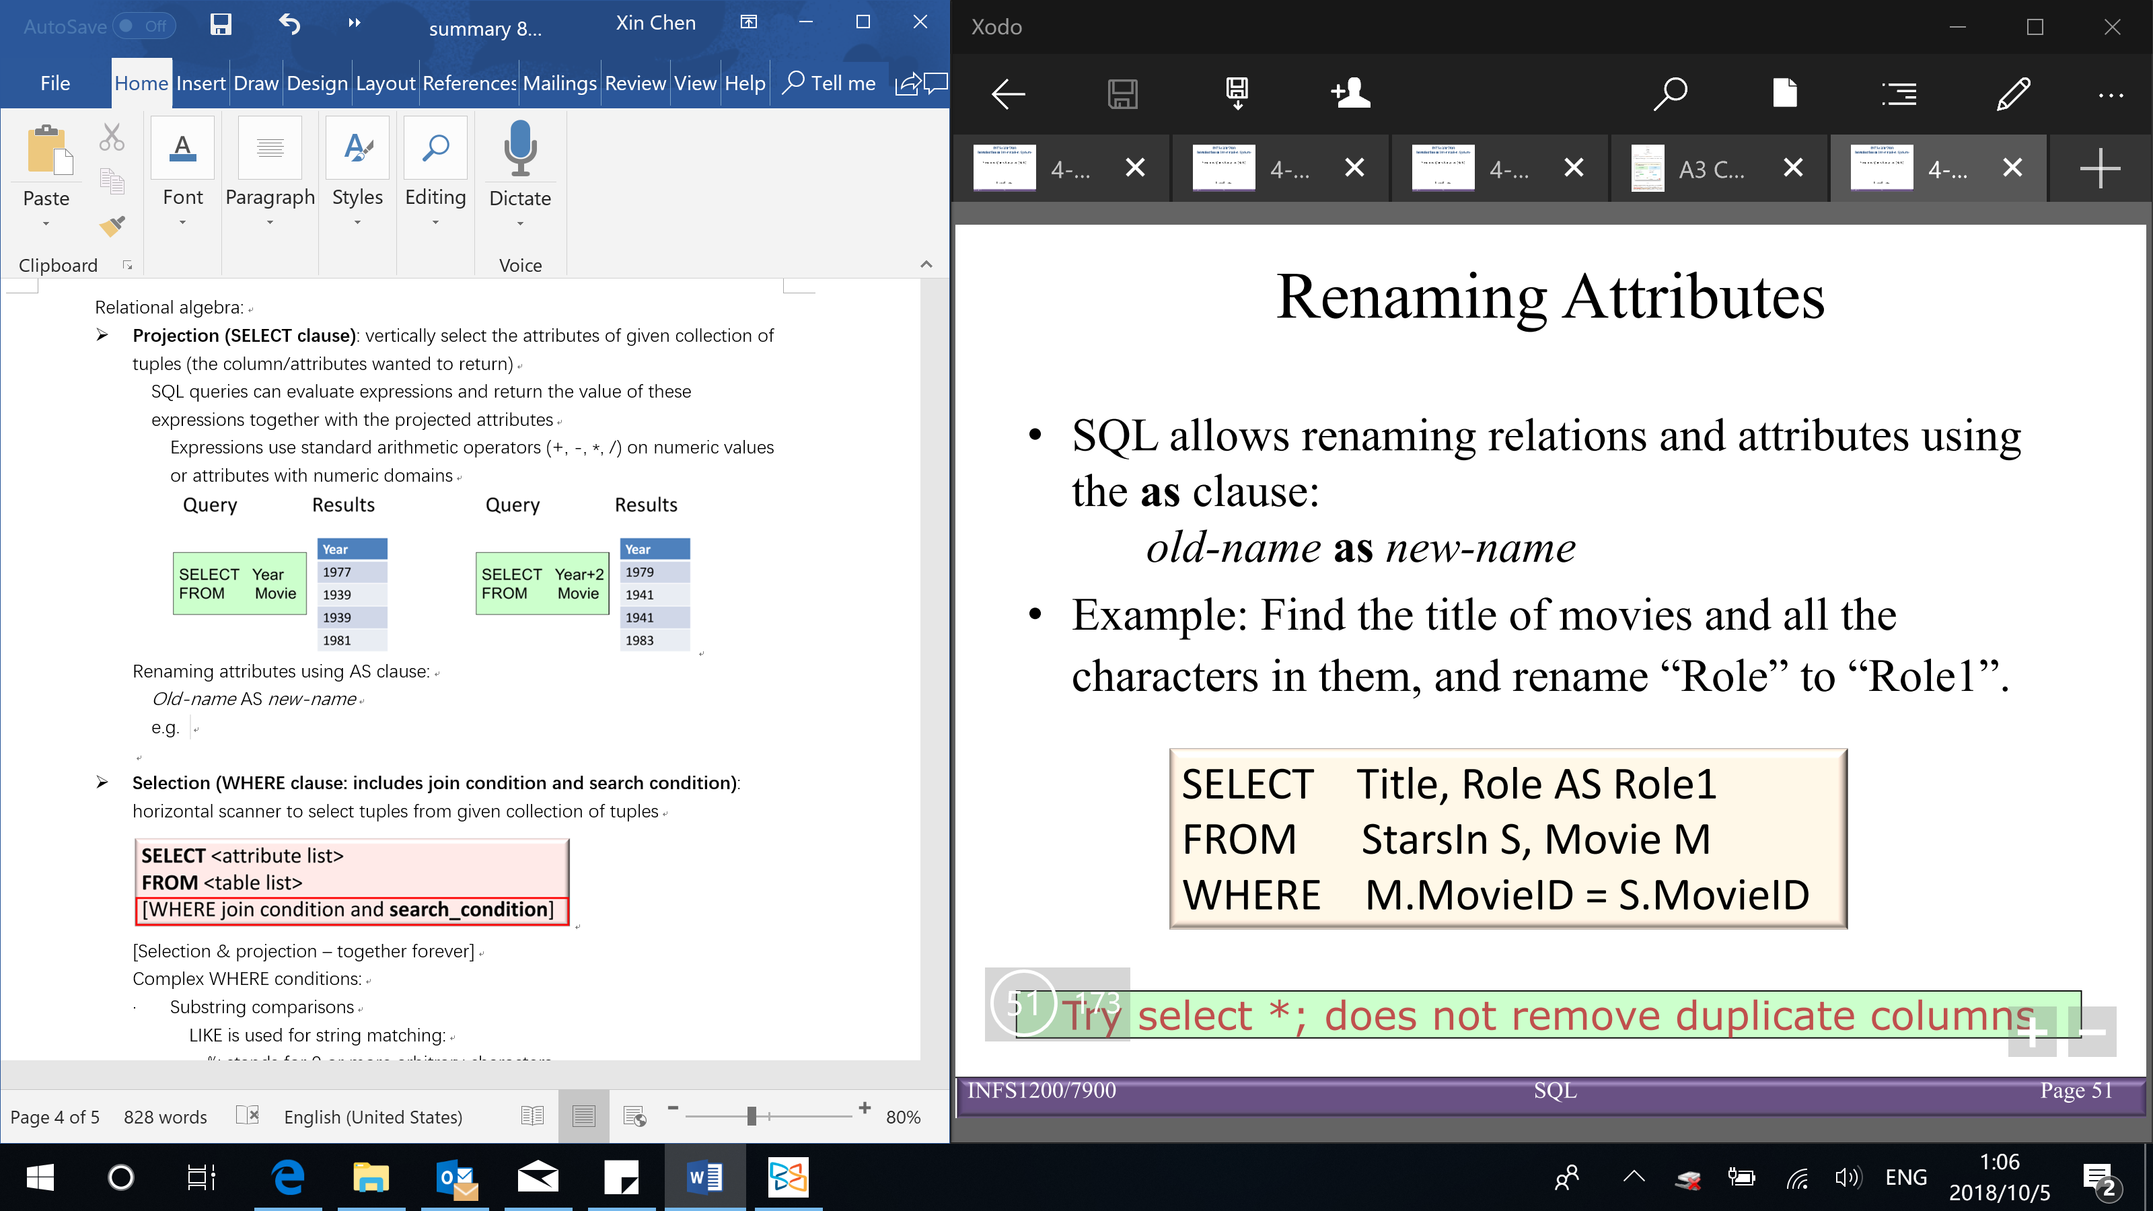

* **Selection (WHERE clause: includes join condition and search condition)**: horizontal scanner to select tuples from given collection of tuples

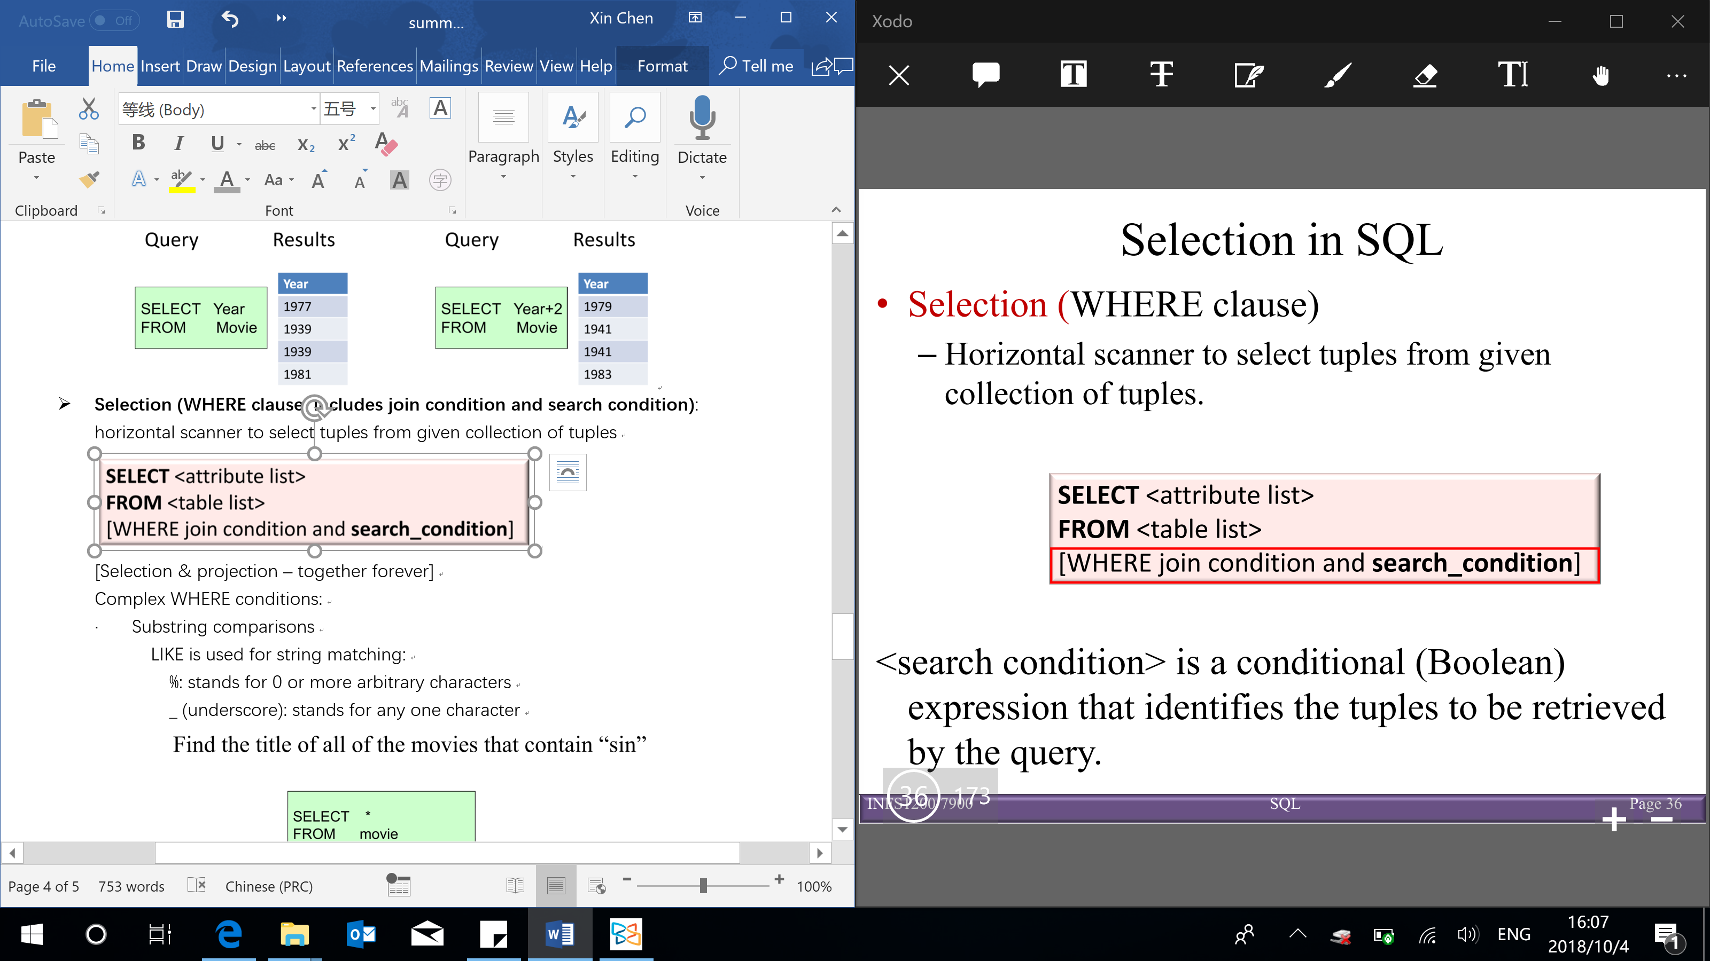

[Selection & projection – together forever]

Complex WHERE conditions:

* Substring comparisons

LIKE is used for string matching:

%: stands for 0 or more arbitrary characters

_ (underscore): stands for any one character

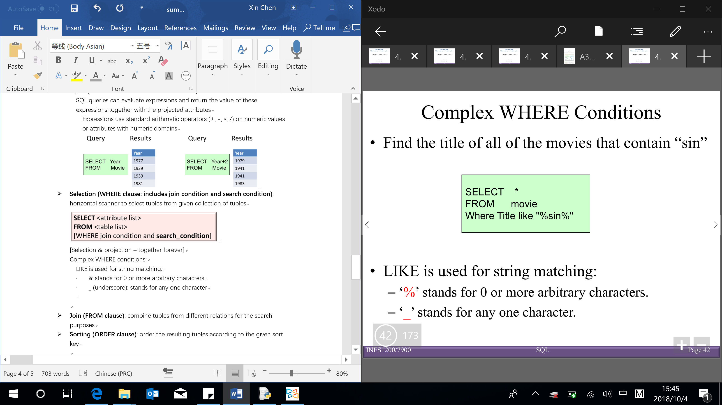

IN

e.g. WHERE LName IN (‘Jones’, ‘Wong’, ‘Harrison’)

IS

e.g. WHERE No IS NULL

* Arithmetic operators and functions

+, -, *, /, date, time, year etc

e.g. WHERE Salary*2 > 50000 & WHERE Year(Sys_Date – Bdate) > 55

BETWEEN … AND …

e.g. WHERE Salary BETWEEN 1000 AND 3000

* **Join (FROM clause & part of WHERE clause)**: combine tuples from different relations for the search purposes

<join condition> – corresponds to a join condition in relational algebra

Alias for Table names are used to give a table a temporary name to make the query more readable

e.g. FROM StarsIn S

Joining 2 tables: R1, R2 on their shared attribute – each tuple of R1 is concatenated with every tuple in R2 having the same values on the join attributes

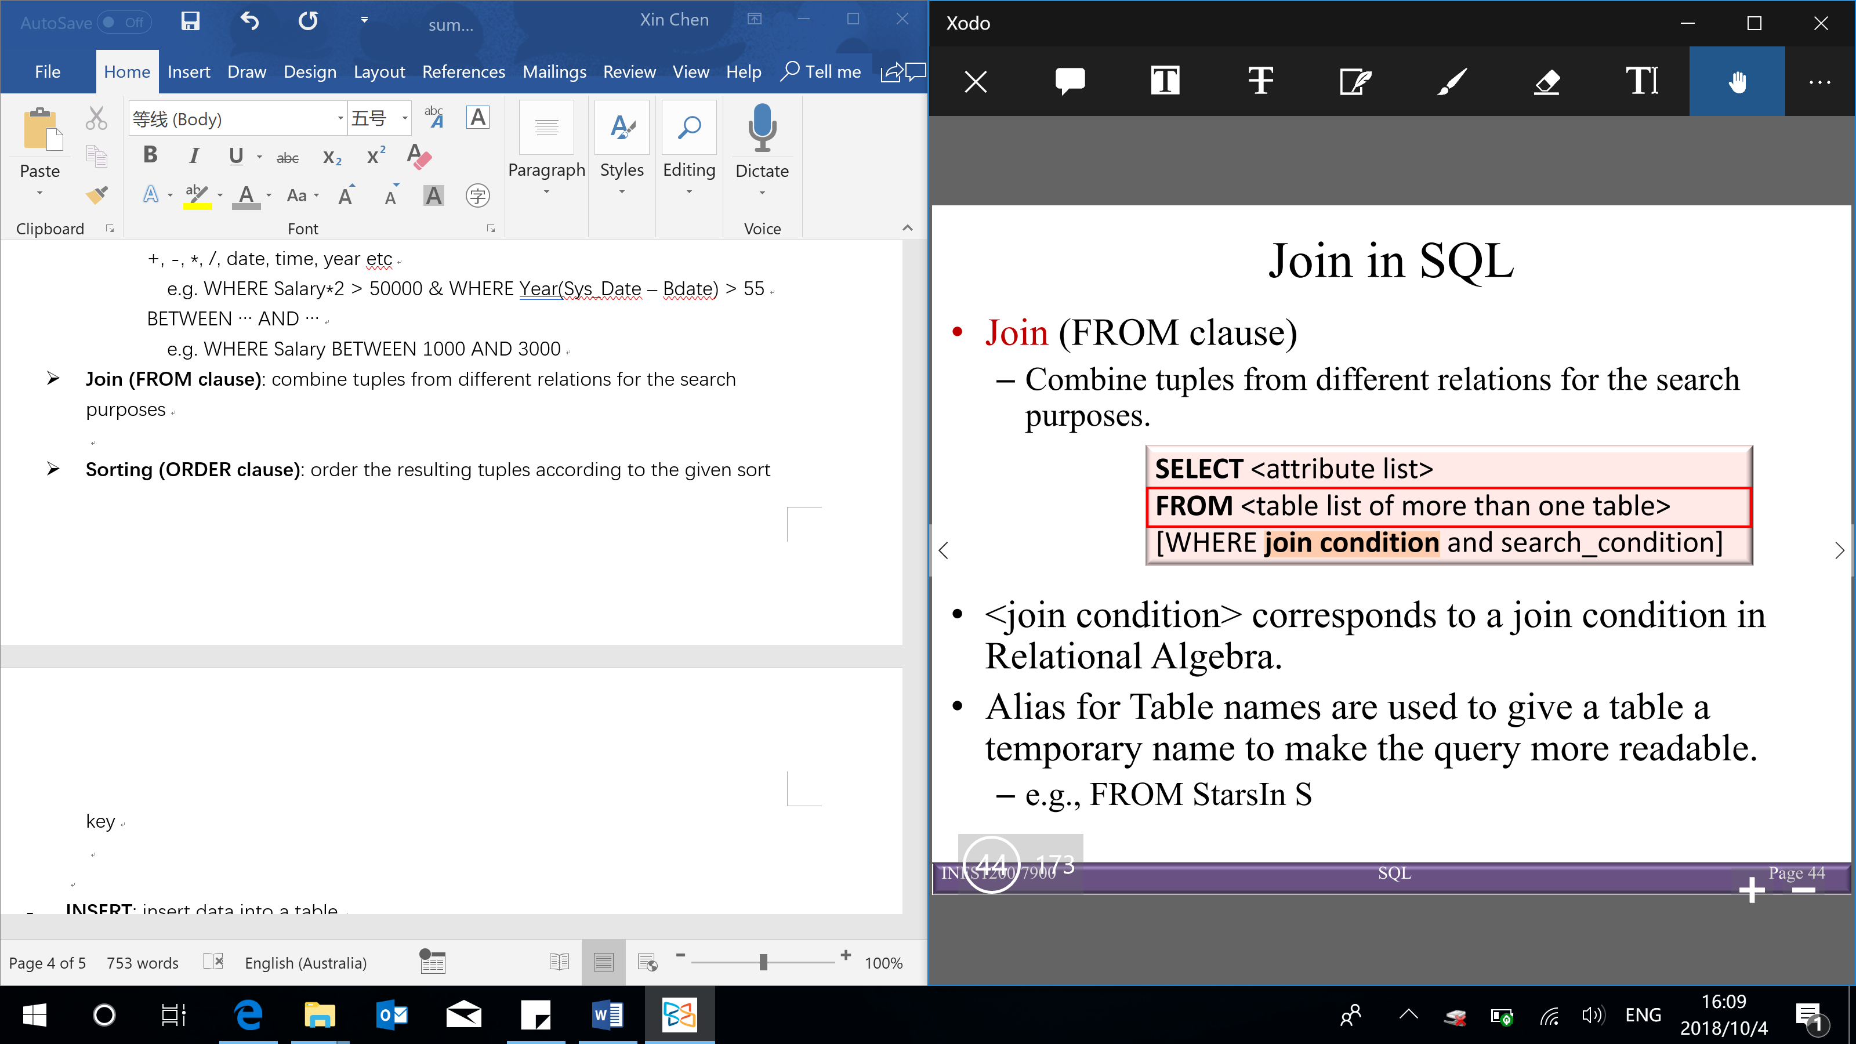

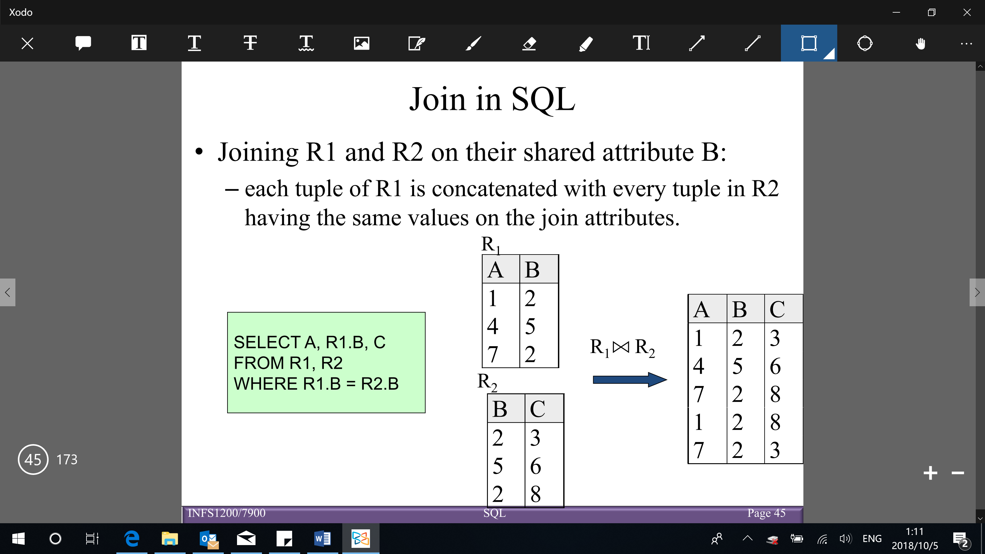

* **Sorting (ORDER clause)**: order the resulting tuples according to the given sort key (swap the order of the tuples didn’t give you a new relation, they still are the same relation – as it’s based on set theory)

Order is specified by:

* ASC – ascending order: from small to large value (default)
* DESC – descending order: from large to small value

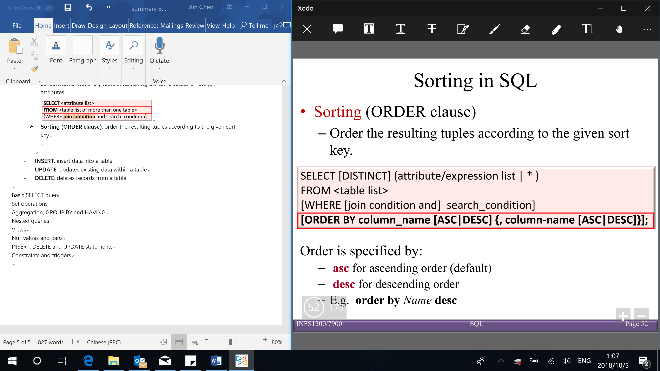

* **INSERT**: insert data into a table
* **UPDATE**: updates existing data within a table
* **DELETE**: deletes records from a table

Conceptual procedural evaluation strategy (how a SQL query is evaluated):

1. Compute the cross-product of relation-list
2. Discard resulting tuples if they fail qualifications (WHERE clause)
3. Delete attributes that are not in target-list (SELECT clause)
4. If DISTINCT is specified, eliminate duplicate rows
5. If ORDER BY is specified, sort the results

**Set operations**

Relation is a set of tuples (no duplicates)

(each automatically eliminates duplicates – by default

To retain all duplicates can use multiset versions: UNION ALL, INTERSECT ALL, EXCEPT ALL

Suppose a tuple have duplicates which occurs $m$ times in $relation r$ and $n$ times in $relation s$, then the number of duplicates will be:

* $m+n$ times in $r UNION ALL s$
* $min⁡(m,n)$ times in $r INTERSECT ALL s$
* $max⁡(0, m-n)$ times in $r EXCEPT ALL s$)

**Union compatibility**

* 2 relations $R_{1}(A_{1},A_{2},…, A_{n})$ and $R_{2}(B_{1},B_{2},…, B_{n})$ are union compatible iff/if and only if:

They have the same degree n (number of columns)

Their columns have corresponding domains ($domain\left(A_{i}\right)=domain\left(B_{i}\right) for 1≤i≤n$)

[Note: the corresponding columns do not have to have the same column name]

Set theory, and hence elementary set operators also apply to relations:

* **UNION (algebra operation: $∪$)**: produces a relation that includes all tuples that appear only in $R_{1}$, or only in $R_{2}$, or in both $R_{1}$ and $R_{2}$ ( $R_{1},R_{2}$ must be union compatible)

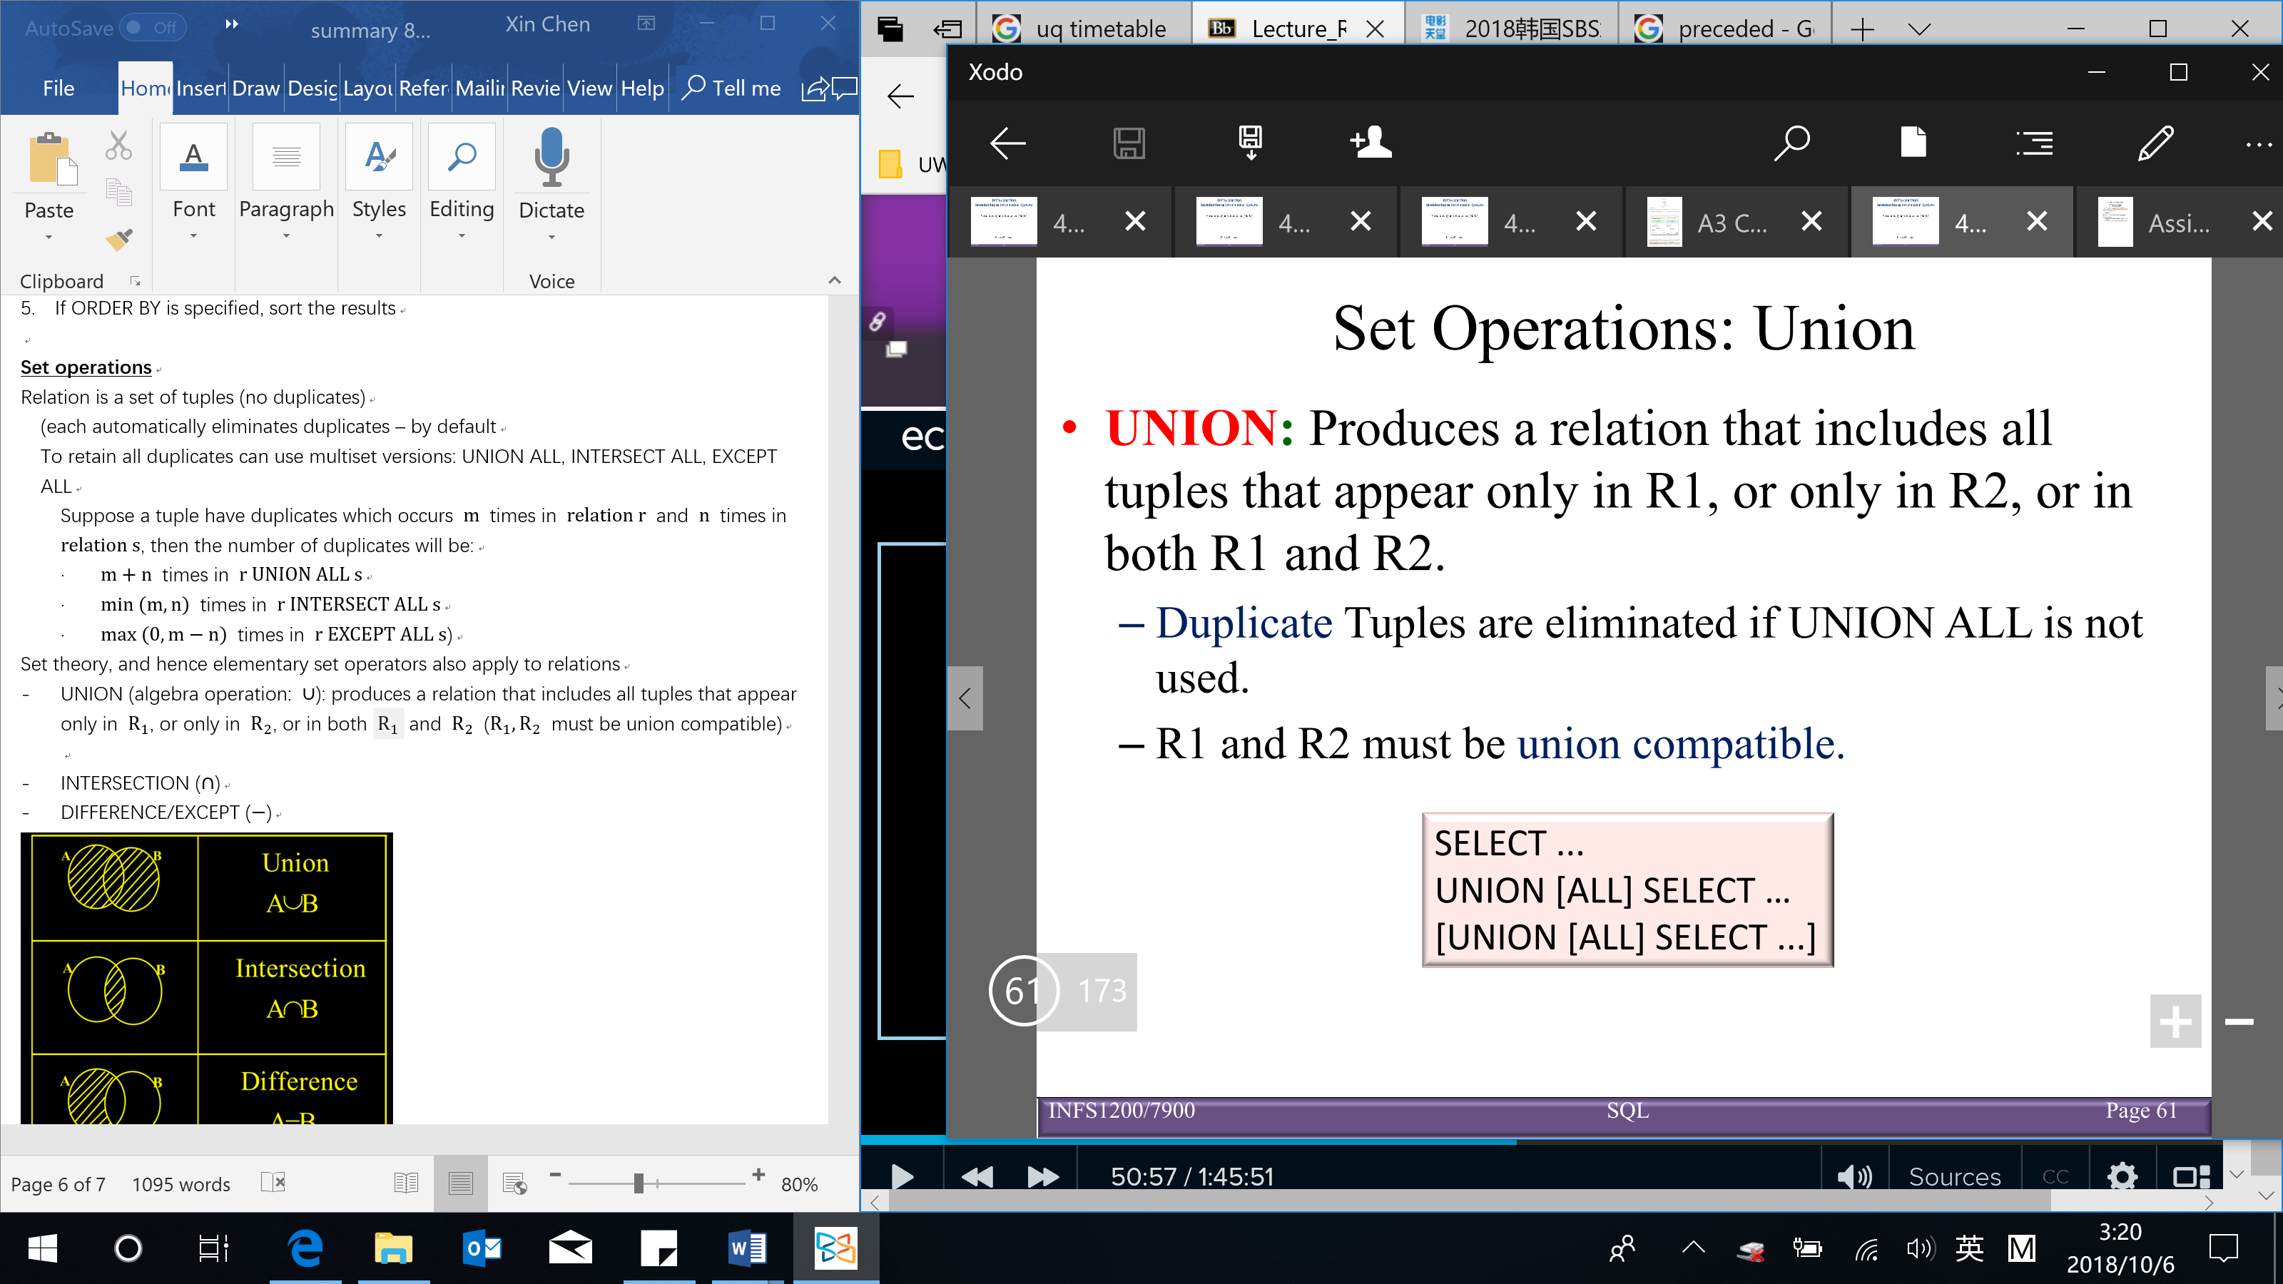

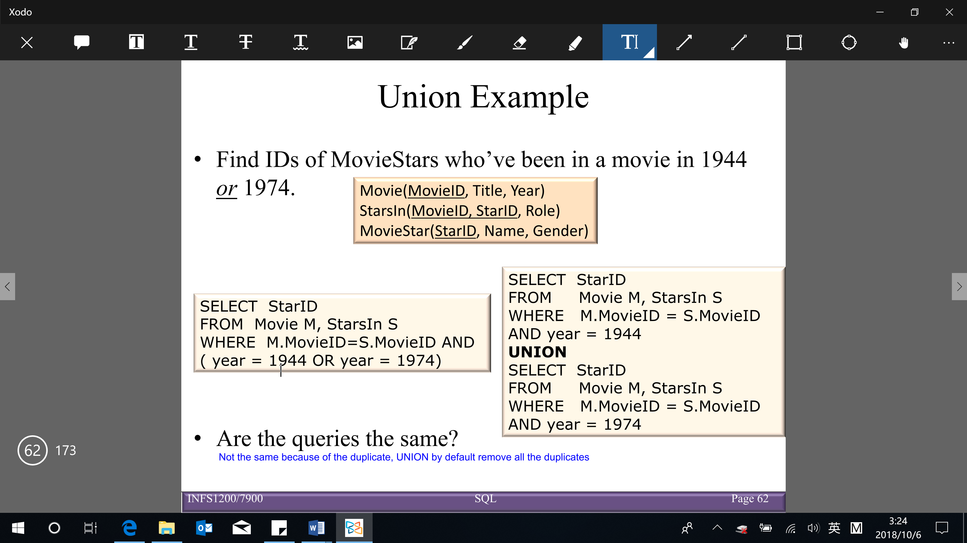

* **INTERSECTION ($∩$)**: produces a relation that includes the tuples that appear in both $R_{1}$ and $R_{2}$ ( $R_{1},R_{2}$ must be union compatible)

【Note: INTERSECT is part of the SQL standard, BUT is not implemented in MySQL】

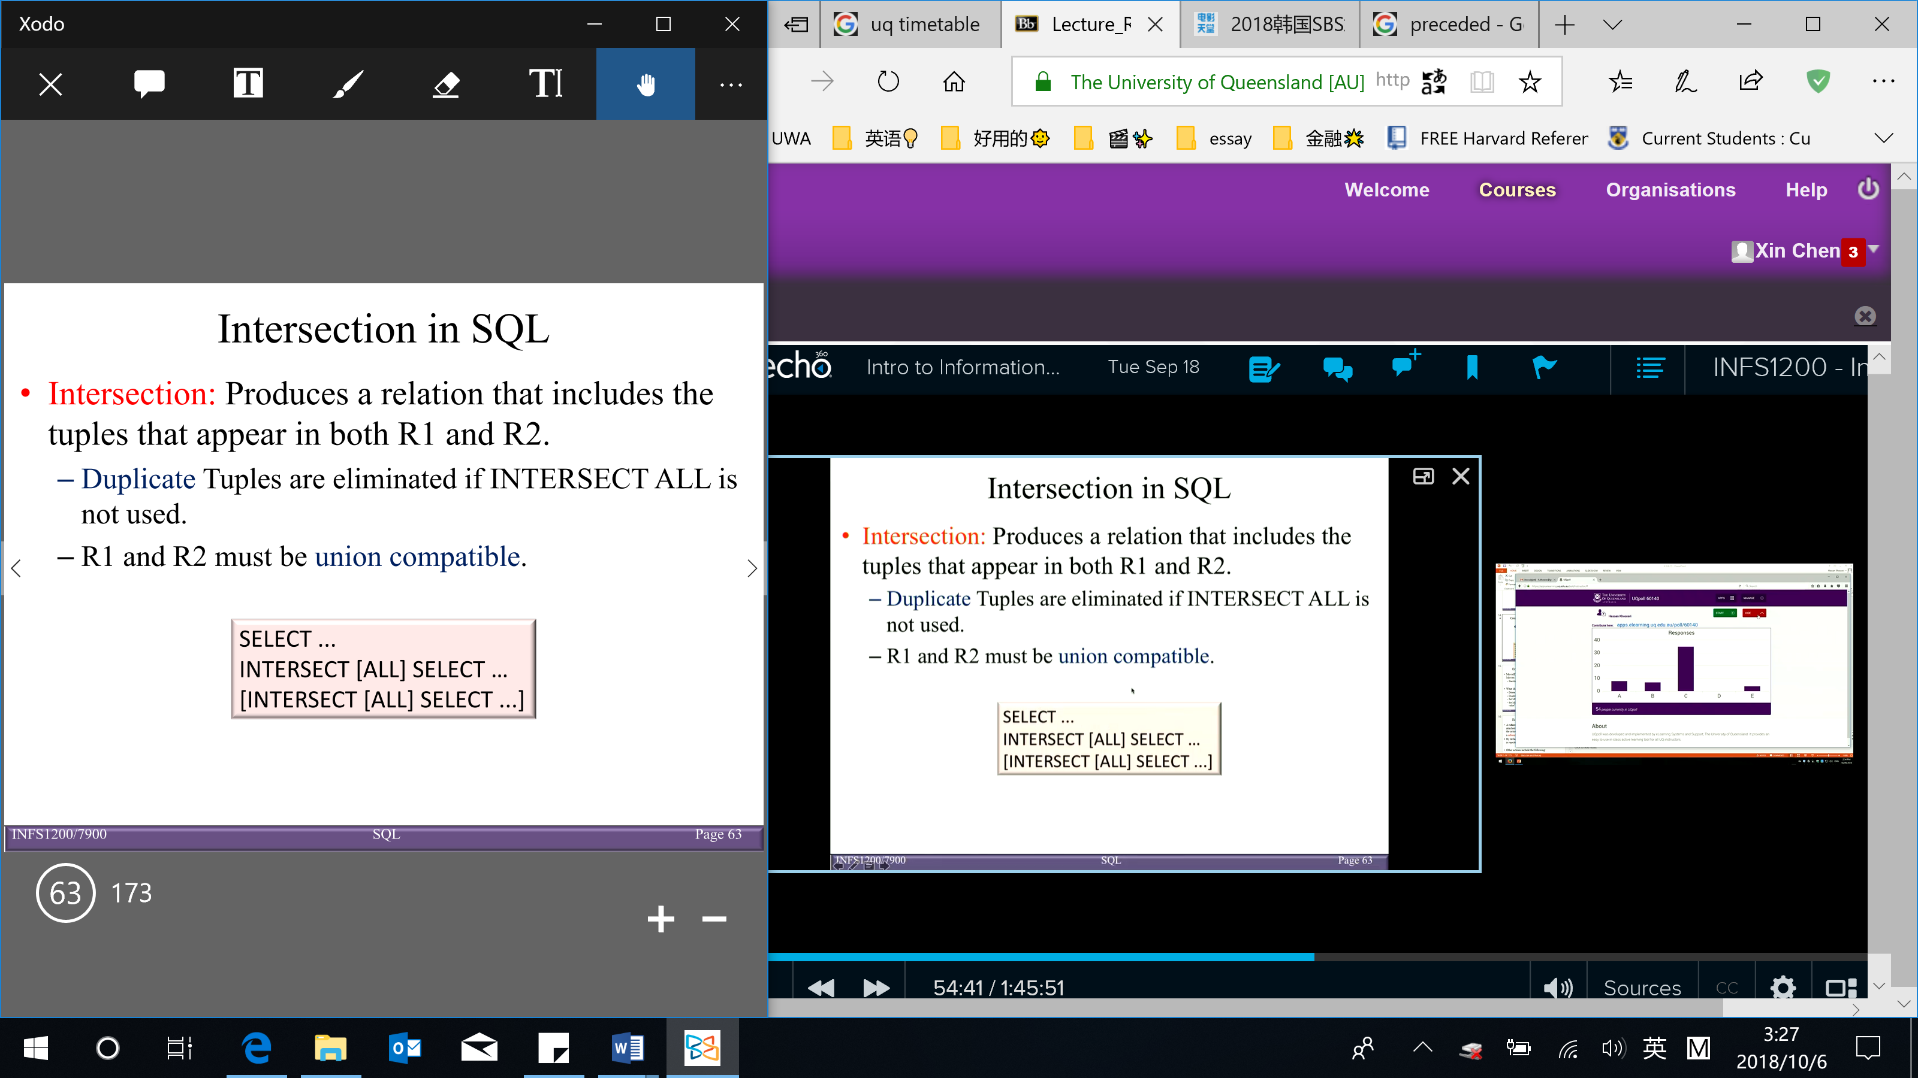

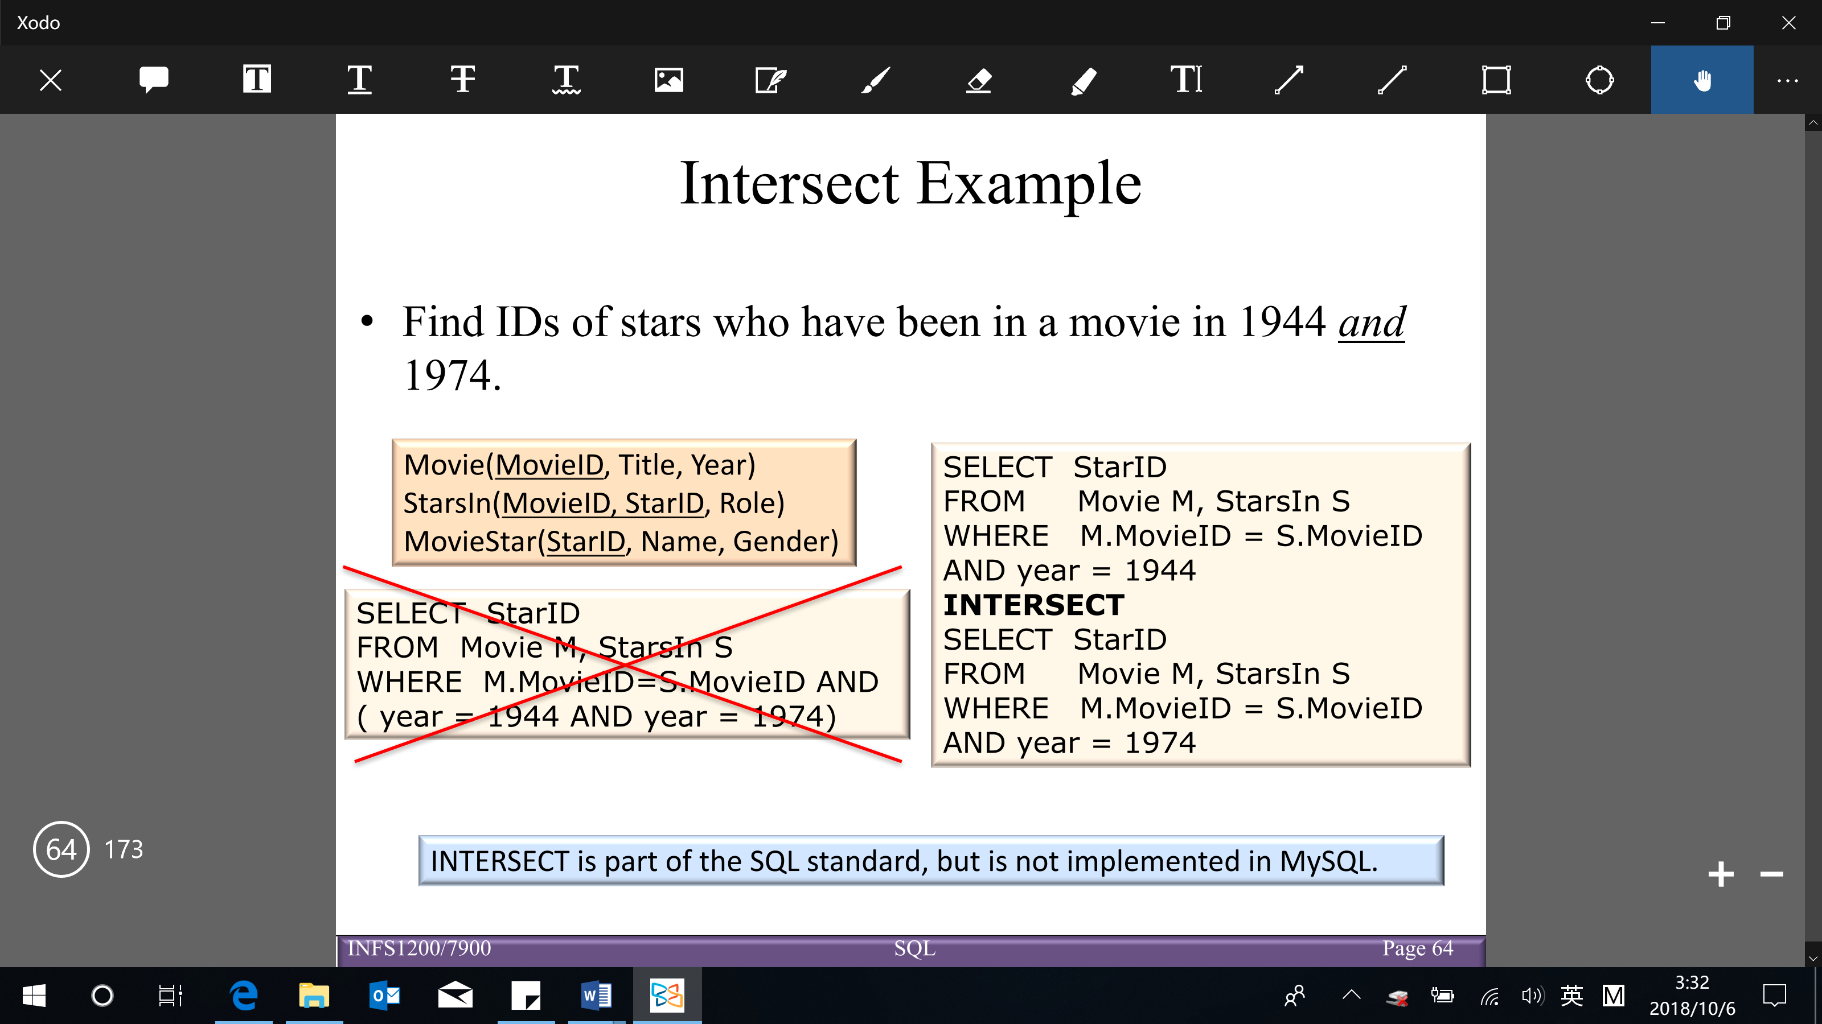

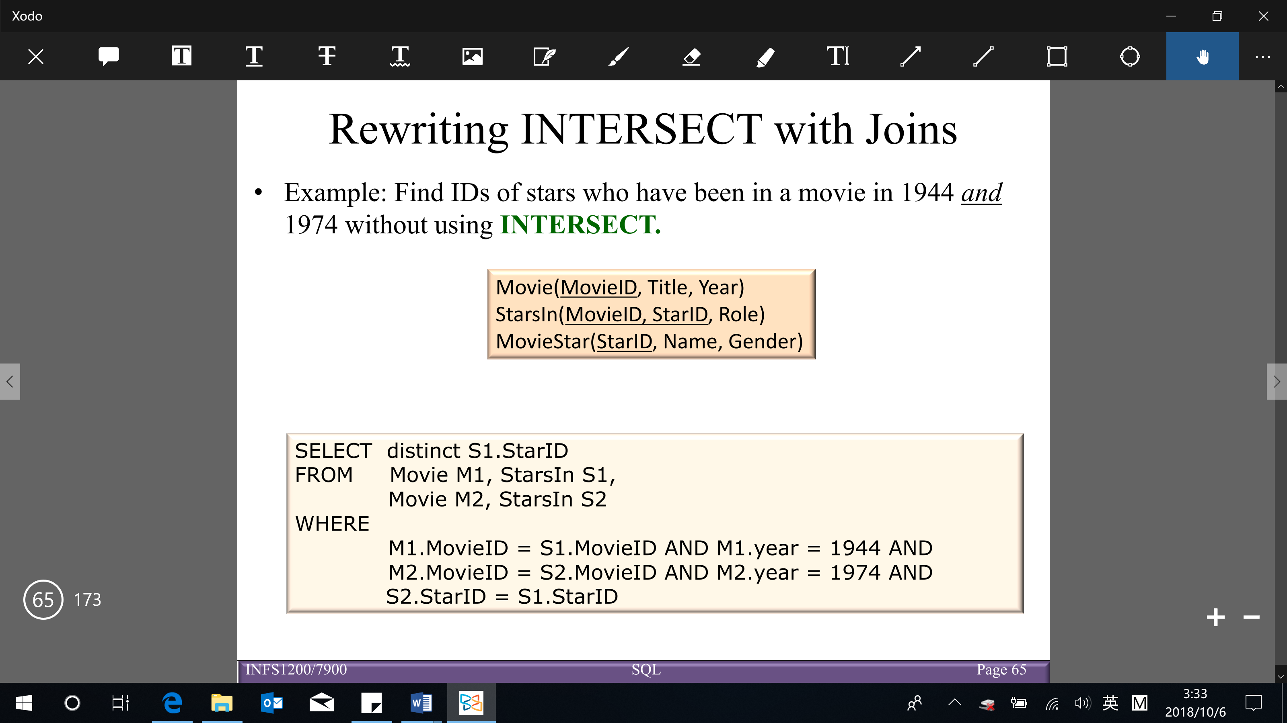

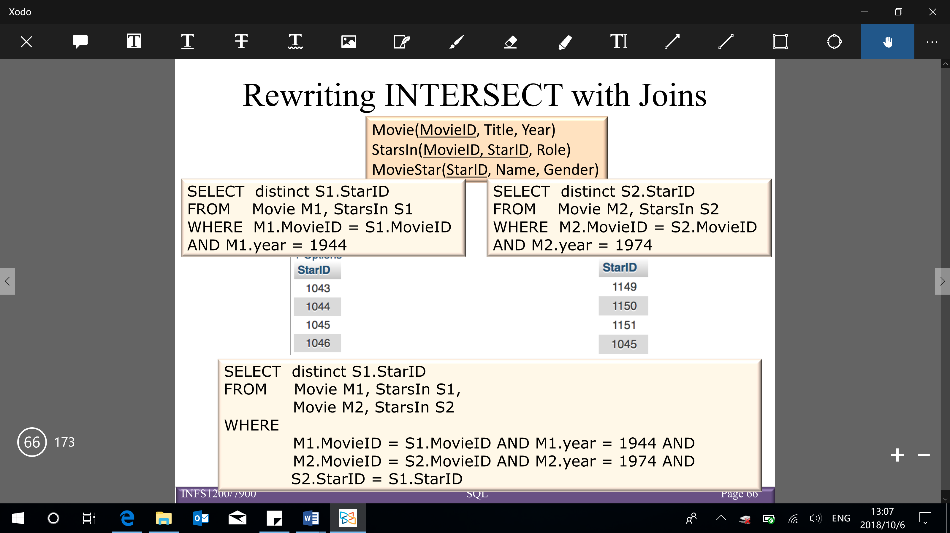

Final answer: 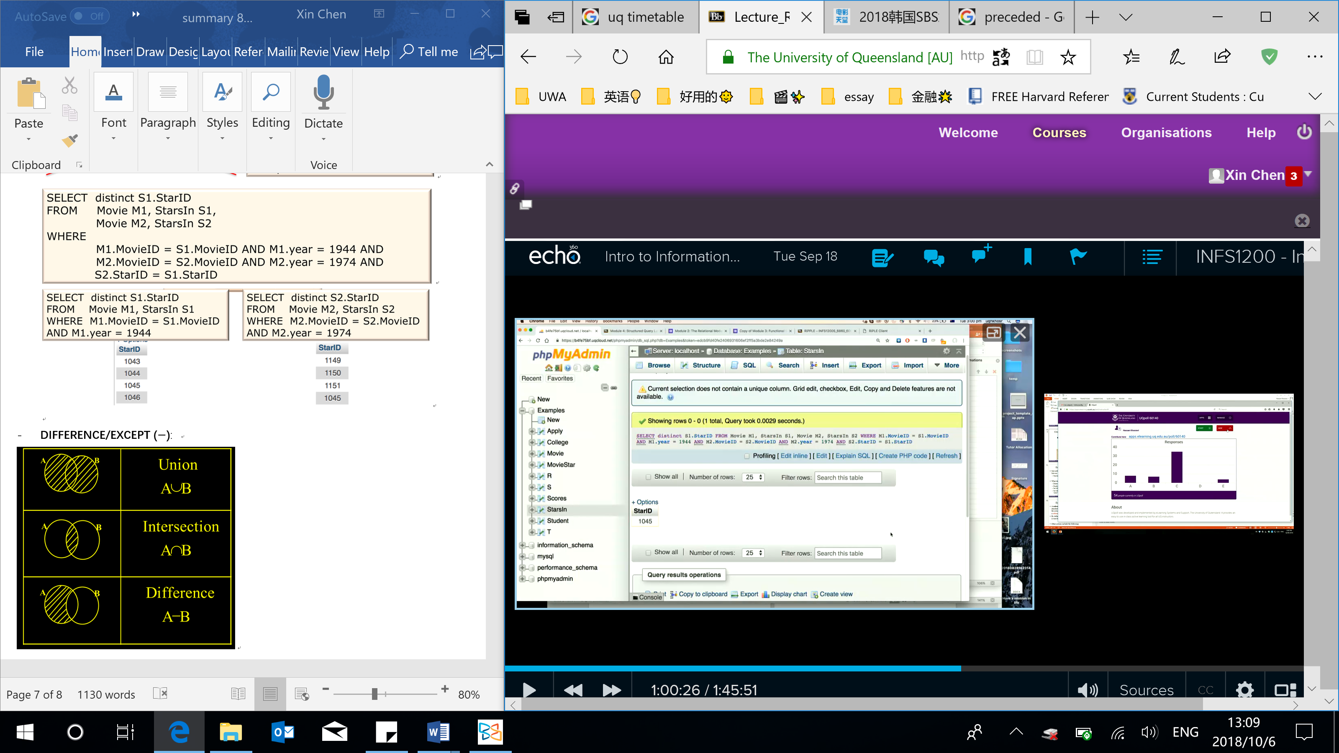

* **DIFFERENCE/EXCEPT/MINUS ($-$)**: produces a relation that includes all the tuples that appear in $R_{1}$, but do not appear in $R_{2}$ ( $R_{1},R_{2}$ must be union compatible)

【Note: EXCEPT is part of the SQL standard, BUT is not implemented in MySQL → EXCEPT queries can be implemented using nested queries】

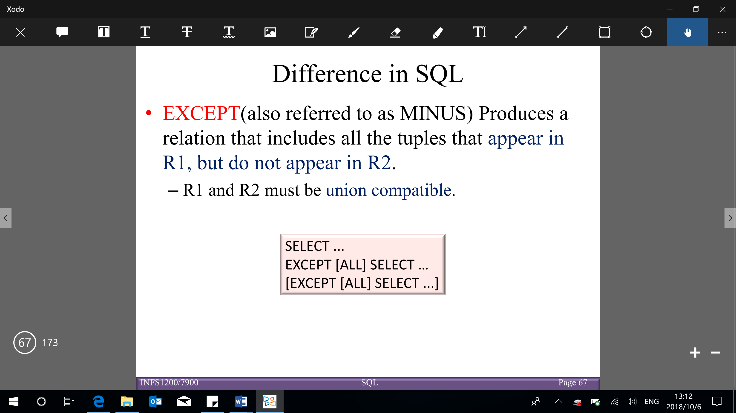

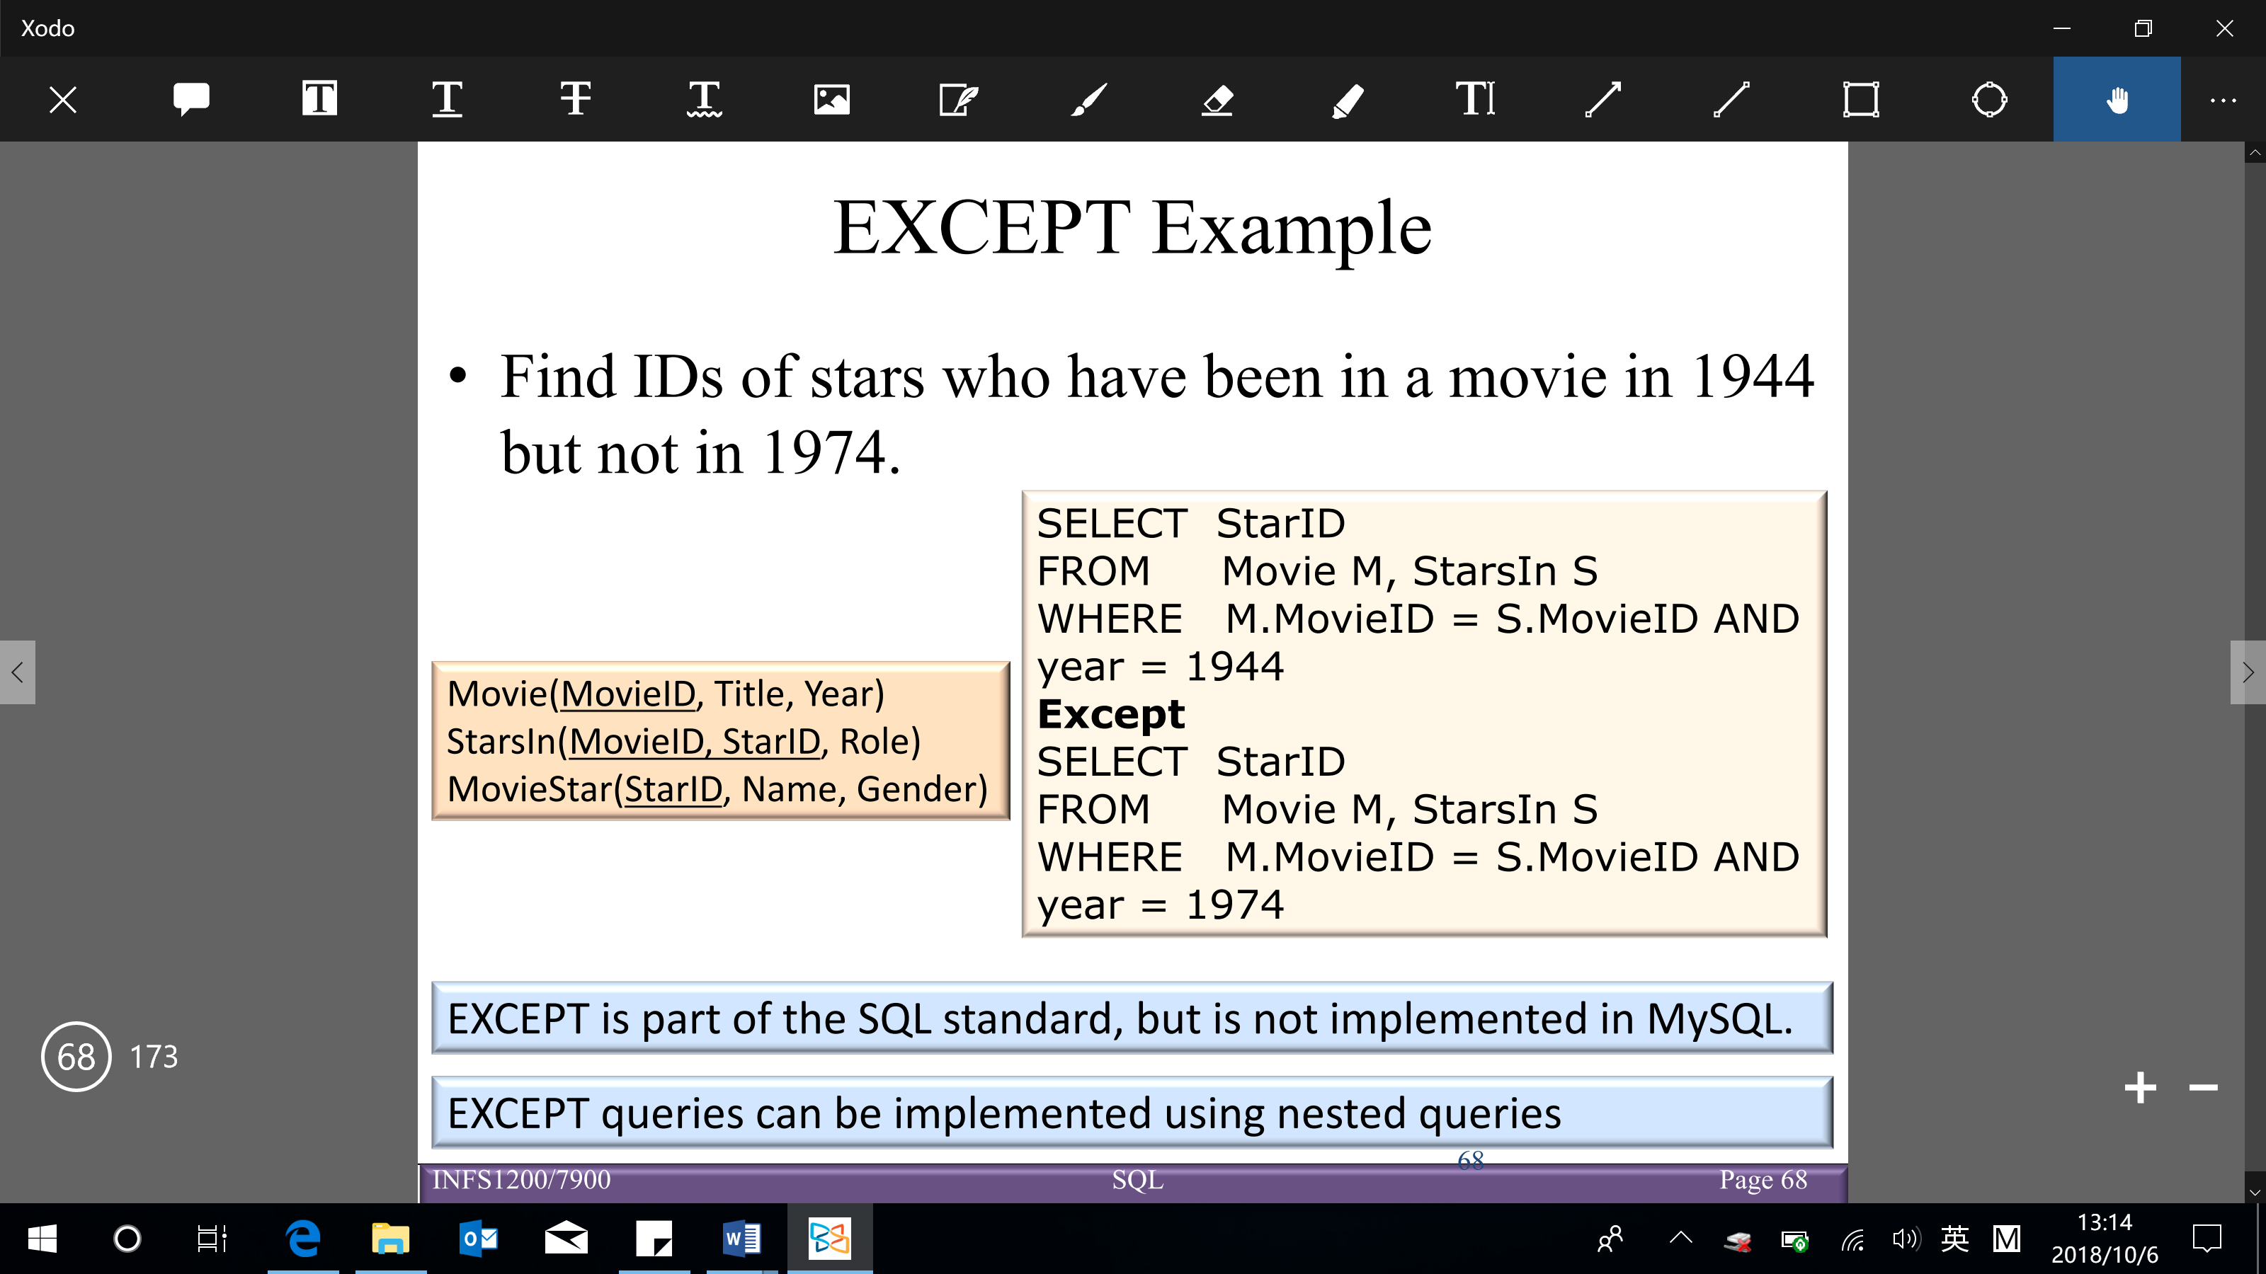

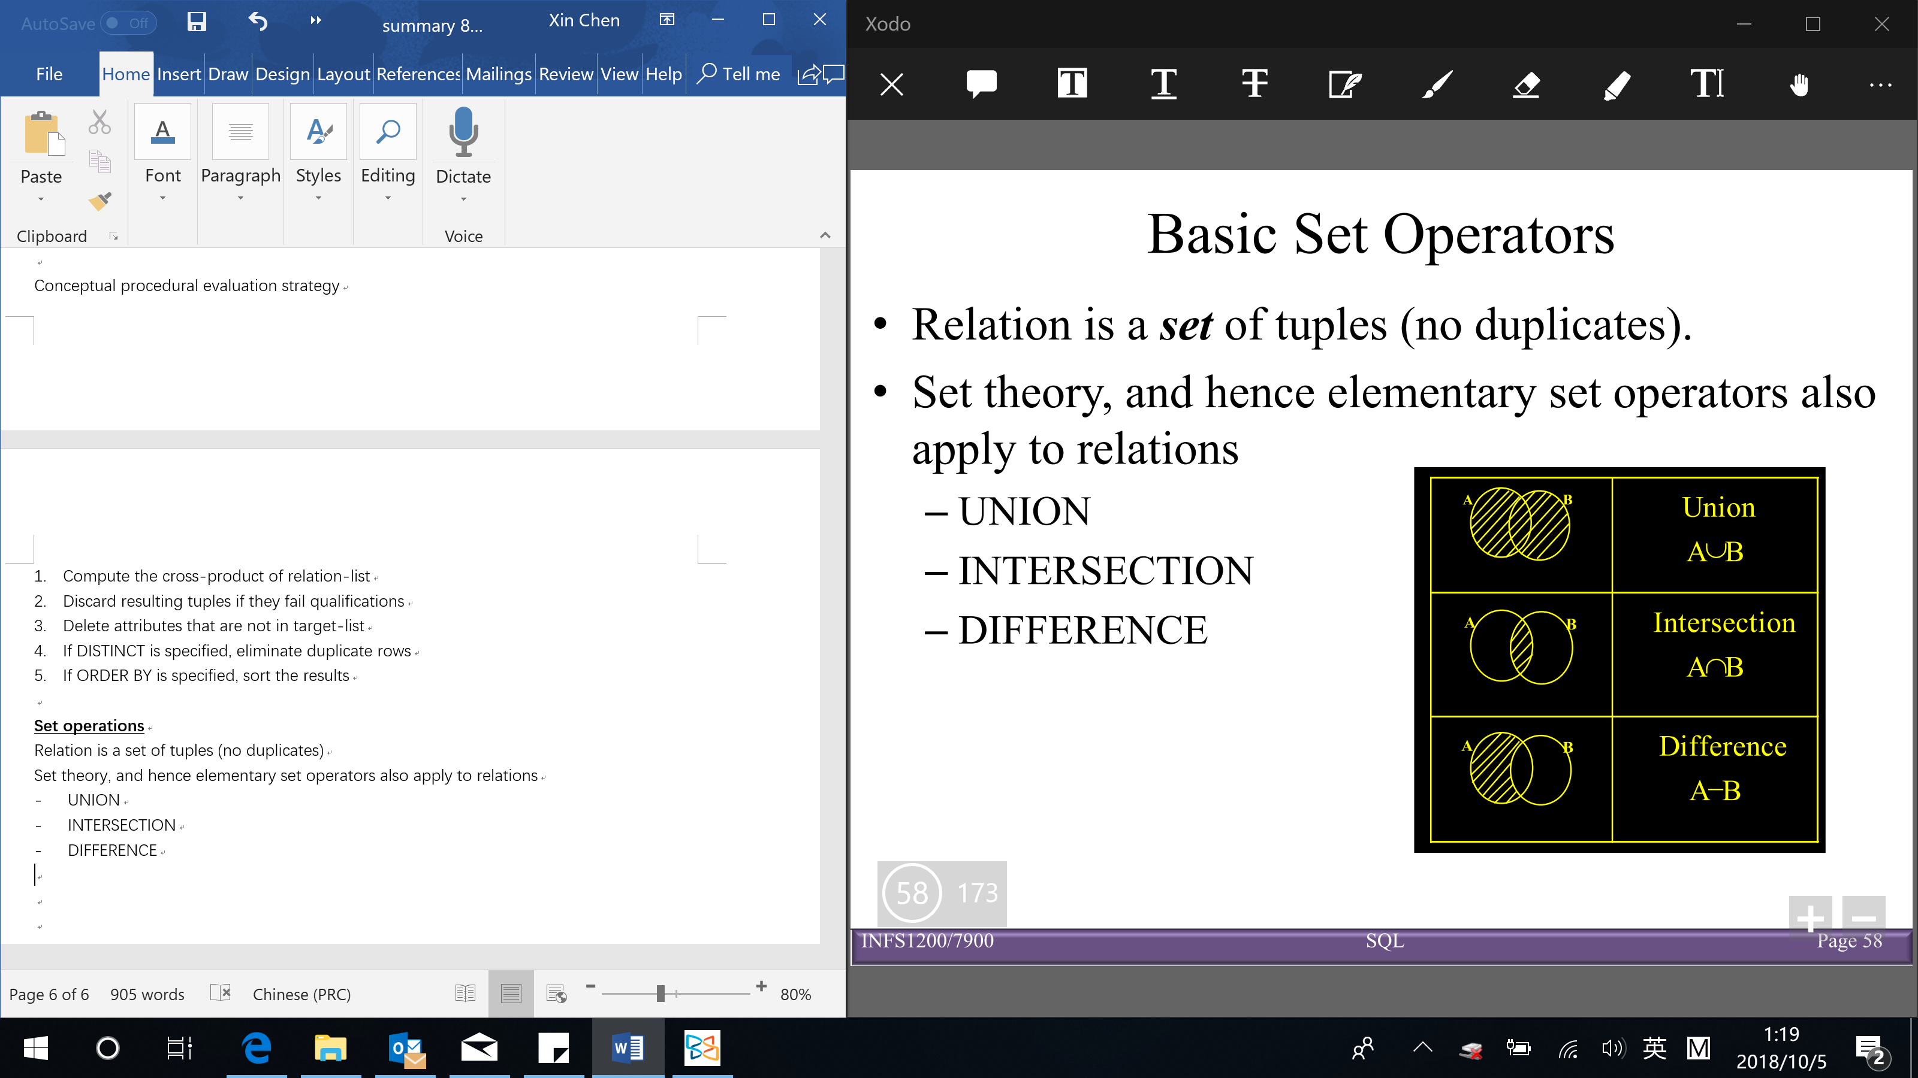

Properties of set operators:

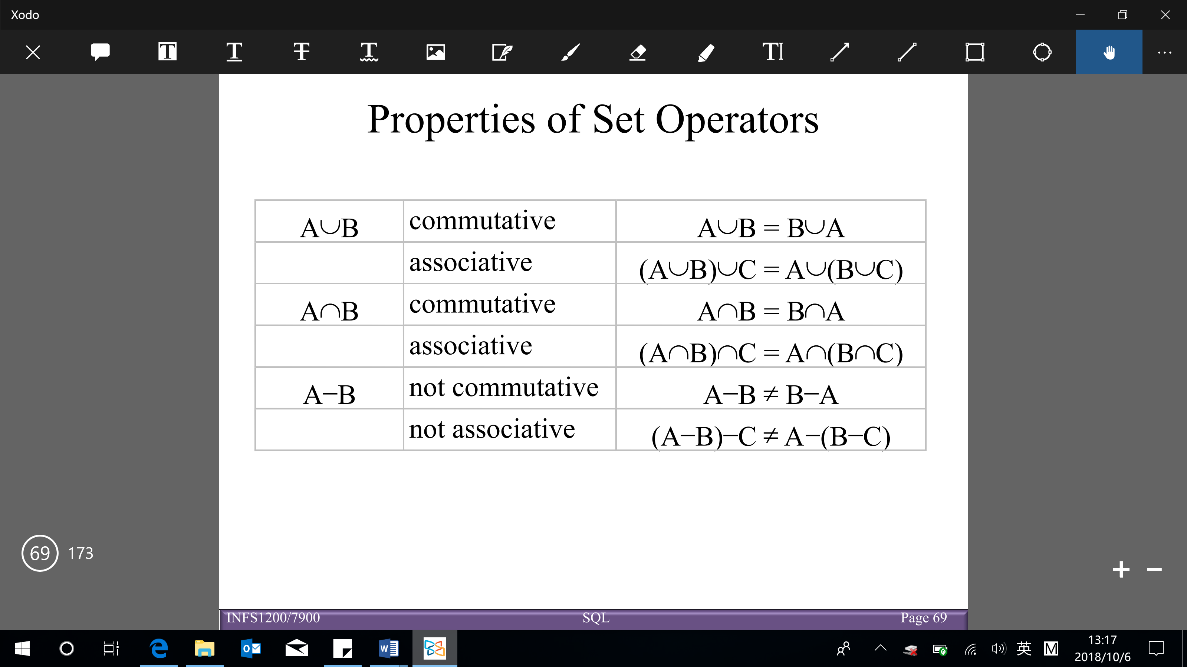

**Aggregation, GROUP BY and HAVING**

**Aggregation in SQL**

* Aggregates are functions that produce summary values (cannot have nested aggregatino)

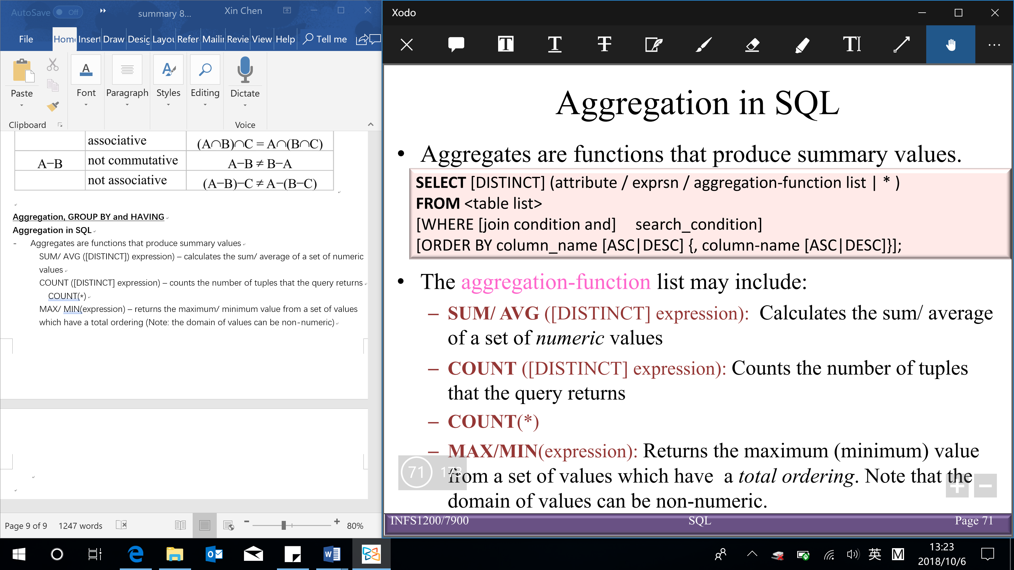

Aggregation functions:

* + SUM/ AVG ([DISTINCT]) expression) – calculates the sum/ average of a set of numeric values
  + COUNT ([DISTINCT] expression) – counts the number of tuples that the query returns

COUNT(*)

* + MAX/ MIN(expression) – returns the maximum/ minimum value from a set of values which have a total ordering (Note: the domain of values can be non-numeric)

**GROUP BY and HAVING** (similar to for loop in python)

* Divide tuples into groups (GROUP BY) and apply aggregate operations to each group (HAVING)

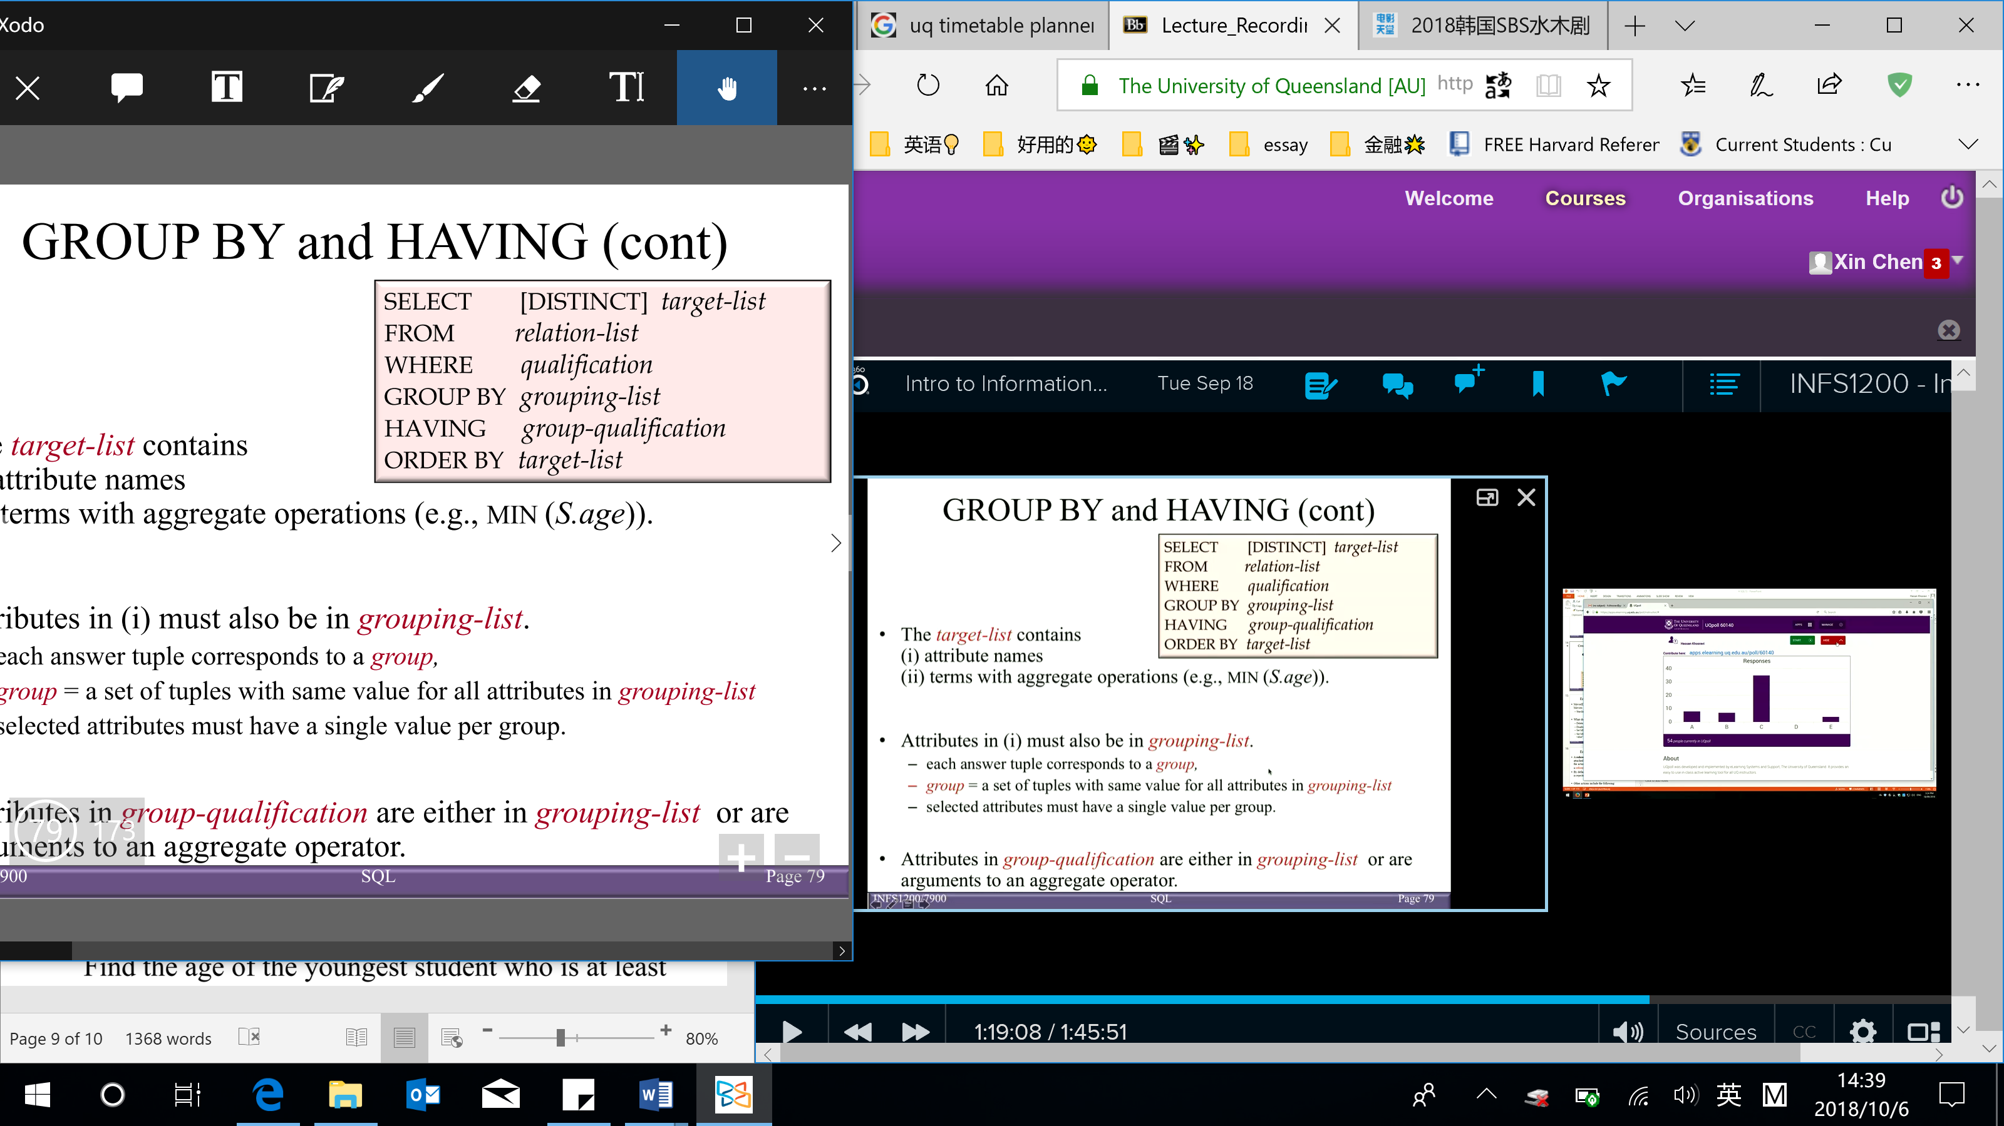

*Target-list* contains:

* 1. Attribute names (must also be in *grouping-list*)

Each answer tuple corresponds to a *group*

*Group* = a set of tuples with same value for all attributes in *grouping-list*

Selected attributes must have a single value per group

* 1. Terms with aggregate operations

*Group-qualification*: attributes in *group-qualification* are either in *grouping-list* or are arguments to an aggregate operator

* GROUP BY clause

(Aggregation functions can also be applied to groups of rows within a table)

When GROUP BY is used in a SQL statement, any attribute appeared in SELECT clause must also appeared in an aggregation function or in GROUP BY clause

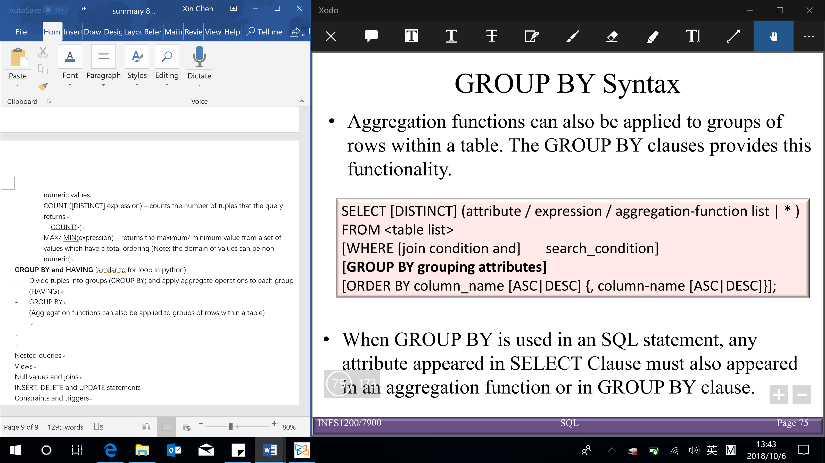

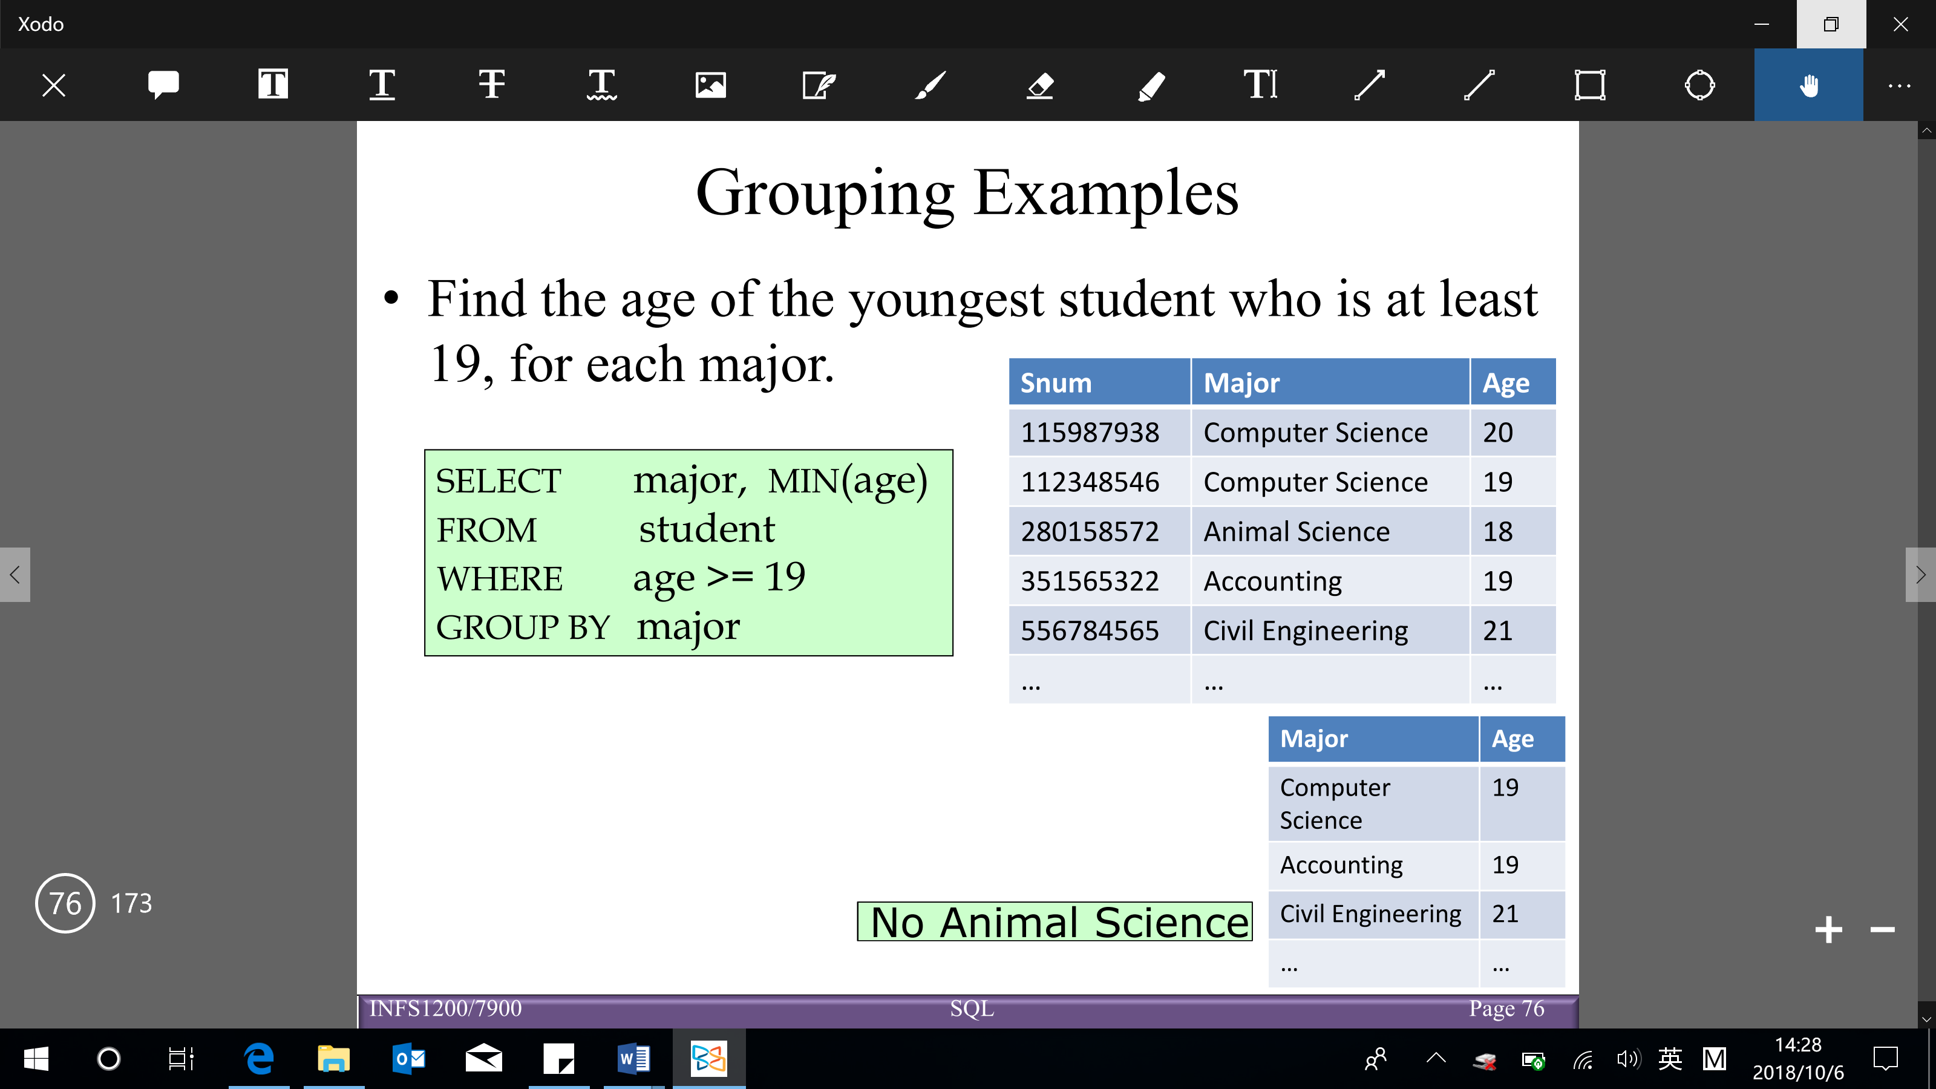

* HAVING clause (following the GROUP BY clause)

Conditions imposed on the selection of groups to be included in the query result

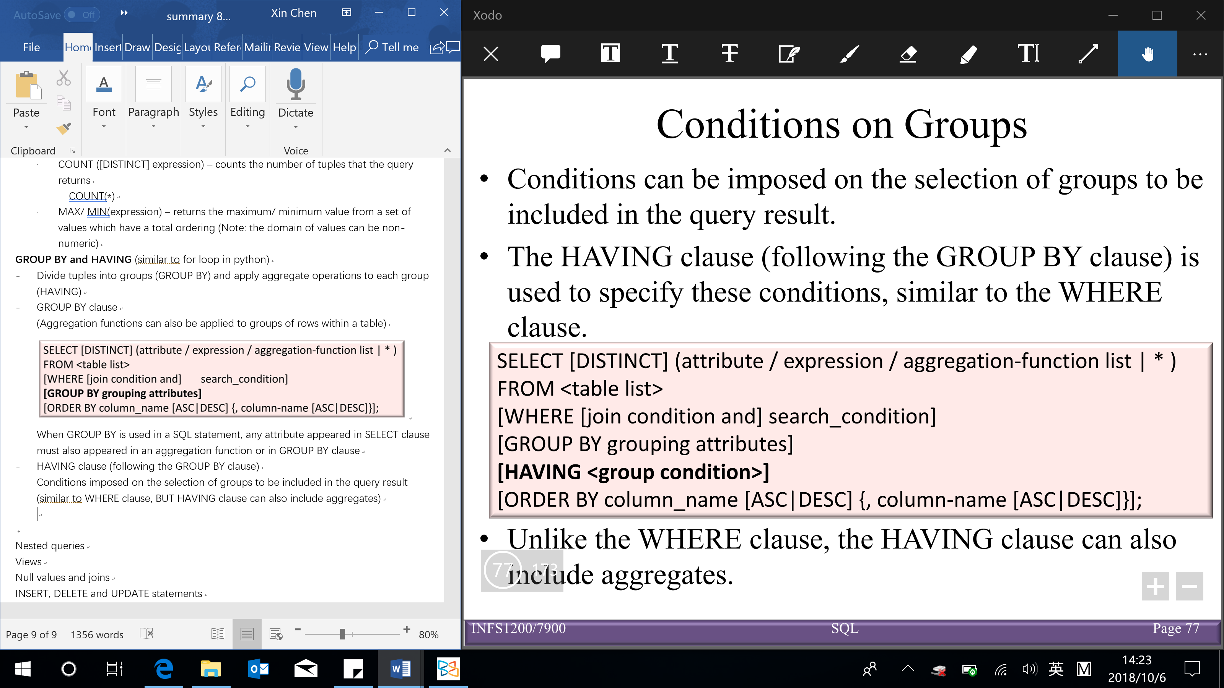

(similar to WHERE clause, BUT HAVING clause can also include aggregates

WHERE clause: conditions on each tuple

HAVING clause: conditions on the groups)

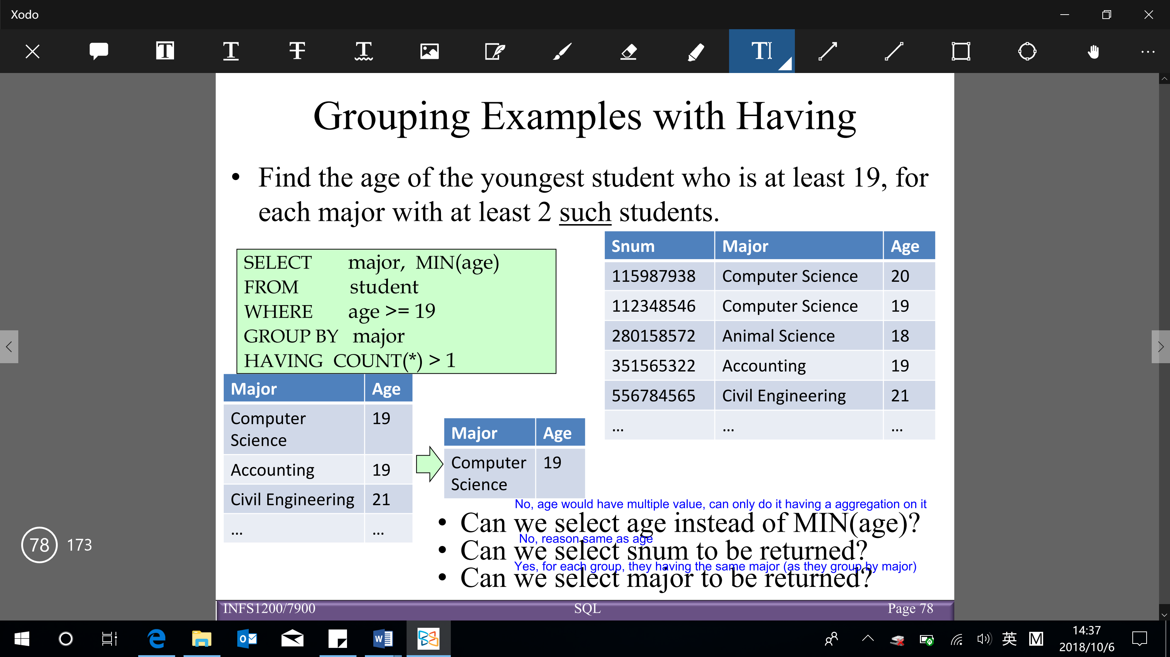

Conceptual evaluation of a query:

1. Compute the cross-product of relation-list (FROM clause)
2. Keep only tuples that satisfy qualification (WHERE clause)
3. Partition/ divide the remaining tuples into groups by where attributes in grouping-list (GROUP BY clause)
4. Keep only the groups that satisfy group-qualification (expressions in group-qualification have a single value per group) (HAVING clause)
5. Delete fields that are not in target-list (SELECT clause)

→ Generate one answer tuple per qualifying group

**Nested queries**

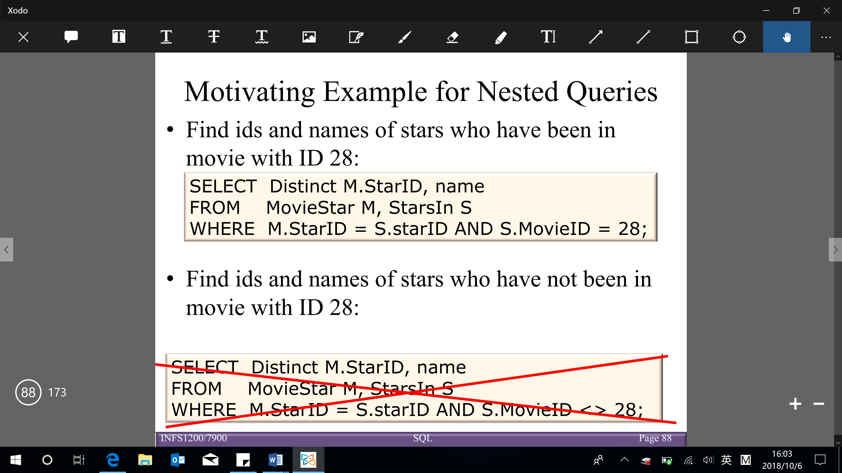

* **Nested query/ sub-query**: query that appears within another query

Useful for expressing queries where data must be fetched and used in a comparison condition

* + Inside the WHERE clause of another SELECT statement (other query search conditions, including joins, can also appear in the outer query WHERE clause, either before or after the inner query)
  + Inside an INSERT, UPDATE or DELETE statement
  + Nesting can occur at multiple levels
  + Sub-query cannot include the ORDER BY clause BUT DISTINCT may effectively order the results of a sub-query, since most systems eliminate duplicates by first ordering the results

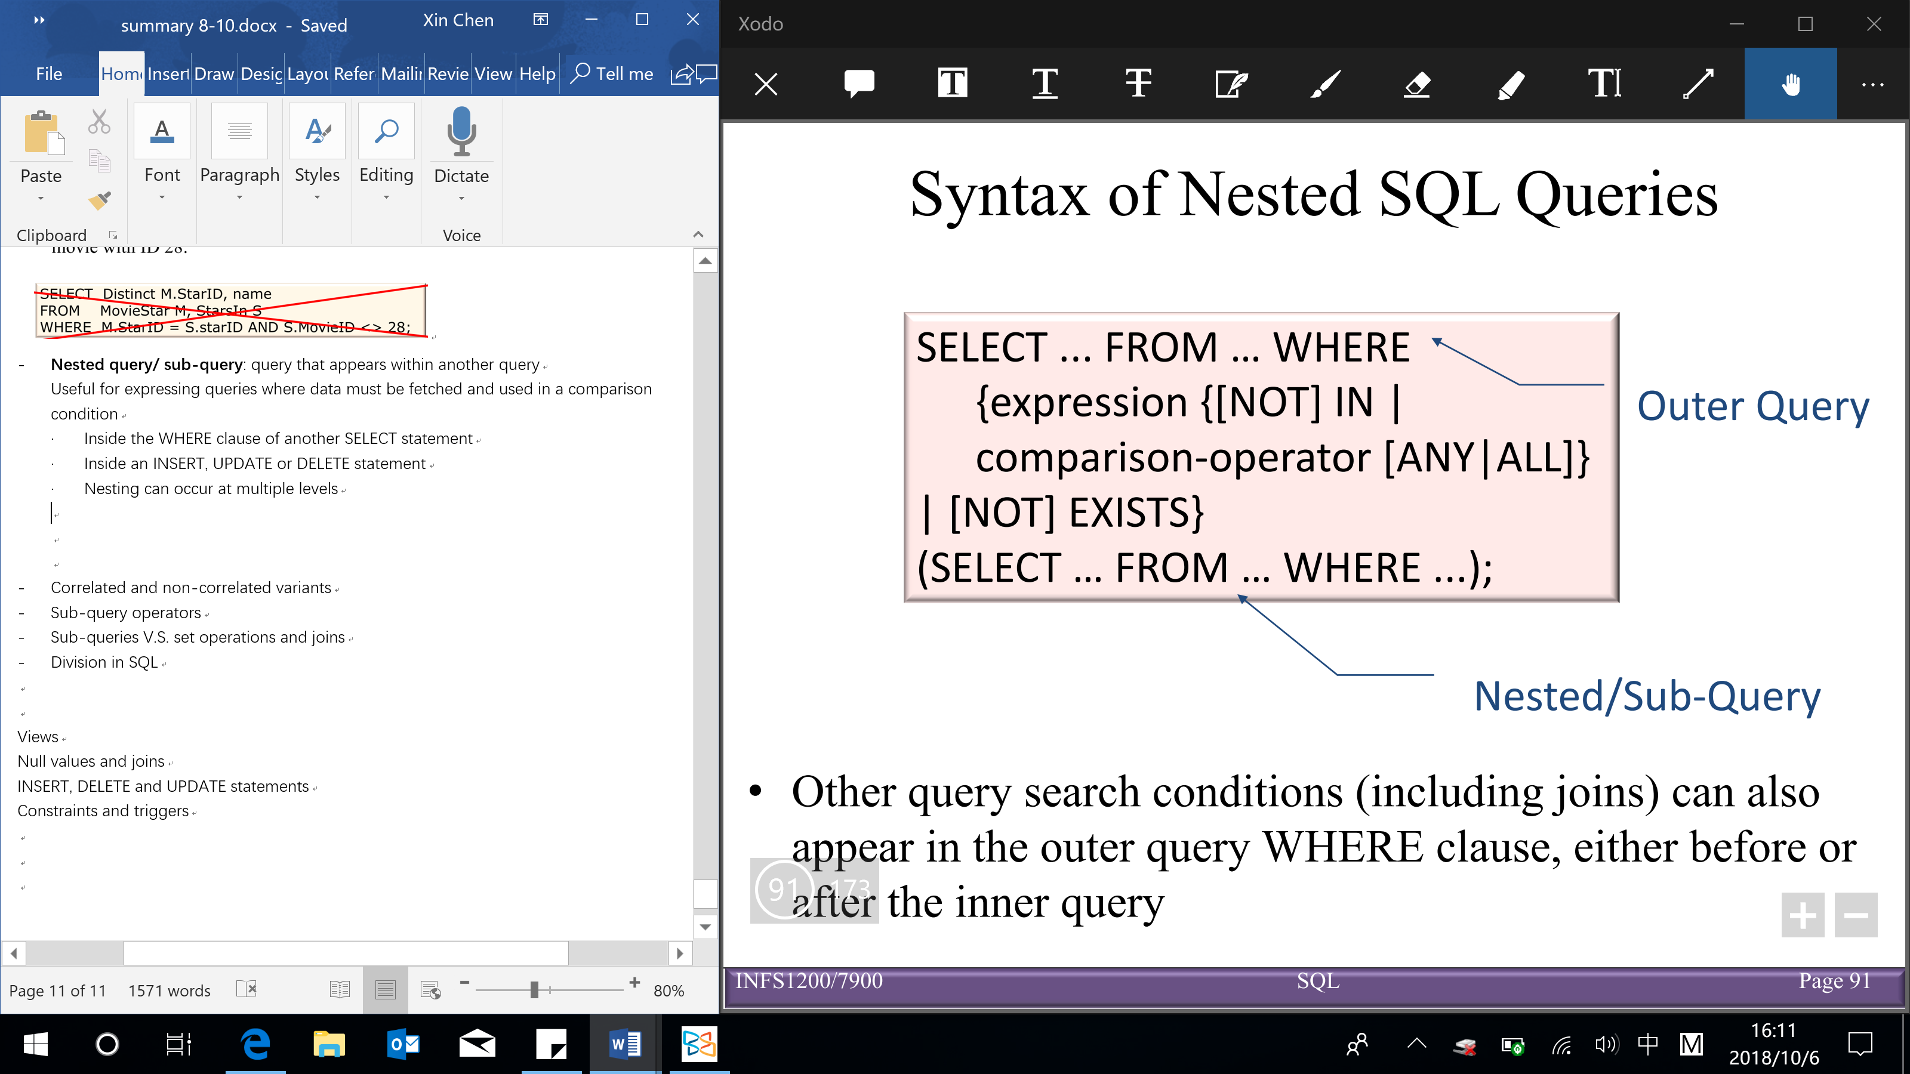

* **Correlated and non-correlated variants**

Non-correlated nested queries:

* + Results are returned from an inner query to an outer clause (sub-queries are evaluated from the ‘inside out’)
  + The outer query takes an action based on the results of the inner query
  + The inner query doesn’t depend on the outer query (run independently), so it could be computed just once

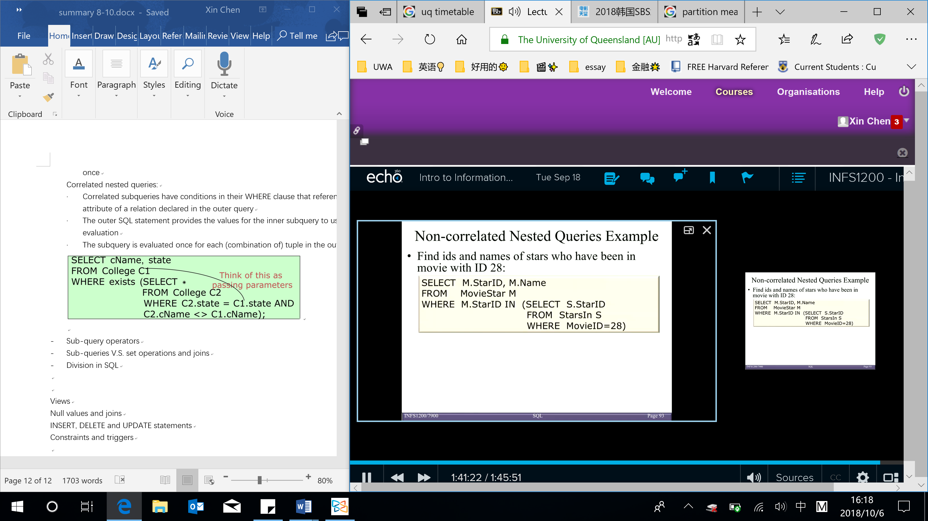

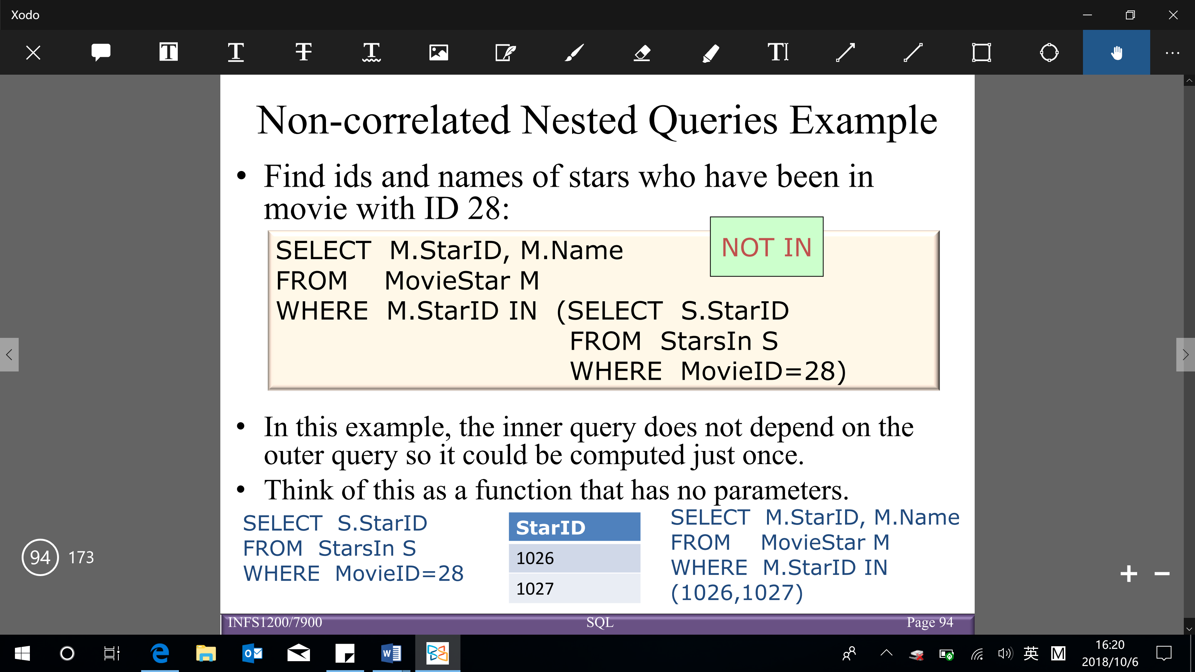

Correlated nested queries:

* + Correlated subqueries have conditions in their WHERE clause that references some attribute of a relation declared in the outer query
  + Inner query is depended on outer query
  + The outer SQL statement provides the values for the inner subquery to use in its evaluation
  + The subquery is evaluated once for each (combination of) tuple in the outer query

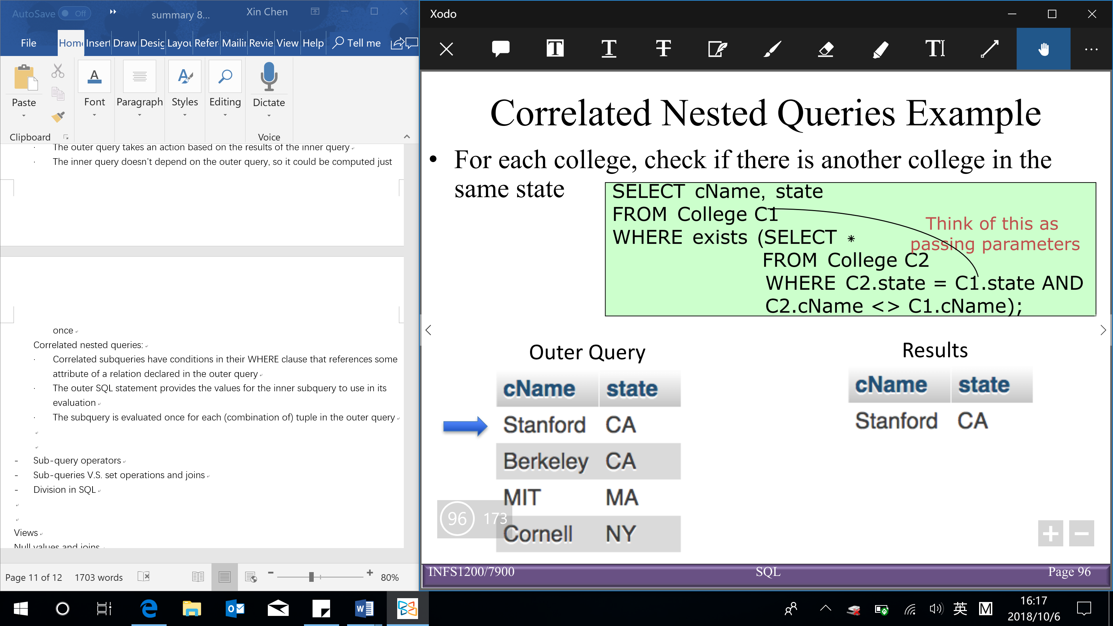

* **Sub-query operators**

Sub-queries (inner query) that return a set:

[expression and attribute list in sub-query SELECT clause must have same domain]

* + expression {[NOT] IN (sub-query)

Expression is checked for membership (an element of) in the set (of tuples) returned by sub-query

(include only one expression or column name)

(whether the value in outer query inside the result of inner query or not)

* + expression comparison-operator [ANY|ALL] (sub-query)

Expression is compared with the set (of tuples) returned by the sub-query

(include only one expression or column name)

ANY: evaluates to true if one comparison is true

ALL: evaluates to true if all comparisons are true

e.g. > ANY X → return the value greater than MIN(X)

> ALL X → return the value greater than MAX(X)

Comparison-operator: $>, <, =, ≥, ≤, <>$

Equivalence:

* ‘IN’ and ‘= ANY’
* ‘NOT IN’ and ‘<> ALL’

Non-equivalence:

* ‘NOT IN’ and ‘<> ANY‘

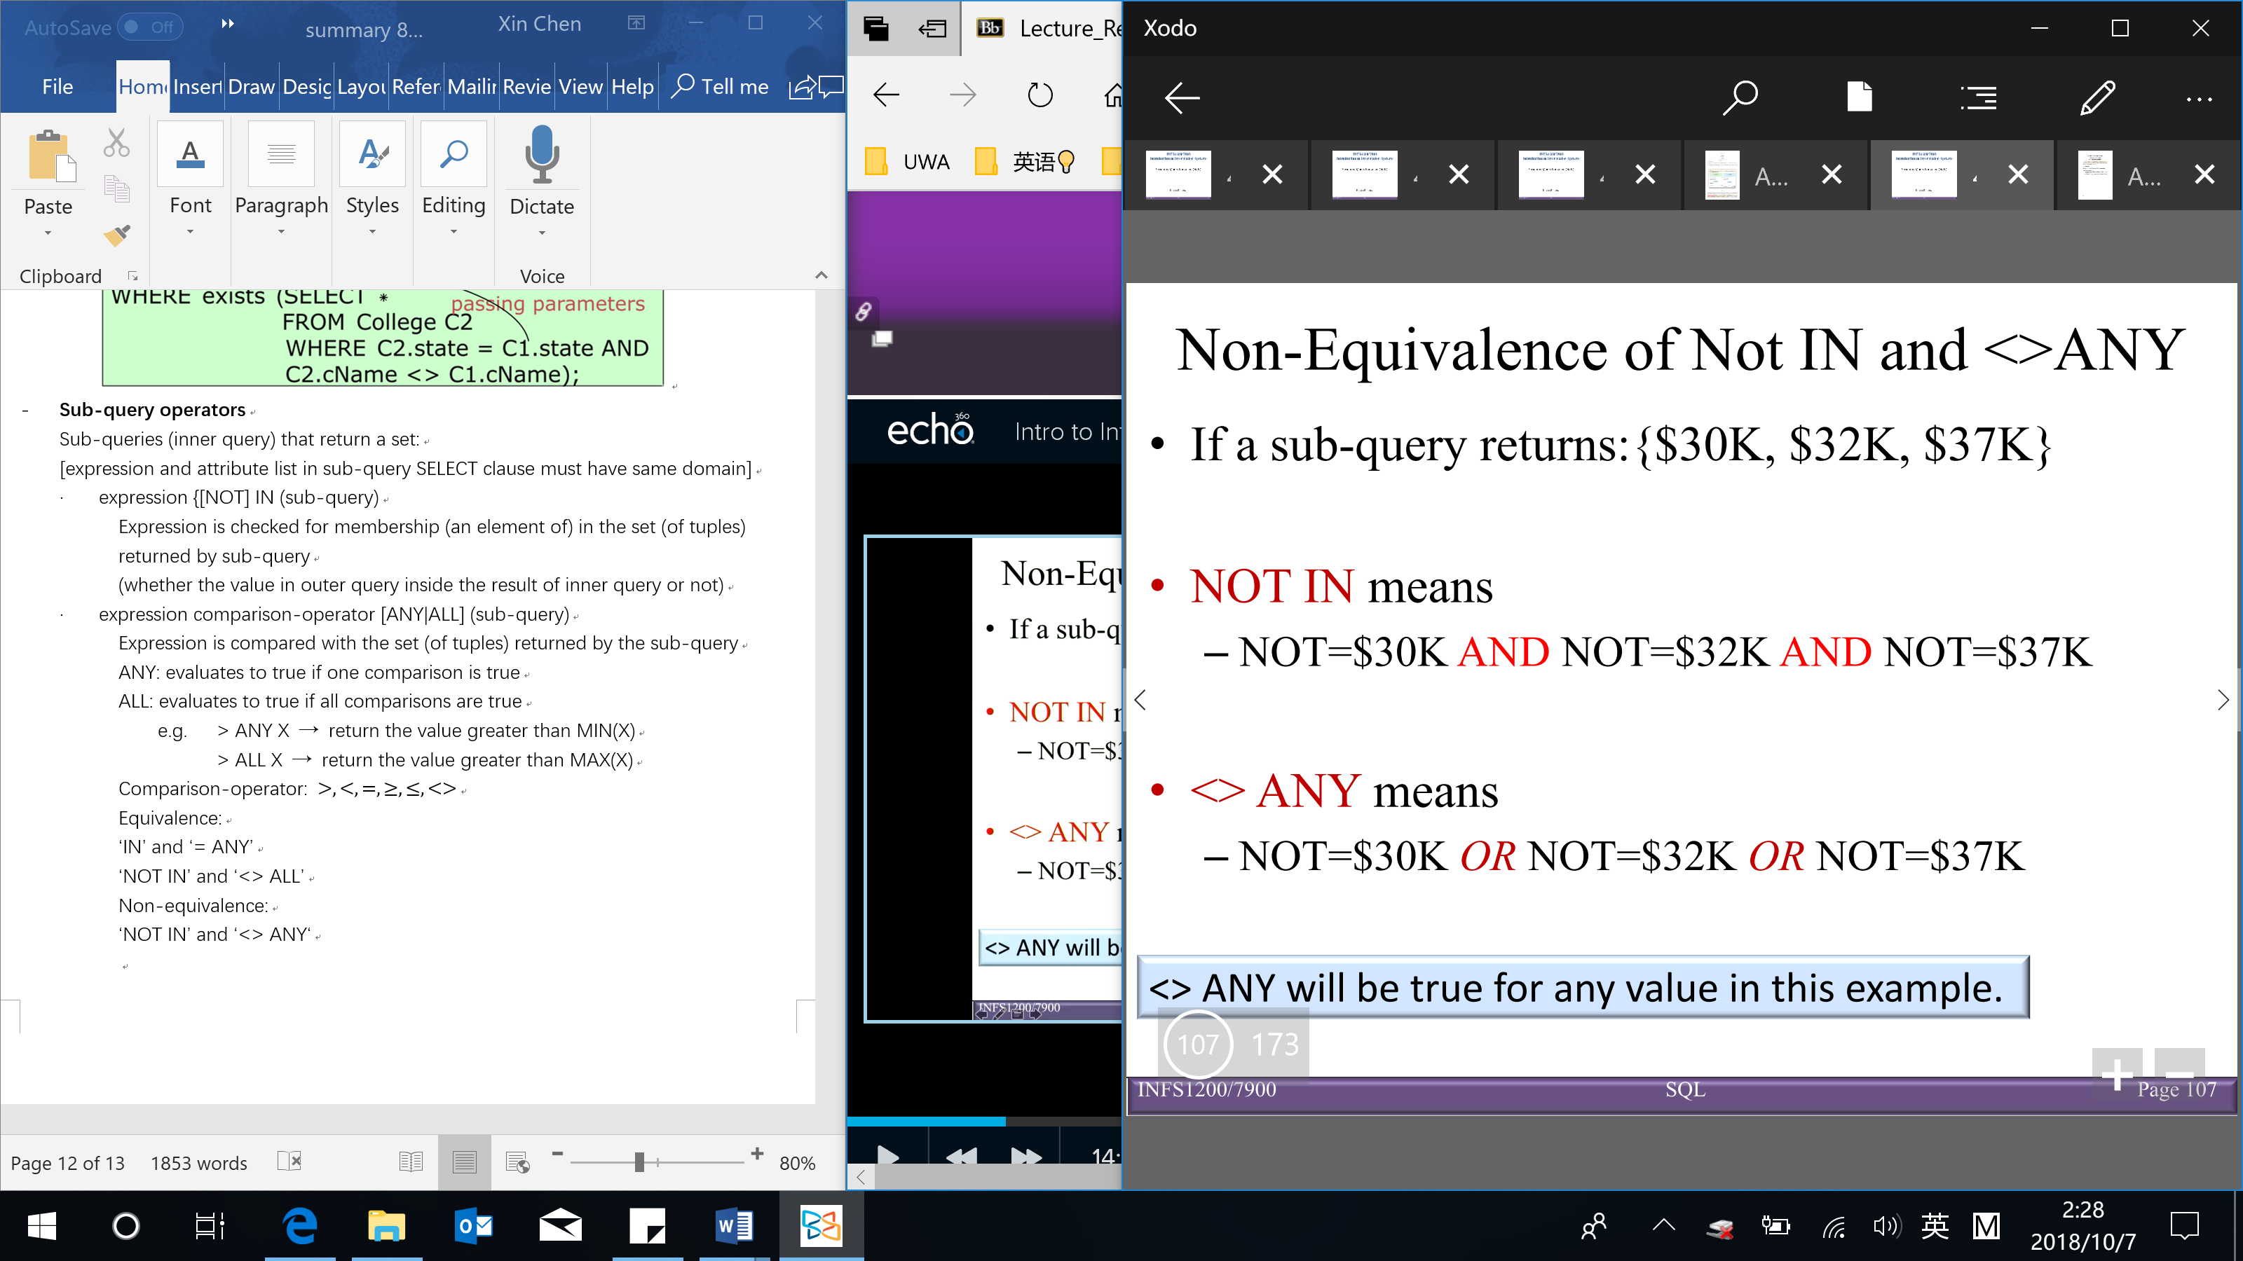

Sub-queries that return a single value

[expression and attribute list in sub-query SELECT clause must have same domain]

* + expression comparison-operator (sub-query)

Expression is compared with the value returned by the sub-query

The sub-query must evaluate to a single value otherwise an error will occur

Comparison-operator: $>, <, =, ≥, ≤, <>$

Using the EXISTS function:

* + The EXISTS function tests for the existence or nonexistence of data that meet the criteria of the sub-query → return True or False (and won’t do the join)

WHERE EXISTS (sub-query) – evaluates to true if the result of the correlated sub-query is not-empty set

WHERE NOT EXISTS (sub-query) – evaluates to true if the result of the correlated sub-query returns an empty set

* + Sub-queries are used with EXISTS and NOT EXISTS are always correlated
* **Sub-queries V.S. set operations and joins** (these 3 can be used to write the same query)

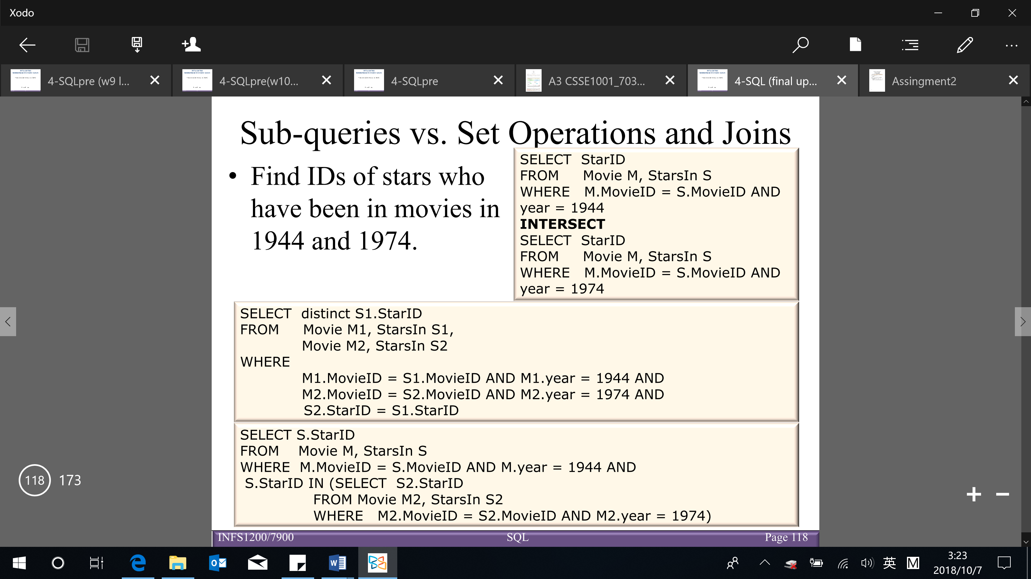

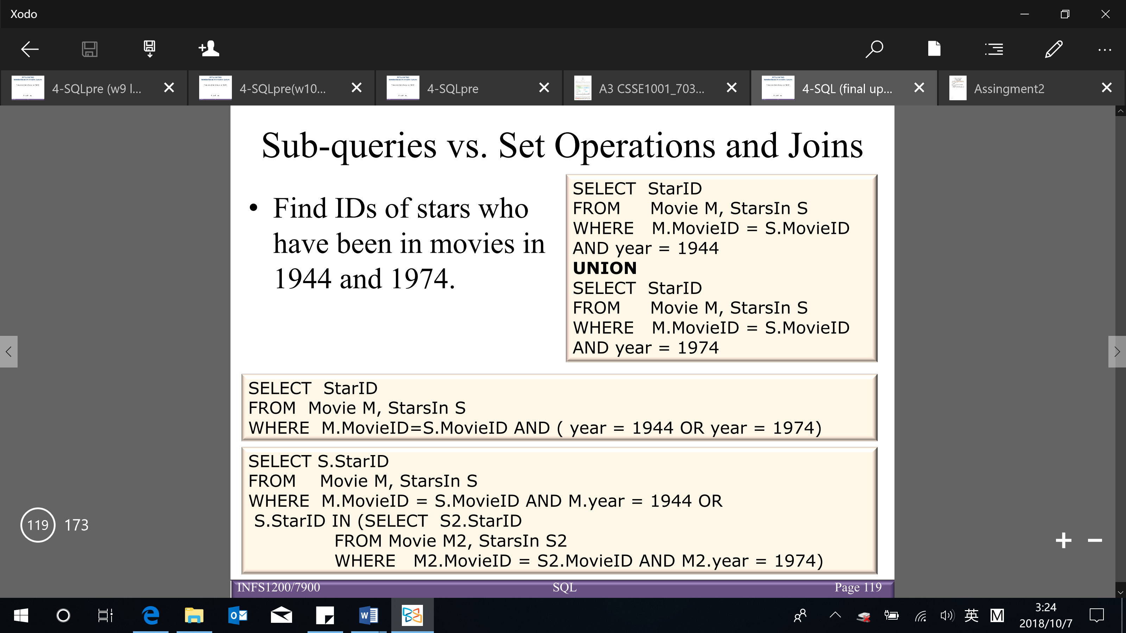

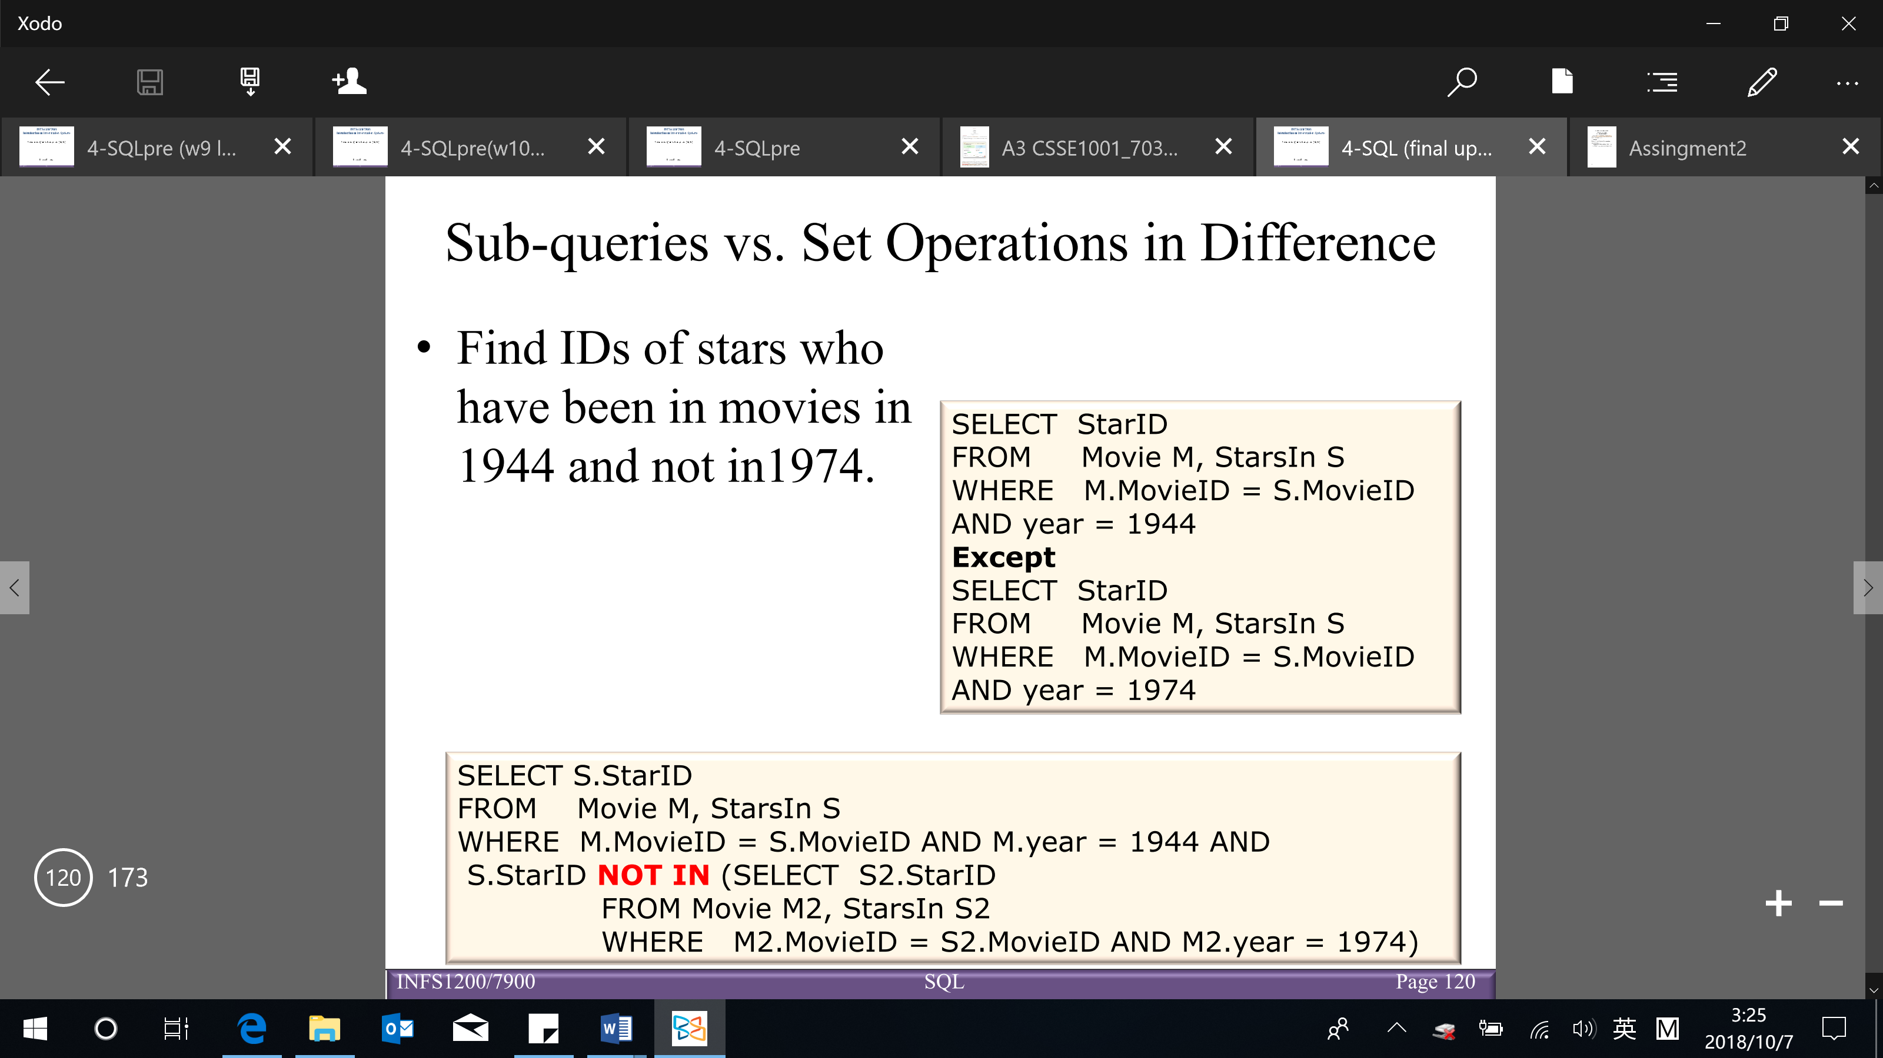

Joins V.S. sub-queries:

* + Advantages of join queries:

The join implementation can display data from all tables in the FROM clause

Sub-query implementation can only display data from the table(s) in the outer query

* + Advantages of nested sub-queries

The ability to calculate an aggregate value on the fly and feed it back to the outer query for comparison is an advantage sub-queries have over joins

Conclusion:

* Use joins when you are displaying results from multiple tables
* Use sub-queries when you need to compare aggregates to other values
* **Division in SQL**

Division is useful for answering queries include a ‘for all’ or ‘for every’ phrase (e.g. find movie stars who were in all movies)

[BUT there is no direct way to express division in SQL → have to express the query through double negation and existential quantifiers]

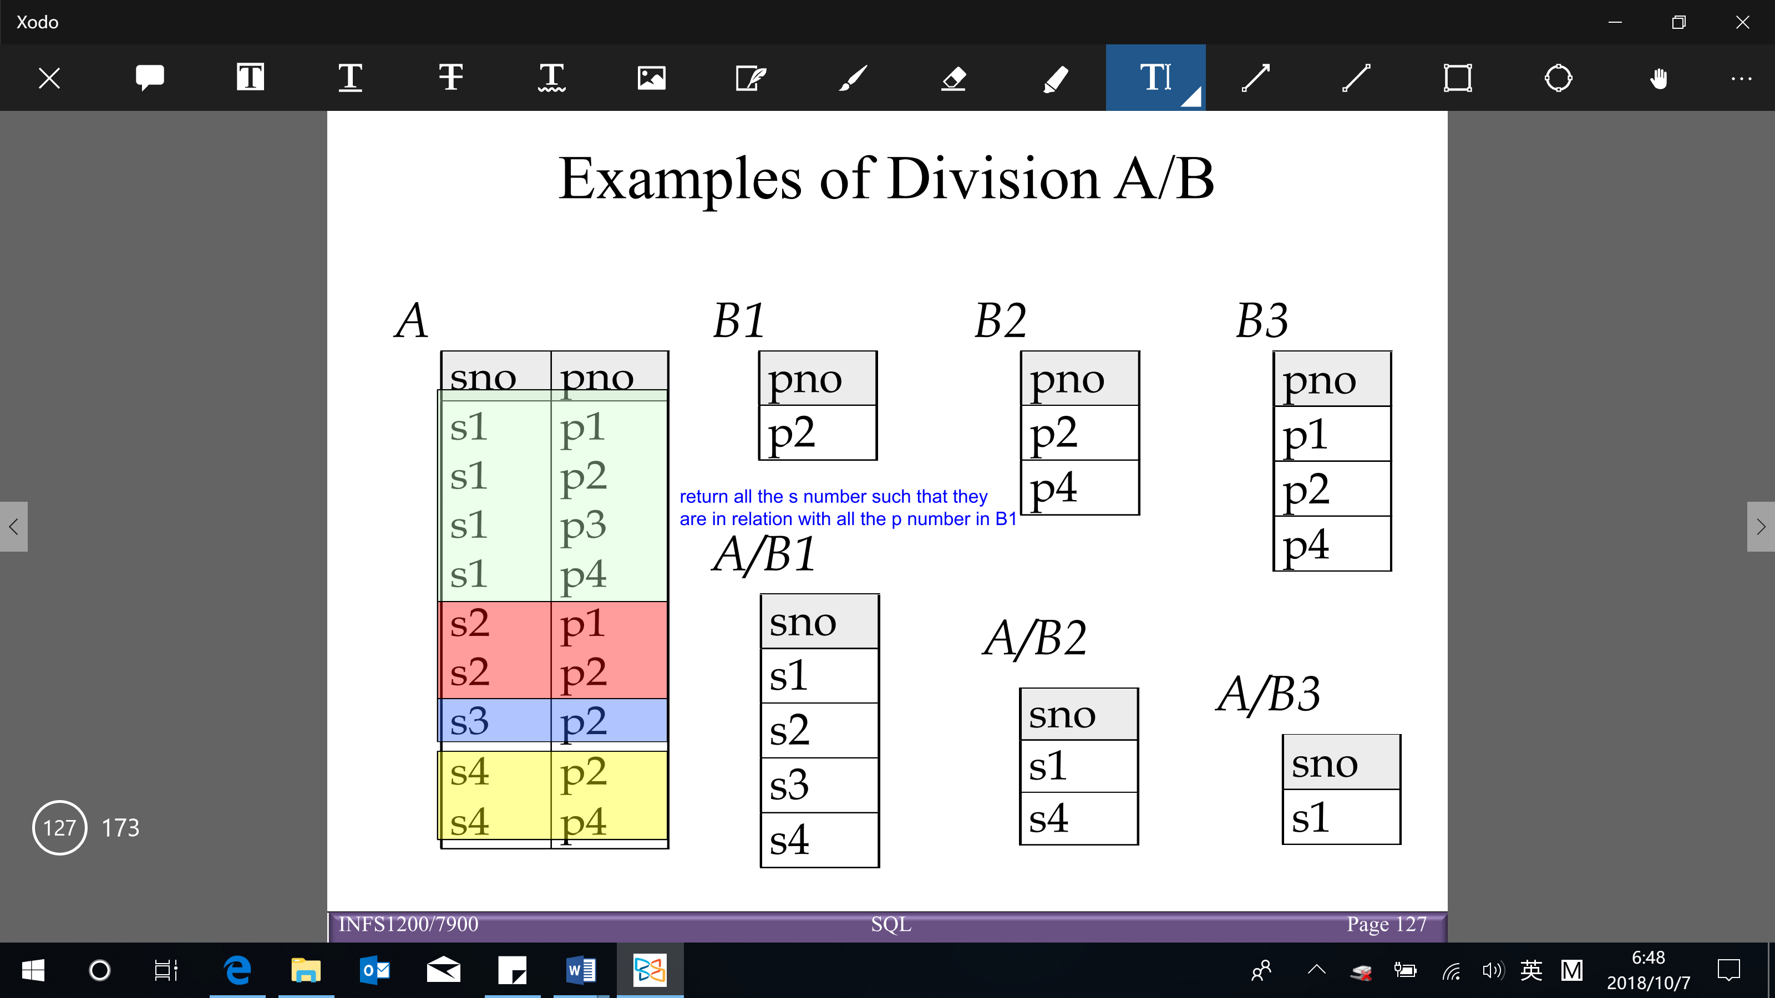

Division in SQL using EXCEPT

[BUT EXCEPT is not implemented in MySQL → using double negation]

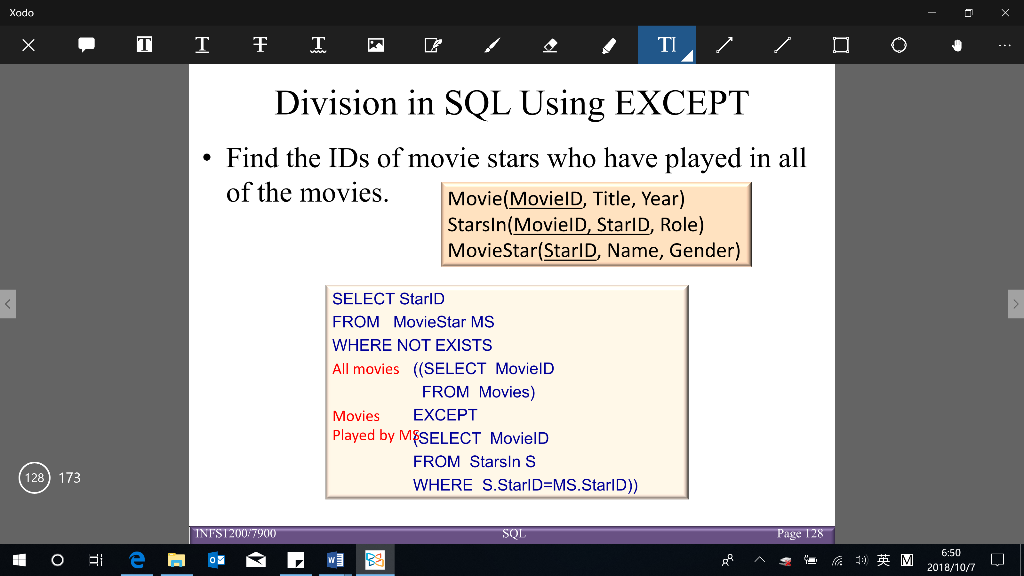

Double negation:

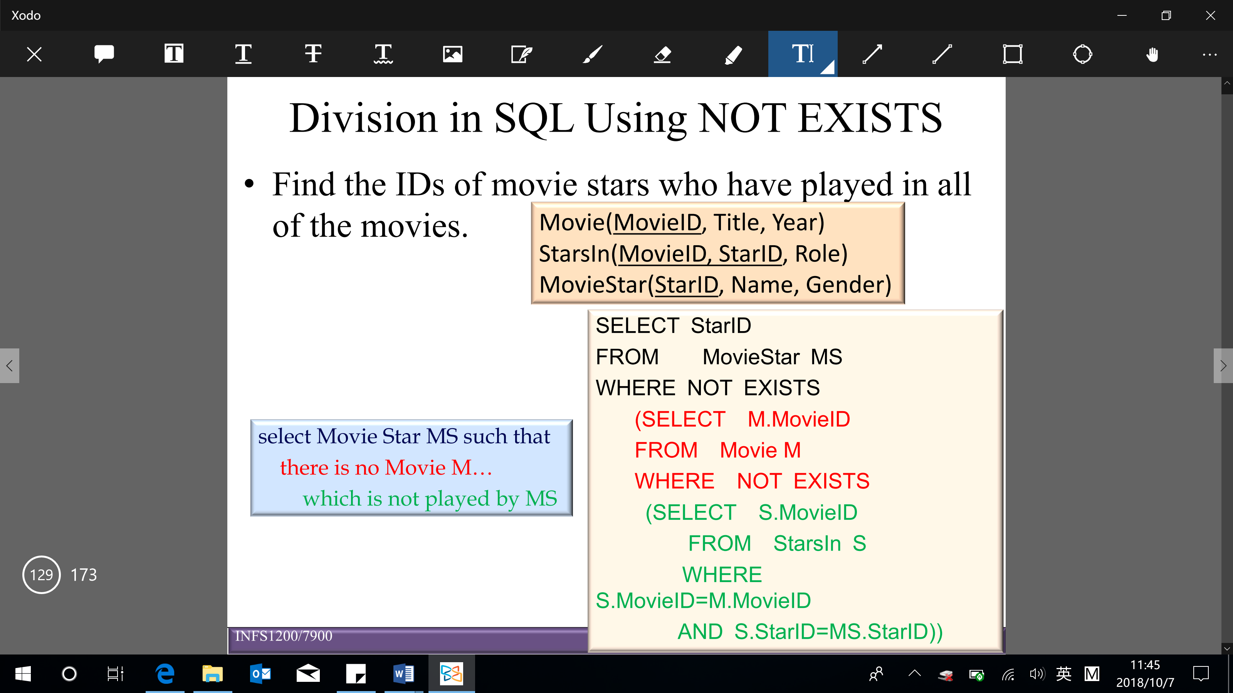

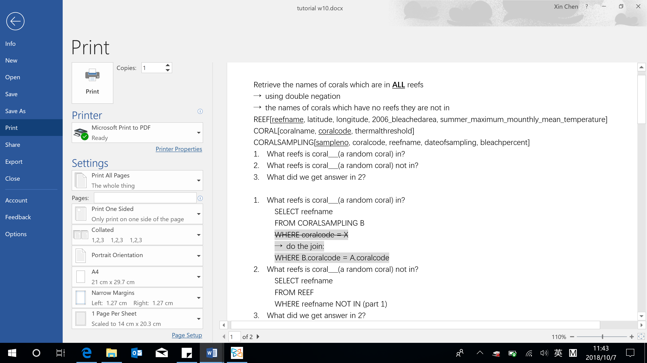

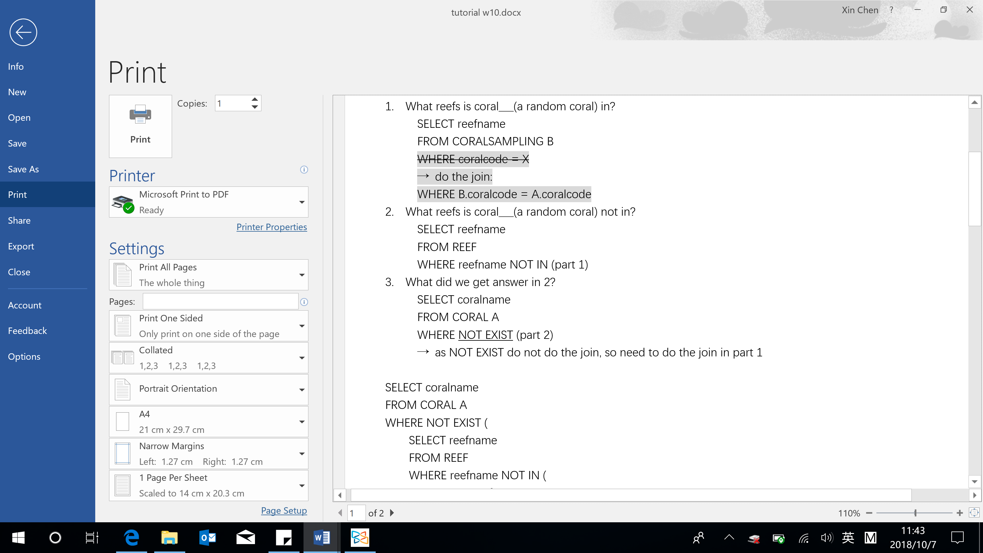

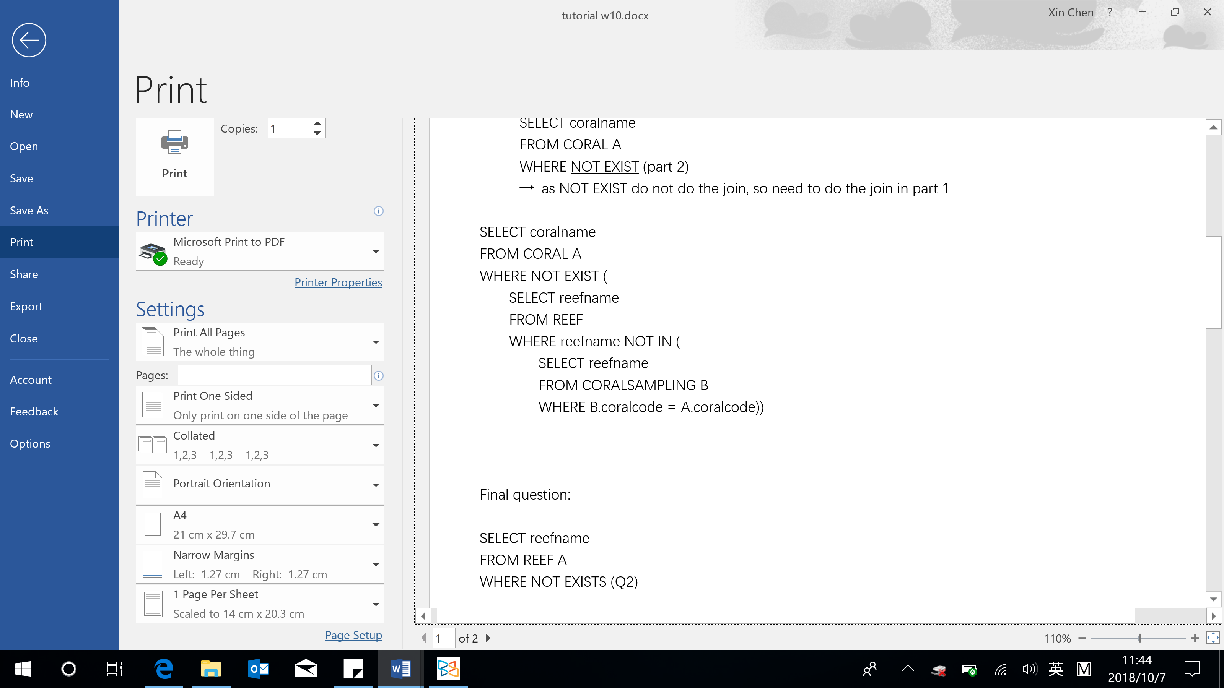

**Views**

* A single table that is derived from other tables, which could be base tables or previously defined views
* Types of views:

Virtual tables – do not physically exist on disk

Materialized – by physically creating the view table (must be updated when the base tables are updated)

* Benefits of using views

Simplification: view can hide the complexity of underlying tables to the end-users

Security: views can hide columns containing sensitive data from certain groups of users

Computed columns: views can create computed columns, which are computed on the fly

Logical data independence: views provide support for logical data independence, that is users and user’s programs that access the database are immune from changes in the logical structure of the database (wouldn’t influence the based table)

* Defining a view

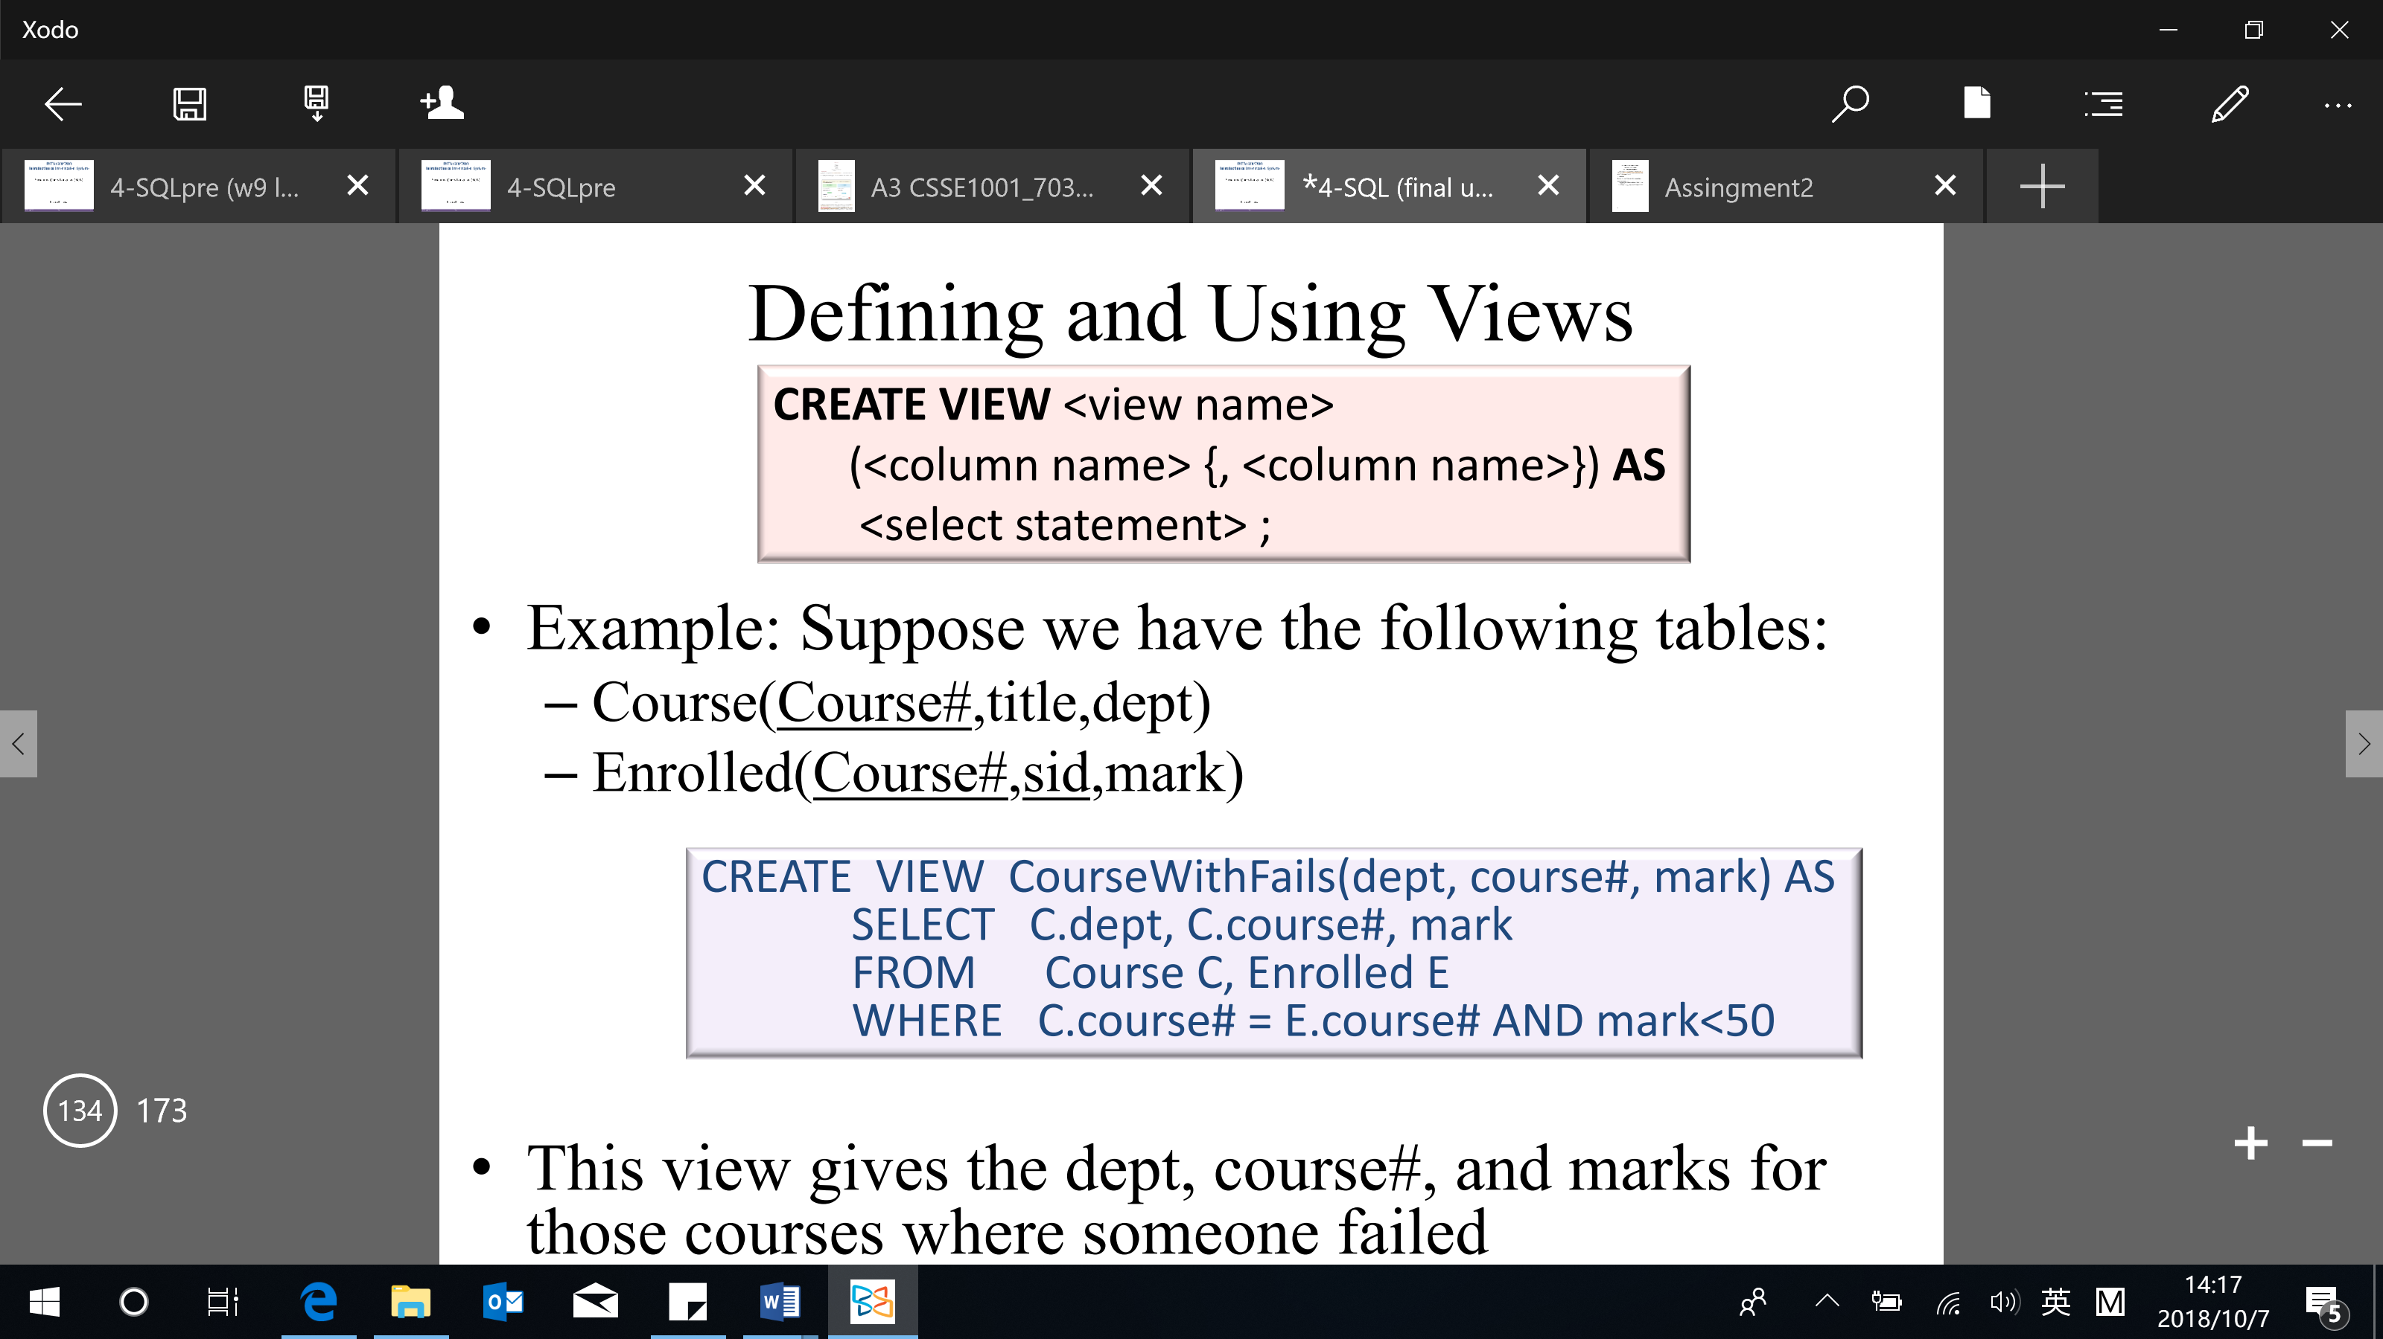

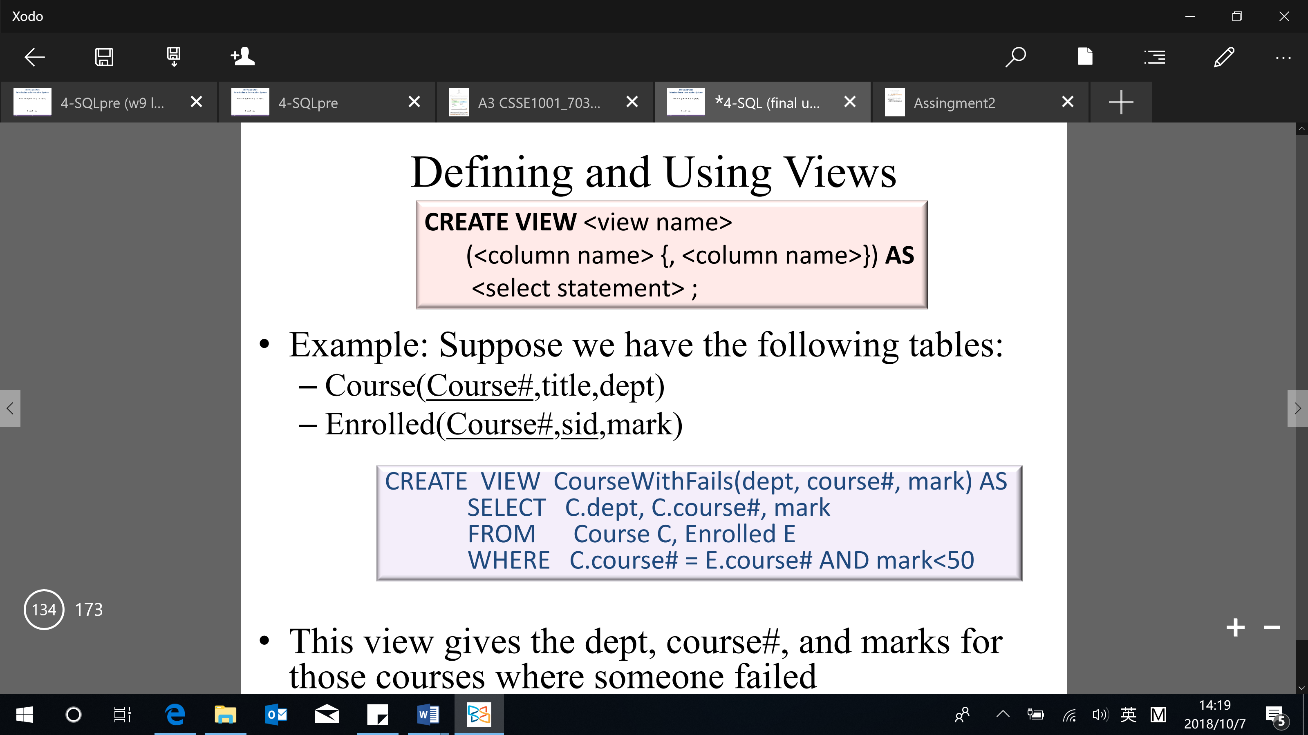

* View updates (one challenge of using view): must occur at the base tables

DBMS’s restrict view updates only to some simple views on single tables (called updatable views)

* Dropping views

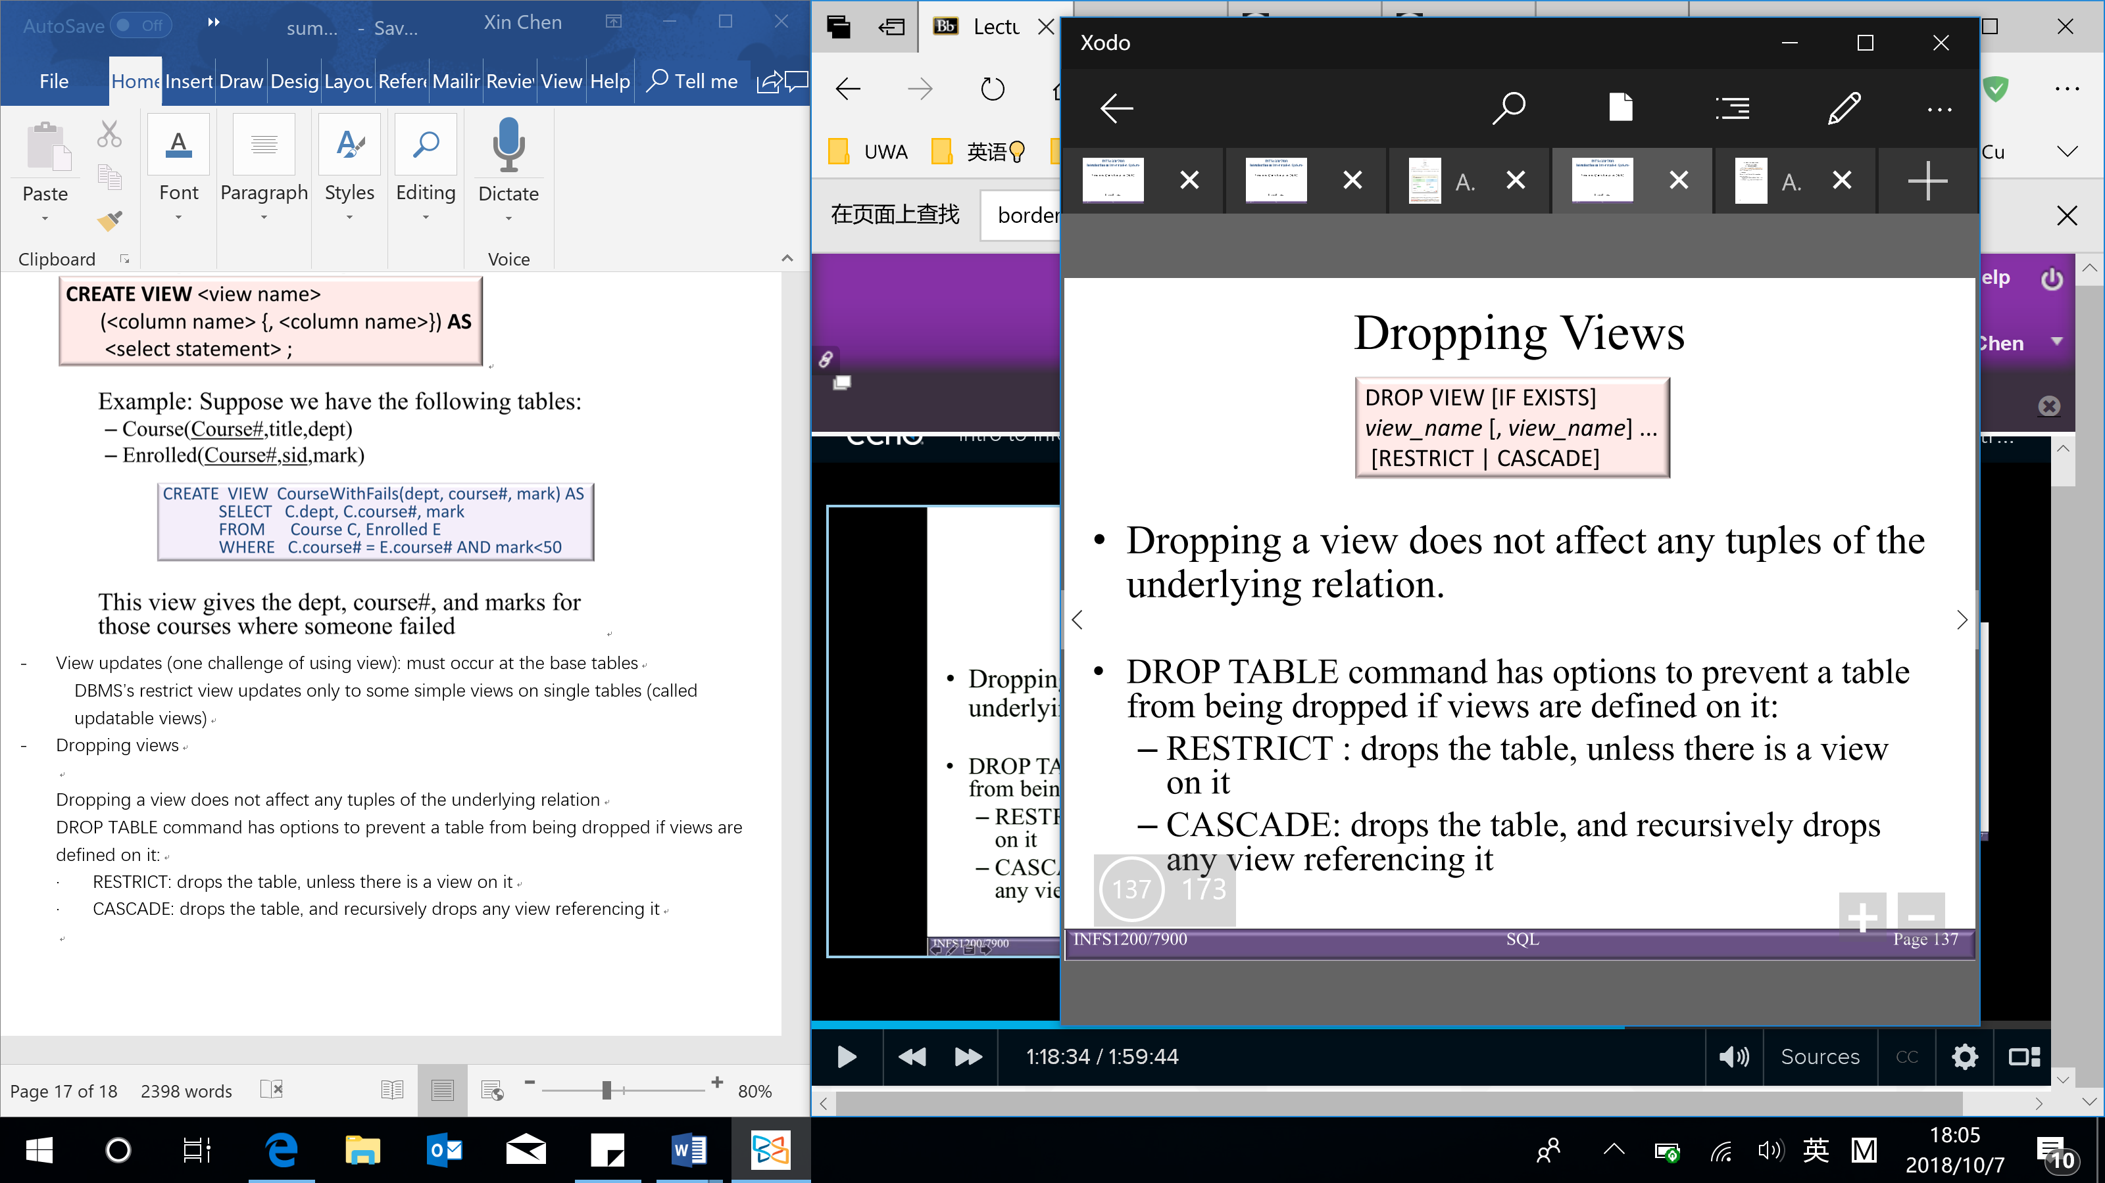

Dropping a view does not affect any tuples of the underlying relation just cannot query the view anymore (no data is lost)

Similar to DROP TABLE command, DROP VIEW has options to prevent a table from being dropped if views are defined on it:

* RESTRICT: drops the table, unless there is a view on it
* CASCADE: drops the table, and recursively drops any view referencing it

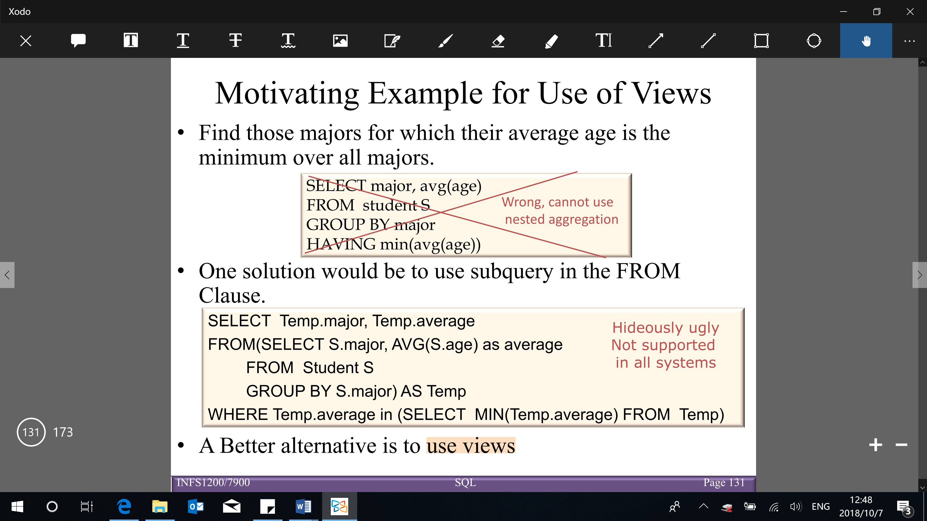

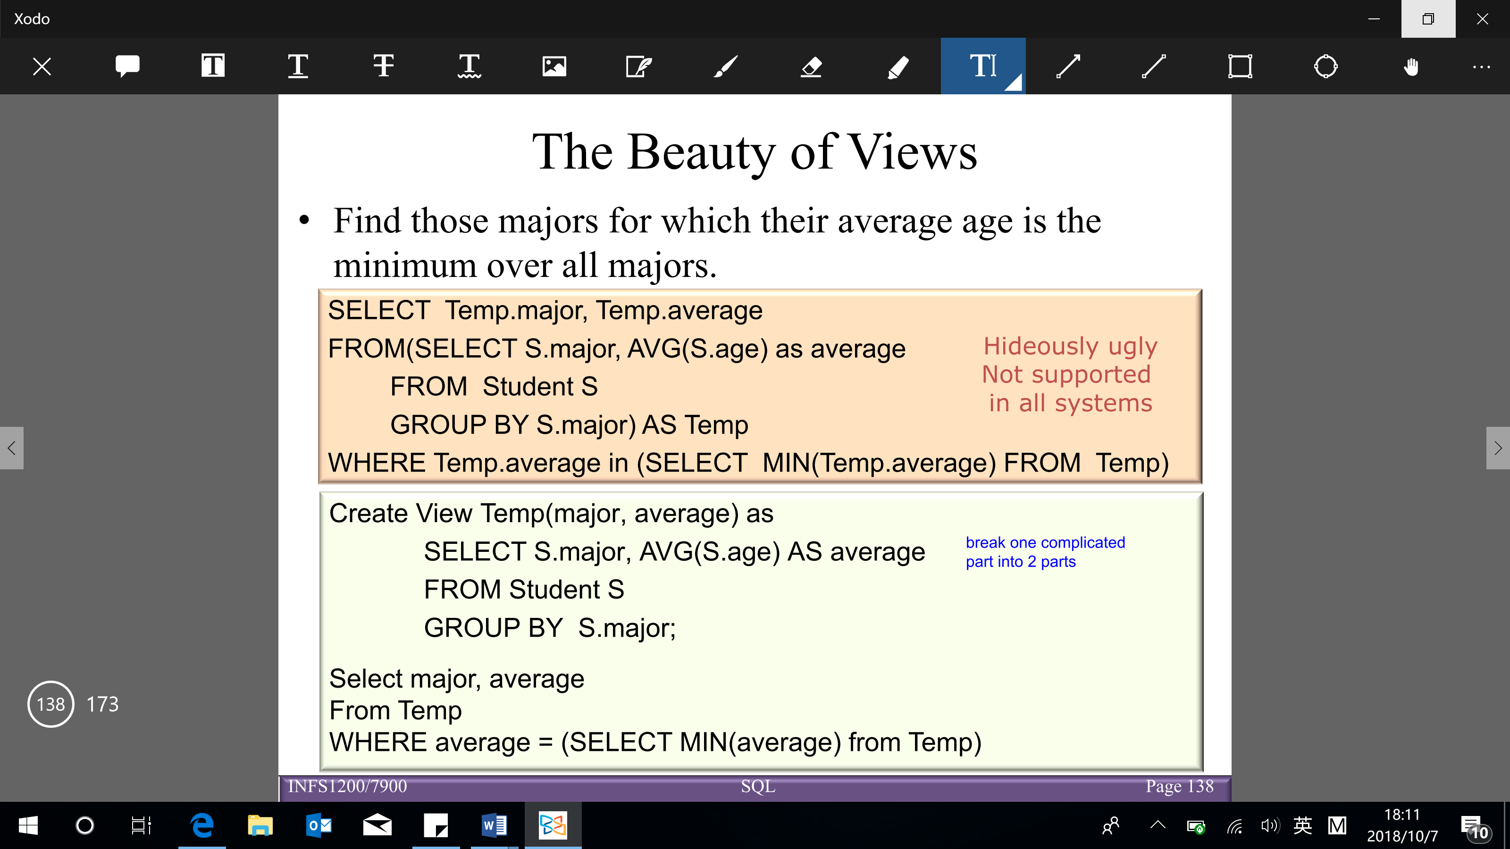

**Null values and joins**

NULL value

* A value of NULL: indicates the value is unknown
* IS NULL (IS NOT NULL) can be used to check for null values (whether the value is known or not known)
* Operations on NULL value

NULL requires a 3-valued (true, unknown, false) logic using the truth value unknown

* + OR: (unknown OR true) = true

(unknown OR false) = unknown

(unknown OR unknown) = unknown

* + AND: (true AND unknown) = unknown

(false AND unknown) = false

(unknown AND unknown) = unknown

* + NOT: (NOT unknown) = unknown
  + Comparisons between 2 null values, or between a null and any other value, return unknown because the value of each NULL is unknown
  + All aggregate operations except COUNT(*) ignore tuples with null values on the aggregated attributes

Join

* Join used to combine related tuples from 2 relations into a single tuple in a new (result) relation
* Join operation is needed for organizing a search space of data (have information comes from multiple tables)
* Join relations are specified in the FROM clause
* Based on Cartesian product (donated as x) (give all the combination).

Cartesian product – every row in $R_{1}$ is matched with every row in $R_{2}$ to form tuples in the result relation

The schema of the result relation contains all the columns from $R_{1}$ and all the columns from $R_{2}$

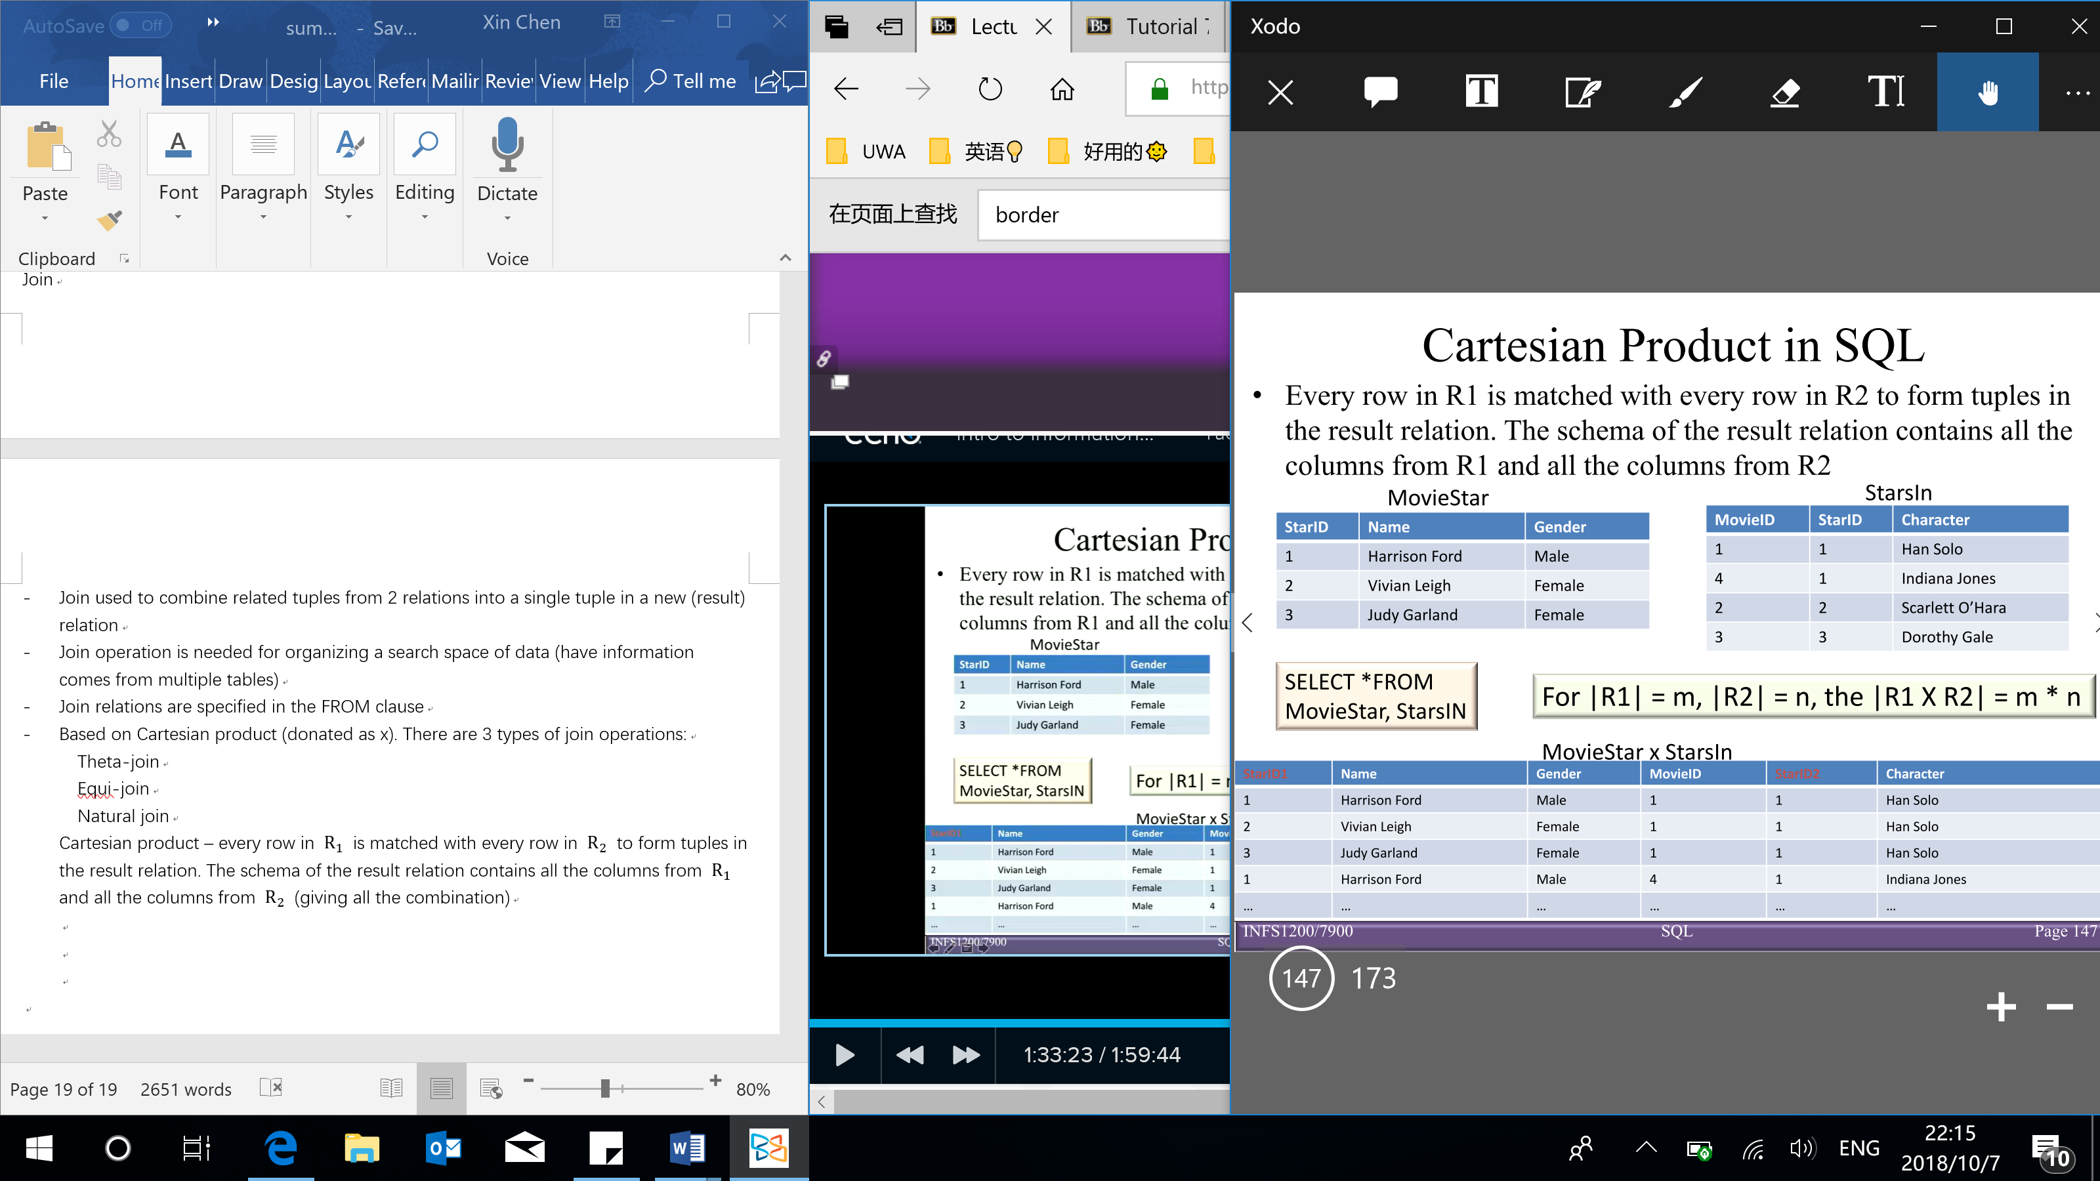

* 3 types of join operations:

Theta-join (most general type of join) – allows several logical operators ($=,≠,<,≤,>,≥$) in WHERE clause

Equi-join – special case of Theta join – condition contains only equalities ($=$)

Natural join (a type of Equi-join and structured in such a way that, columns with same name of associate tables will appear once only/ have one common attribute)

Guidelines:

The associated tables have one or more pairs of identically named columns

The columns must be the same data type

[Natural join of tables with no pairs of identically named columns/ no common attribute will return the cross product of the 2 tables]

* Inner join V.S. outer join

Inner join (default) – a tuple is included in the result relation, only if matching tuples exist in both relations

Outer join – can include the tuples that do not satisfy the join condition

Full outer join – includes all rows from both tables

Left outer join – includes all rows from first table

Right outer join – includes all rows from second table

[matching tuple does not exist, which is indicated by a NULL value]

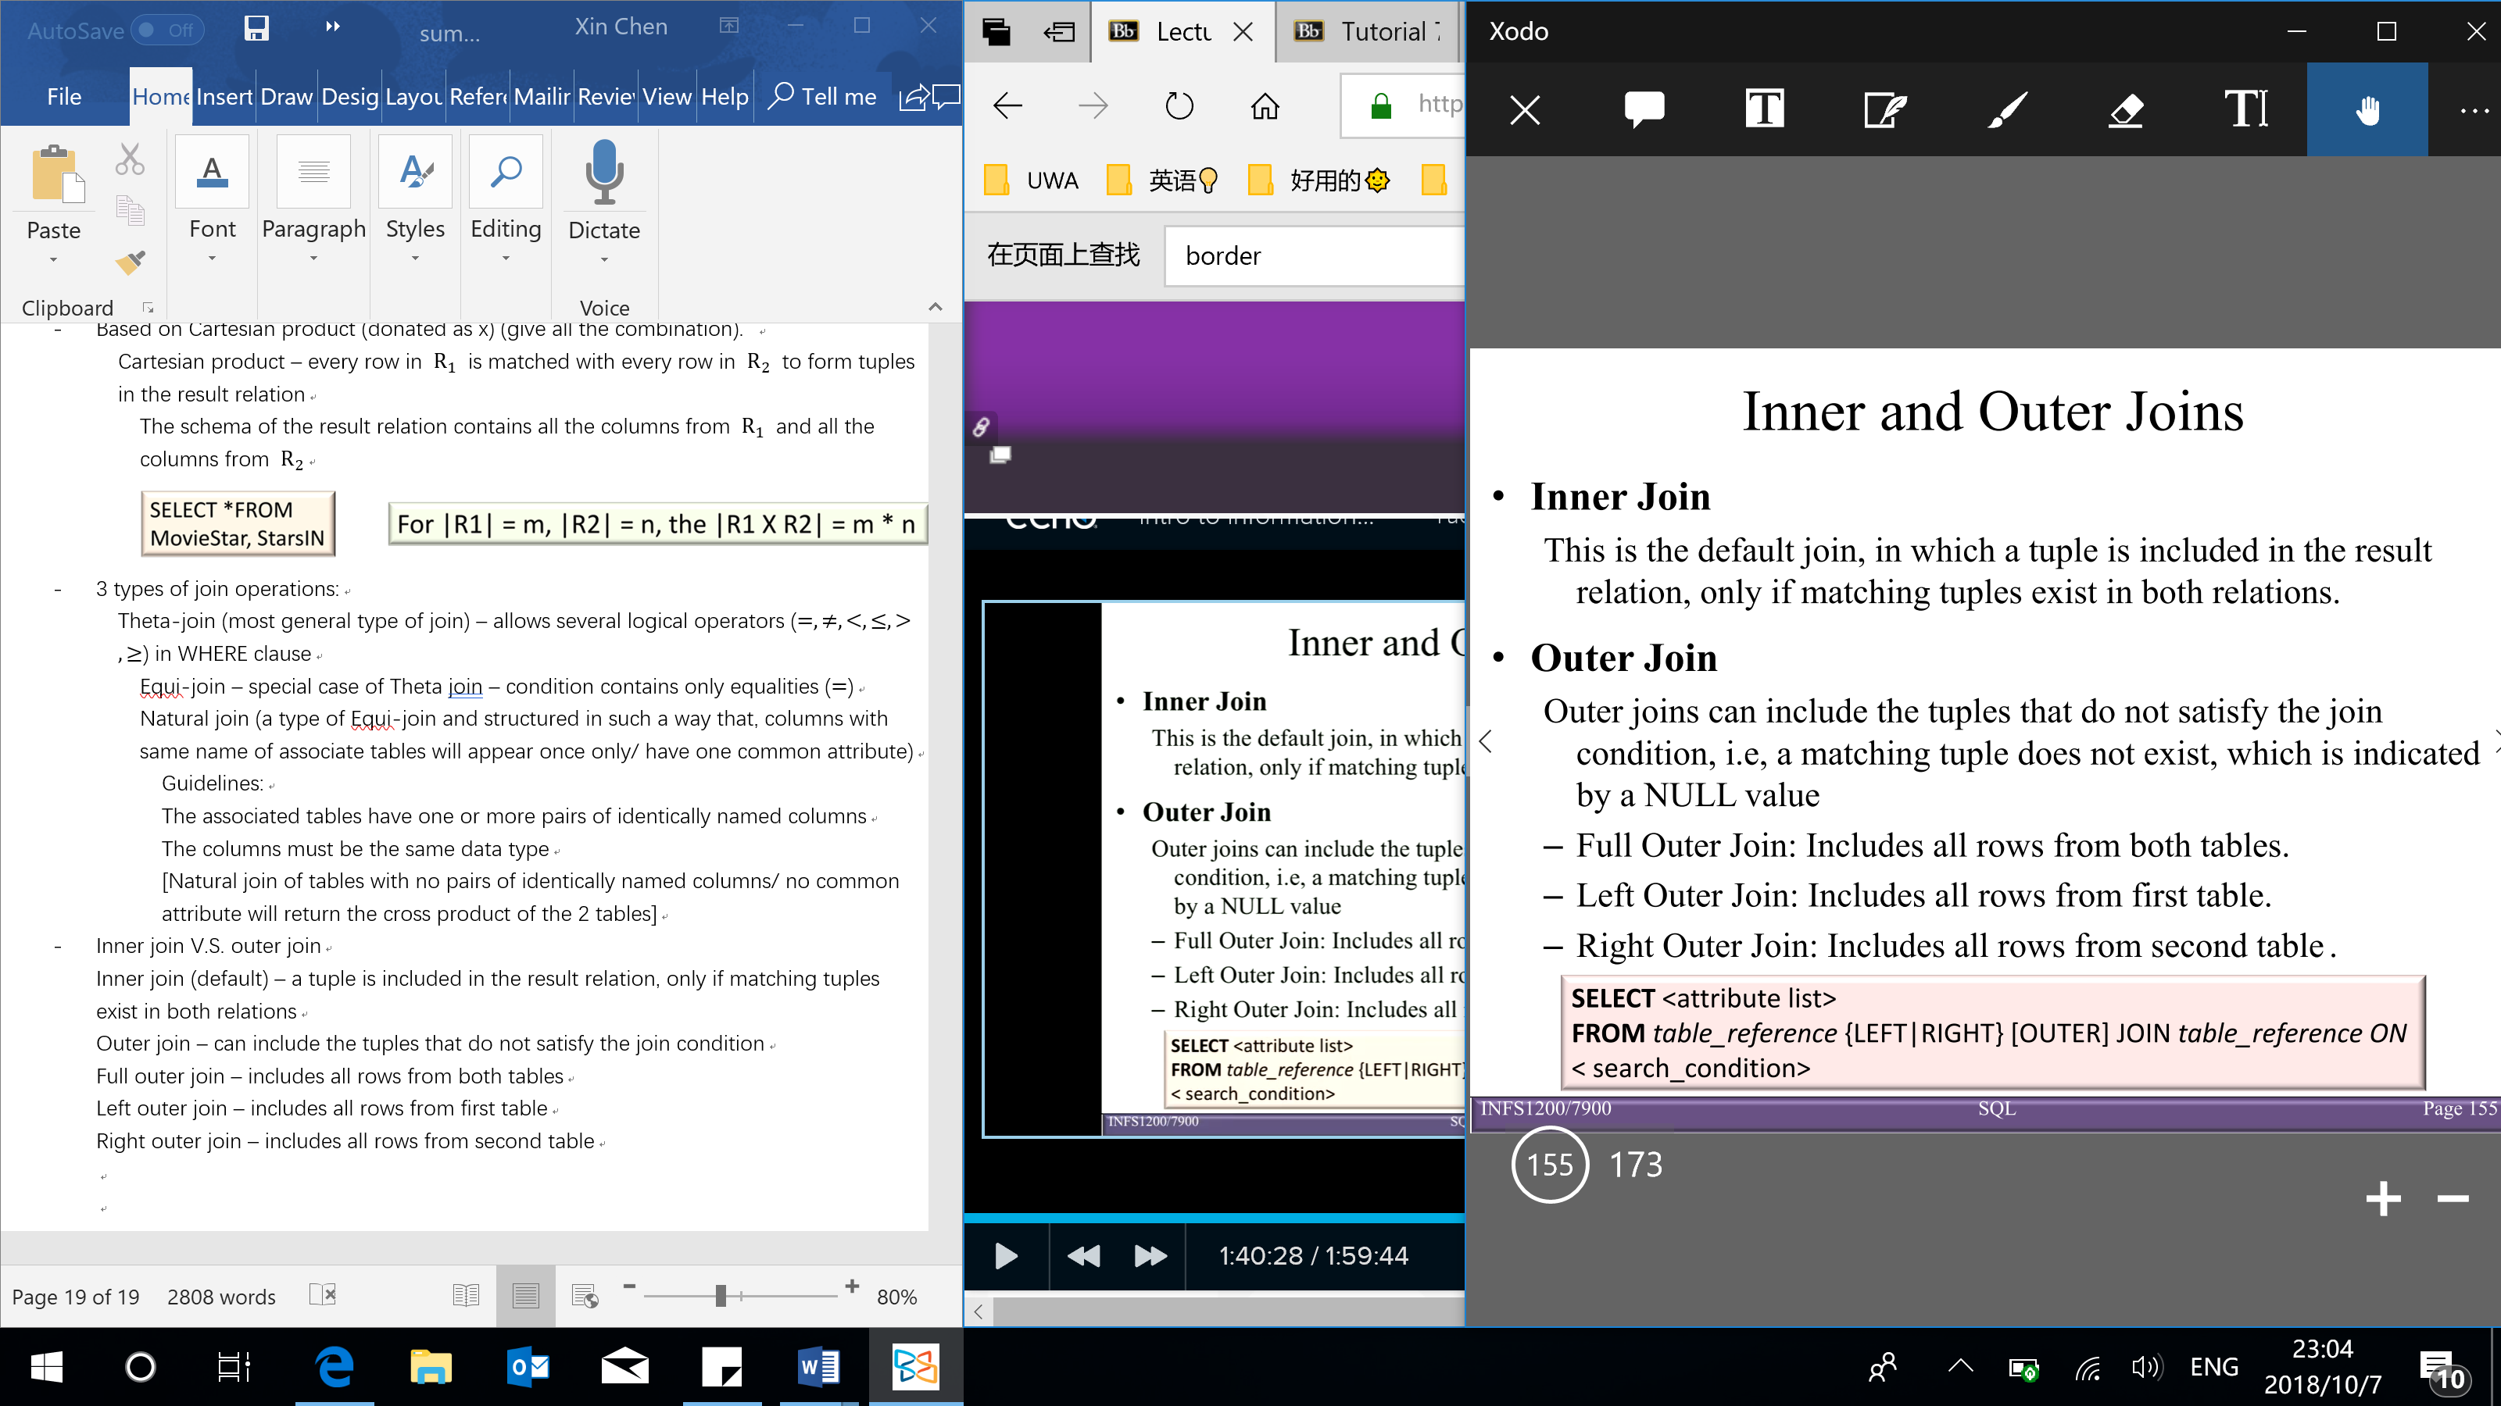

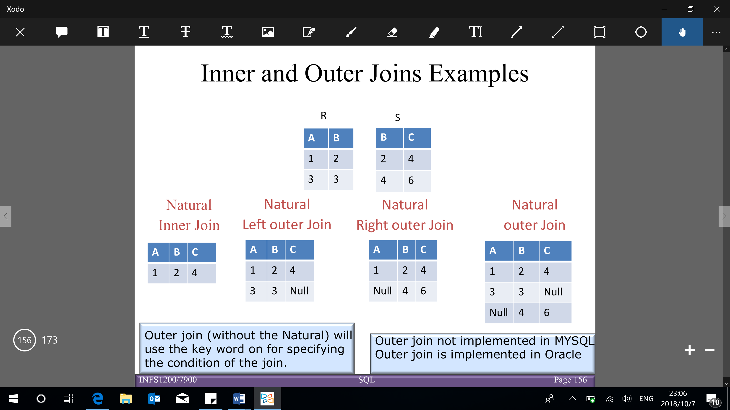

**INSERT, DELETE and UPDATE statements**

INSERT statement – used to add tuples to an existing relation

* Single tuple INSERT:

Specify the relation name and a list of values for the tuple

Values are listed in the same order as the attributes were specified in the CREATE TABLE command

User may specify explicit attribute names that correspond to the values provided in the insert statement. The attributes not included cannot have the NOT NULL constraint

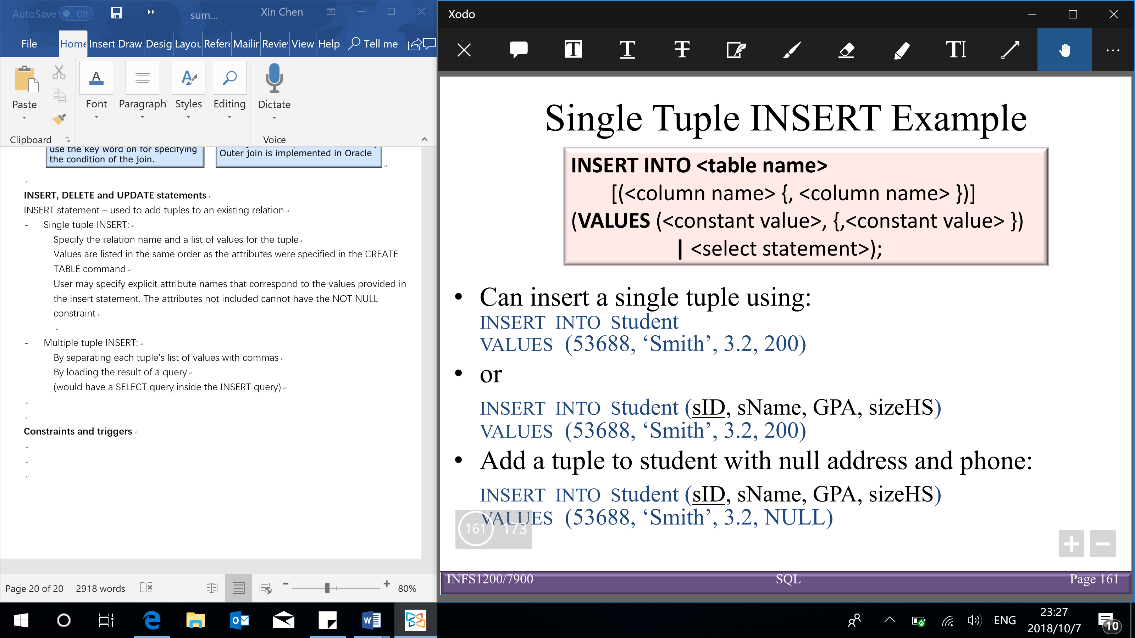

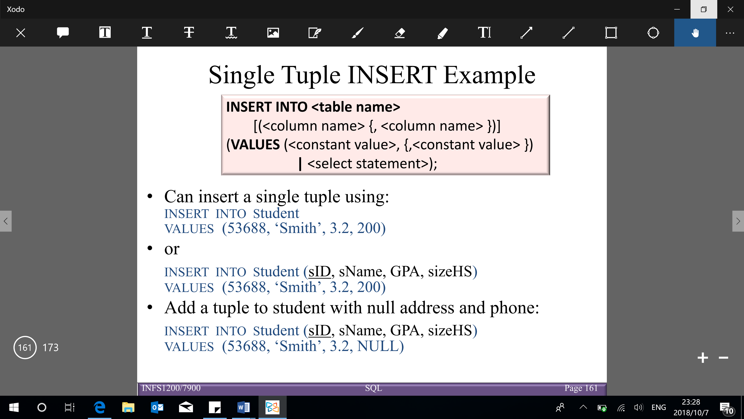

* Multiple tuple INSERT:

By separating each tuple’s list of values with commas

By loading the result of a query

(would have a SELECT query inside the INSERT query)

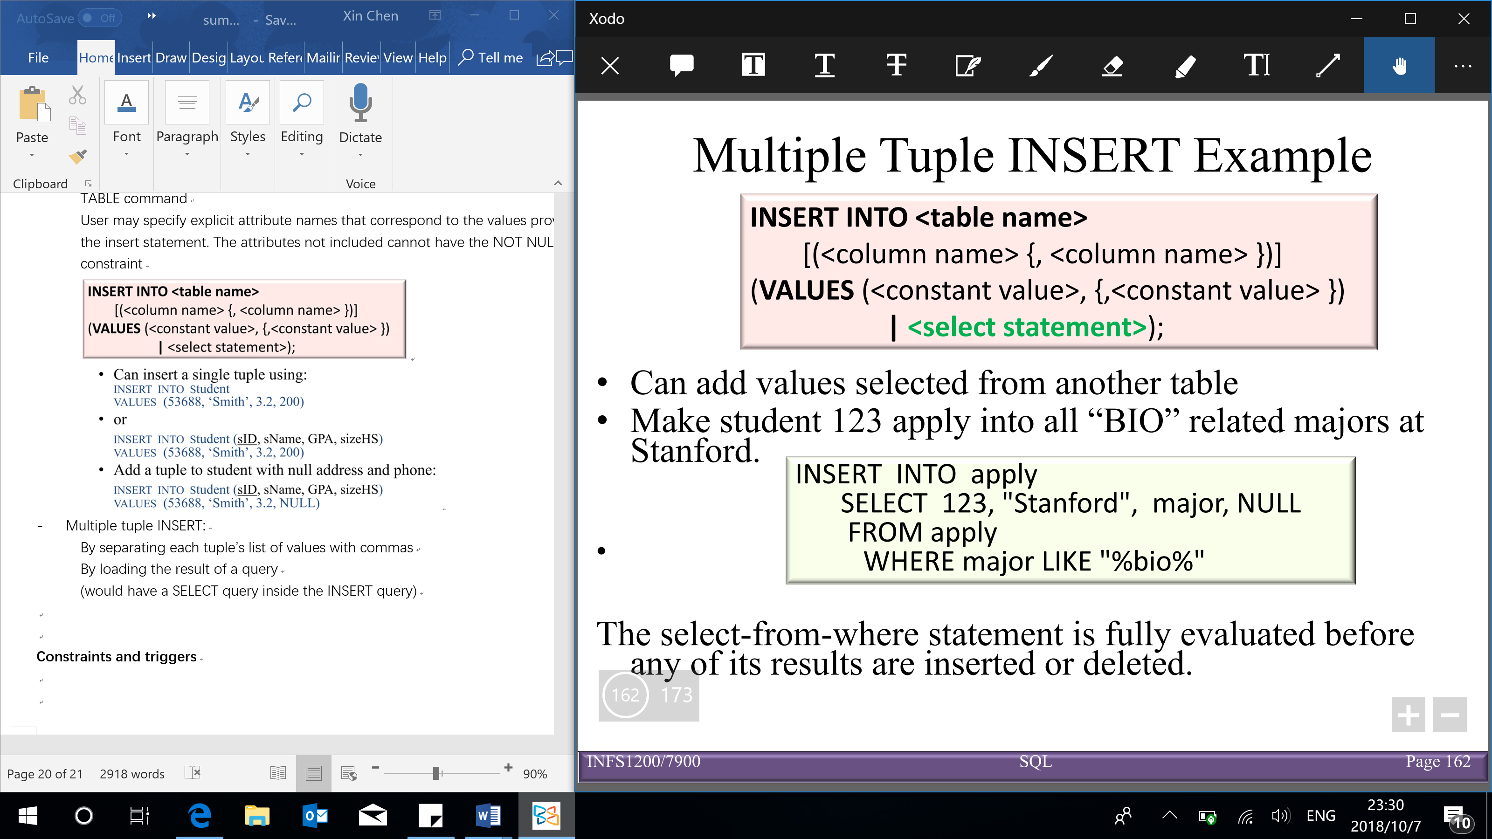

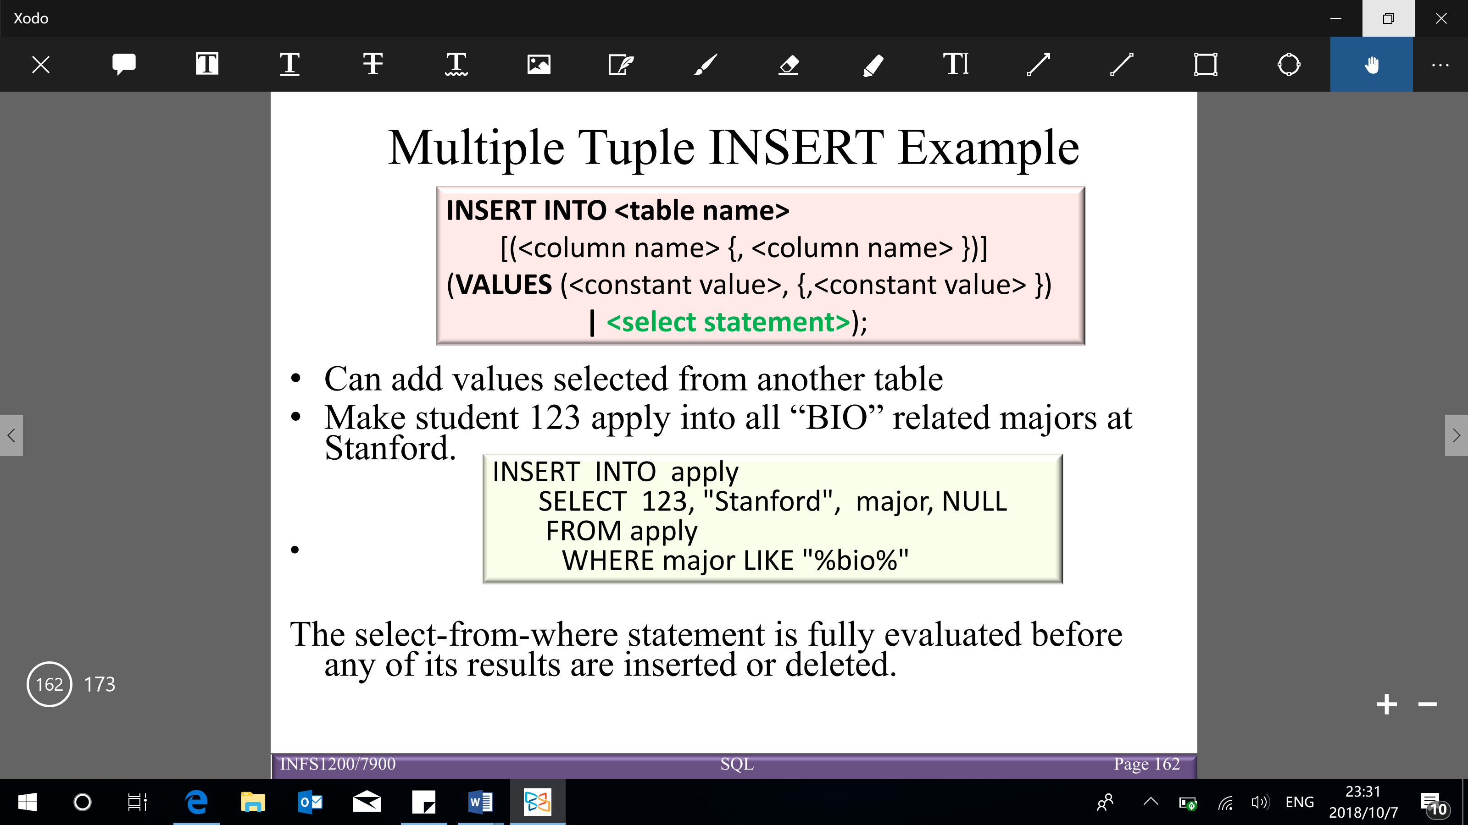

DELETE statement – used to remove existing tuples from a relation

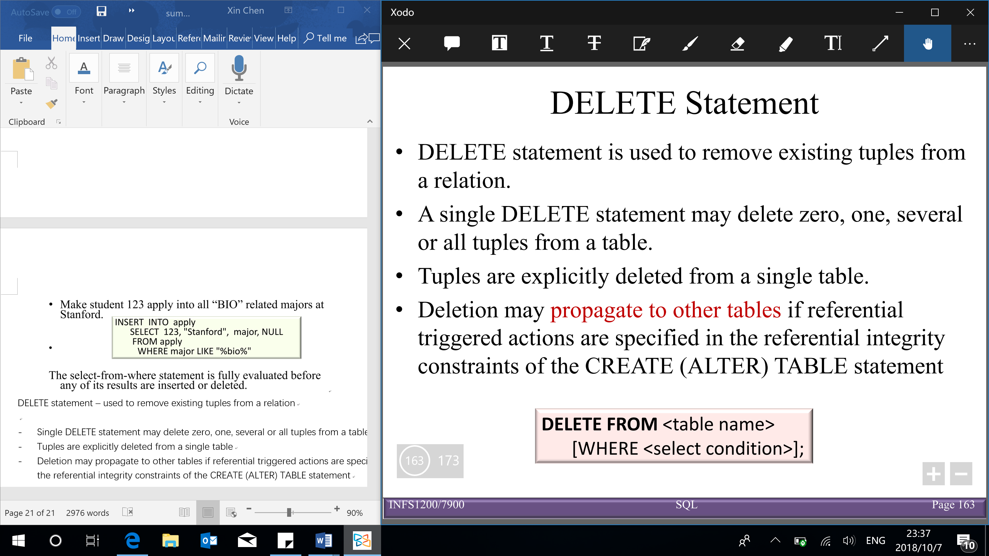

* Single DELETE statement may delete zero, one, several or all tuples from a table

(only whole tuples are deleted, cannot delete part of the tuple)

* Tuples are explicitly deleted from a single table
* Deletion may propagate to other tables if referential triggered actions are specified in the referential integrity constraints of the CREATE (ALTER) TABLE statement

UPDATE statement – used to modify attribute values of one or more selected tuples in a relation

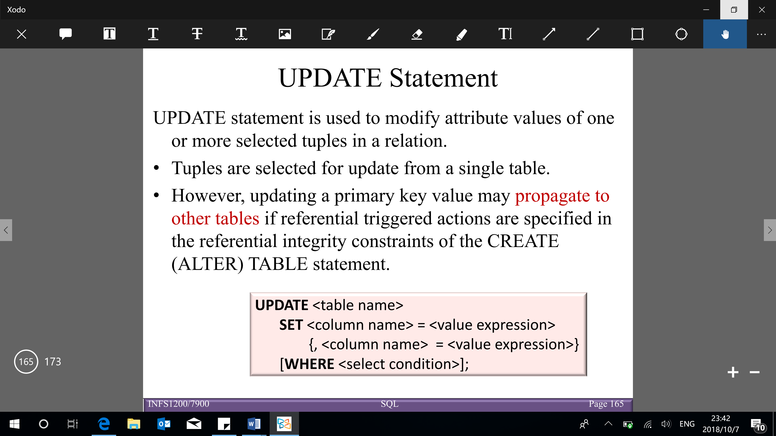

* Tuples are selected for update from a single table
* Updating a primary key value may propagate to other tables if referential triggered actions are specified in the referential integrity constraints of the CREATE (ALTER) TABLE statement

**Constraints and triggers**

Keys, entity, domain and referential integrity constraints are structural constraints that are managed by the DBMS

Semantic constraints can be specified using CHECK and ASSERTION statements

* Constraint is satisfied by a database state if no combination of tuples in the database state violates the constraint
* **CHECK**– constraints write in CREATE TABLE statement

To checked when tuples are inserted or modified

Semantic constraints over a single table are specified using CHECK conditional-expressions/ constraints only used for one table

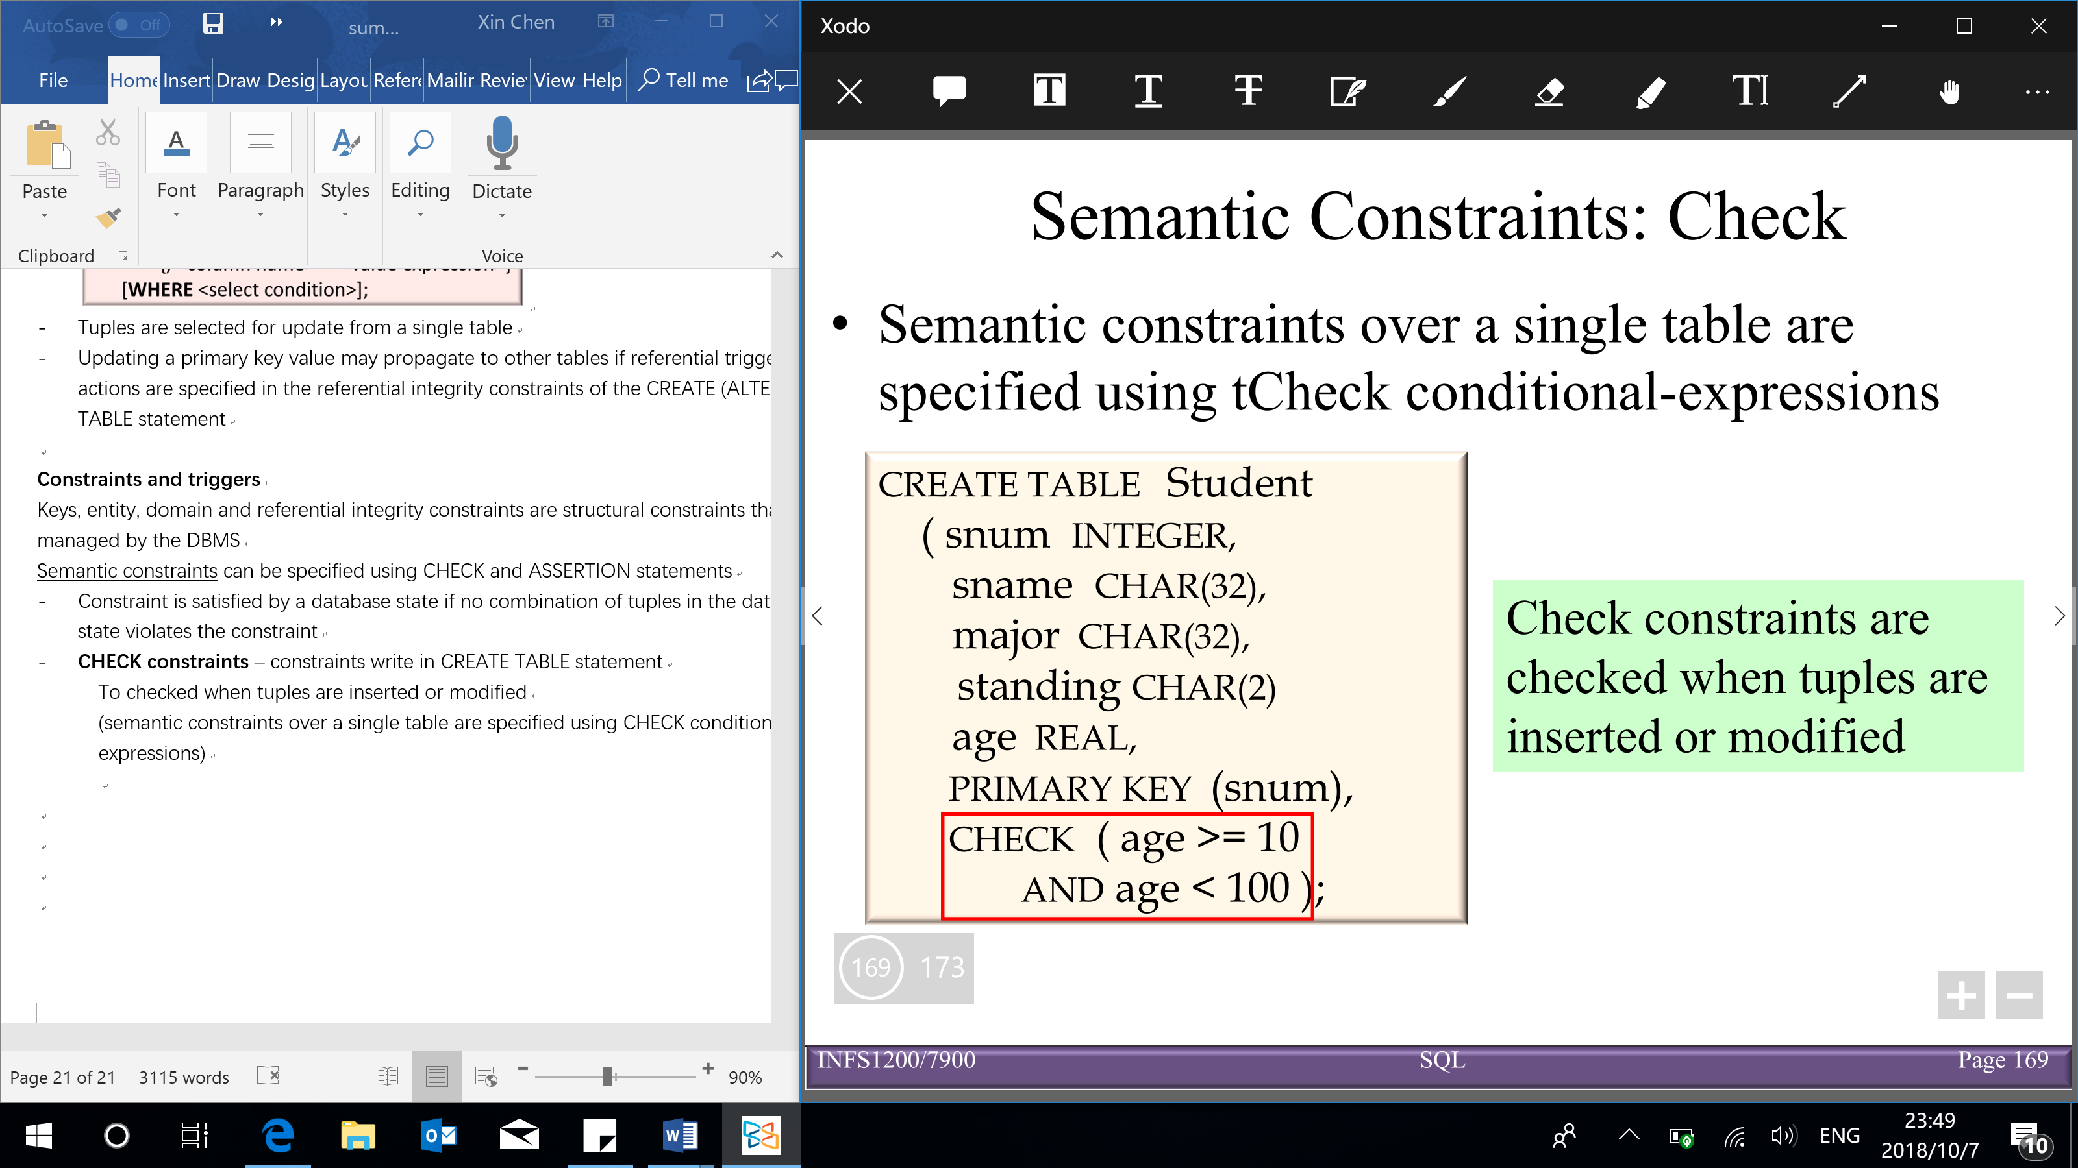

* ASSERTION

Constraint can used with multiple table

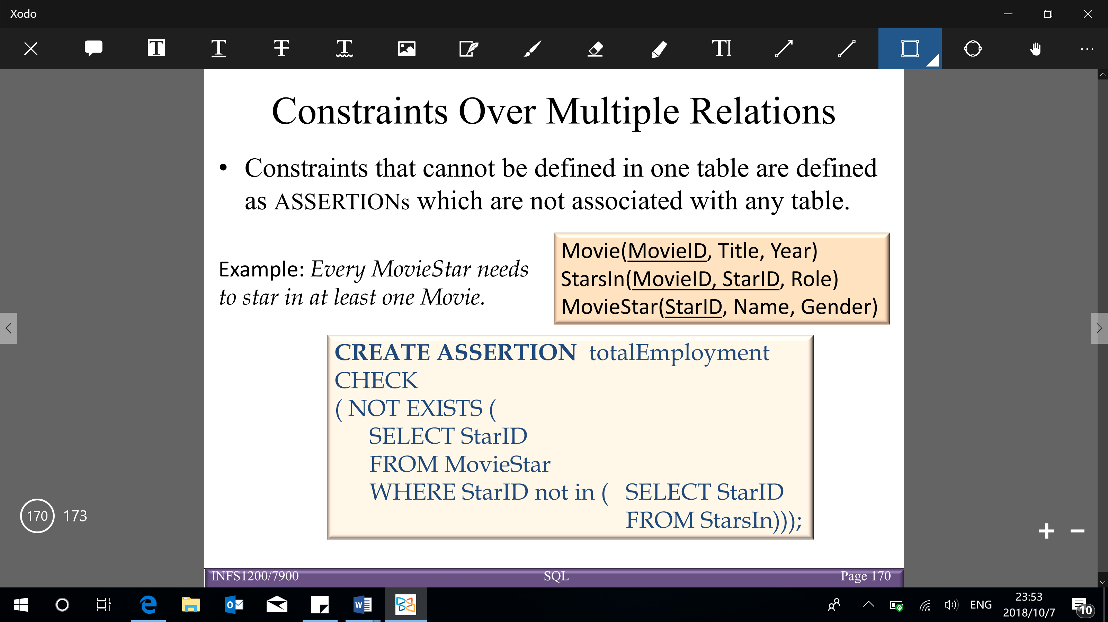

**Triggers**

* (event-driven architecture)

Active database is a database that includes an event-driven architecture

* Triggers are a procedure that start automatically if specified changes occur to the DBMS
* Triggers may cause cascading effects

Parts of triggers (3):

1. Event (activates the trigger)
2. Condition (tests whether the trigger should run)
3. Action (procedure executed when trigger runs)

